Before Using the Product…

Before using the product, please read this user’s manual thoroughly for the effective use of the product.

◈ Notices for the Safety ◈

- Notices for the Safety should be complied by the user to use the product safely and correctly to prevent the occurrence of any accident or danger.
- Notices is divided by ‘Warning’ and ‘Caution’ and each meaning is as follows ;


Warning경고

: in case of violating the instructions, it may cause the significant injury or death.
Caution주의

: in case of violating the instructions, it may cause the slight injury or product damage.

- The meaning of symbols used in the product and user’s manual is as follows:
means “to take care as the danger may occur under the specific conditions”.
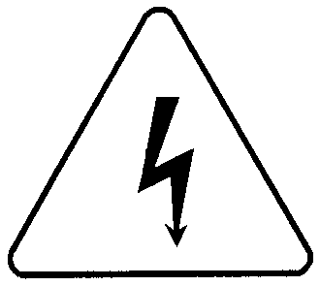
means “to take care as the electric shock may occur under the specific condition”.

- After using the user’s manual, you should keep it in the place where the users can see it easily whenever they need.

□ Notices in Design
Caution

I/O Signal/Communication Cables shall be designed apart at least 100mm from high tension wire or power cable to avoid the influence caused by the noise and the change of magnetic field.
It may cause the malfunction by the noise.
Please take cares not to apply the lamp directly to the product in the place where lots of lamp are installed. The inflow of metal particle is not permitted as it may cause the malfunction of the product.
In case of installation environment with metal particles, it may cause the malfunction and it is required not to flow into the metal particles when installing.

□ Notices in Installation
PLC should be used in the environment condition described in the general standard.
If used out of general standard, it may cause the electric shock, fire, malfunction, damage of product or furious flames etc.
Make sure that the module is fixed correctly.
If the module is not installed correctly, it may cause the malfunction, failure or falling.

□ Notices in Wiring
Caution
Caution
The grounding of FG terminal should be used with the 3rd class grounding for PLC.
If not grounding, it may cause the malfunction.
The wiring in PLC should be connected after confirming the rating voltage of the product and terminal layout.
If connected to the different power from the rating or a wrong wiring, it may cause the fire or failure.
In wiring, tighten the terminal screw with standard torque.
If the terminal screw is loosened, it may cause the short circuit or malfunction.
Cares should be taken not to put the wire remnants or foreign materials inside the module.

□ Notices in Startup and Maintenance

Do not touch the terminal in the state that the power is applied. It may cause the malfunction or electric shock.
When cleaning or tightening the terminal screw, the power should be OFF.

Warning
Caution

Do not remove PCB from the module case or remodel the module. It may cause the failure, malfunction, damage of the product or fire. The installation and removal of the module should be done after Power OFF.
The change of battery should be done in the state of power ON.
In case of changing in the power OFF, it may cause the loss of program.

□ Notices in Disposal
Caution

When the product is disposed, this should be treated as industry waste.

Revision History

Issue Date | Manual number | Revised Content
2002. 10. | 10310000397 | First version issued.
※User’s Manual no is marked on the right bottom side of the back cover.

