To prevent injury and property damage, follow these instructions.

Incorrect operation due to ignoring instructions will cause harm or

damage, the seriousness of which is indicated by the following symbols.

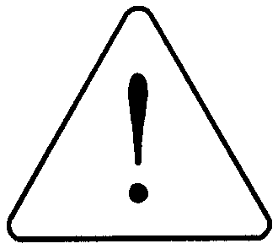
WARNING
CAUTION
This symbol indicates the possibility of
death or serious injury

This symbol indicates the possibility of
injury or damage to property.

■ The meaning of each symbol in this manual and on your equipment is as follows

This is the safety alert symbol.
Read and follow instructions carefully to avoid dangerous situation.

.
This symbol alerts the user to the presence of “dangerous voltage” inside the product that might cause harm or electric shock.
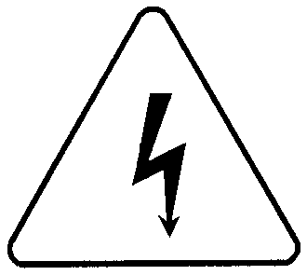

Design Precautions

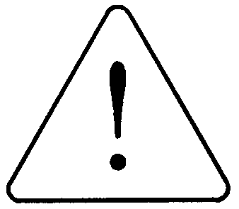
Caution
Caution
 Do not bunch the control wires or communication cables with the main circuit or power wires, or install them close to each other. They should be installed 100mm (3.94inch) or more from each other.
Not doing so could result in noise that would cause erroneous operation.

Installation Precautions
Use the HMI in an environment that meets the general specification contained in this manual or datasheet.
Using the HMI in an environment outside the range of the general specifications could result in electric shock, fire, erroneous operation, and damage to or deterioration of the product.

When install the HMI in environment of much vibration, be sure to insulate the HMI from direct vibration.
Not doing so could cause electric shock, fire, and erroneous operation.

Be sure to there are no foreign substances such as conductive debris inside the module.
Conductive debris could cause fires, damage, or erroneous operation.

Wiring Precautions

Warning
Completely turn off the external power supply when installing or placing wiring.
Not doing so could cause electric shock or damage to the product.

Make sure that all terminal covers are correctly attached.
Not attaching the terminal cover could result in electric shock.

Caution

 Be sure that wiring is done correctly be checking the product’s rated voltage and the terminal layout.
Incorrect wiring could result in fire, damage, or erroneous operation.

 Tighten the terminal screws with the specified torque.
If the terminal screws are loose, it could result in short circuits, fire, or erroneous operation.

 Be sure there are no foreign substances such as sawdust or wiring debris inside the HMI.
Such debris could cause fire, damage, or erroneous operation.

Startup and Maintenance Precautions
Do not touch the terminals while power is on.
Doing so could cause electric shock or erroneous operation.

Switch all phases of the external power supply off when cleaning the HMI.
Not doing so could result in electric shock or erroneous operation.
Warning

 Do not disassemble or modify the HMI.
Doing so could cause trouble, erroneous operation, injury, or fire.

 Use a cellular phone or walky-talky more than 30cm (11.81 inch) away from the HMI
Not doing so can cause a malfunction.
Caution

Disposal Precaution
Caution
 When disposing of this product, treat it as industrial waste.
Not doing so could cause poisonous pollution or explosion.

