Chapter2. Names of Parts

2.1 Names of Parts and Description

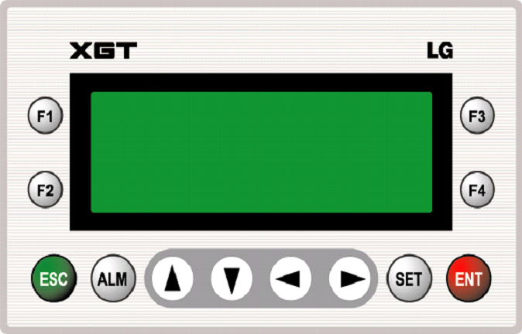

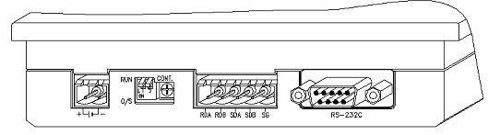

①
②
③
④
⑤

No | Names | Description |  |  | Remark
1 | Power supply connector | 2 pin connector for the external 24VDC input |  |  | DC 24V
2 | Mode switch | Dip switch for selecting O/S Download Mode and Operation Mode. |  |  | Default : RUN
2 | Mode switch | Dip SW. 1 | Dip SW. 2 | Mode | Default : RUN
2 | Mode switch | RUN | RUN | Operating mode | Default : RUN
2 | Mode switch | O/S | O/S | O/S downloading mode | Default : RUN
3 | Variable resistor | Variable resistor for adjusting contrast
4 | RS-422/485 connector | RS-422/485 connector for communication channel 2
5 | RS-232C connector | RS-232C connector for communication channel 1

