Chapter 4. System Configuration

XGT Panel Supports two communication channel independently.(RS-232C, RS-422/485)

4.1 1:1 Configuration

The 1:1 communication system using XGT Panel can be composed as shown below
In this case, the XGT Panel is a master and the others are slave

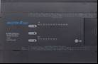
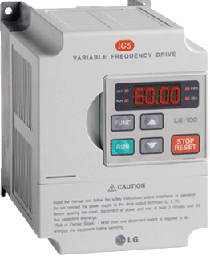
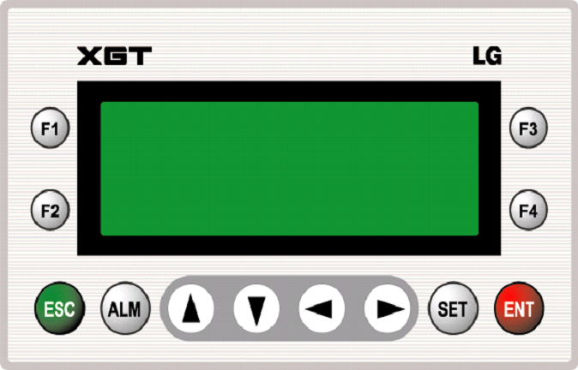
RS-232C
RS-485

RS-422/485

4.2 1:N Configuration

The 1:N multi-drop communication system using XGT Panel can be composed as shown below
In this case, the XGT Panel is a master and the others are slave(Up to 32 station)

RS-422/485

RS-232C
RS-485

4.3 N:1 Configuration

This is the example that the many XGT Panel controls one slave as a multiple master (Available on RS-422/485 only)

RS-422/485

RS-485

4.4 N:M Configuration

This is the example that the many XGT Panel controls many slaves as a multiple master (Available on RS-422/485 only)

RS-422/485

4.5 Slave Configuration

XGT Panel is able to be a slave in the system.
In this case, the master of the system can read or write the system memory area of the XGT Panel..
Refer to ‘Chapter 7.6 System memory’ for details about system memory..
Because channel 1 and channel 2 of XGT Panel are independent, the one channel can be configured as a master and the other channel as a slave.
In some cases, both of the channels can be configured a slave.

