Chapter 5 Panel Editor Installation

5.1 System Requirements

For successful installation of Panel Editor, your computer should meet the following recommended system requirements.

Item | Recommended System Requirements
CPU | Pentium III-class PC (300 MHz or higher recommended)
RAM | 64 MB of RAM(128 MB recommended)
Disk space Required | 44 MB of free disk space during setup, 40 MB after setup
Serial port | Serial communication port 1 or more (used for data communication with XGT-Panel)
Monitor | Super VGA monitor(screen resolution at least 800 x 600, 256 colors. 1024X768 or higher recommended)
Keyboard | Windows compatible keyboard
Mouse | Windows compatible mouse
Printer | Windows compatible printer
O.S | Windows 98, Windows NT4.0 (Intel) with Service Pack 6 or later,  Windows 2000 Professional, or Windows /XP

5.2 Panel Editor Installation

5.2.1 Panel Editor Installation Procedure

This Installation procedure is same in Windows 98/NT4.0/2000/XP

1) Execute XGTEditor_Setup (English).exe

The Installation Wizard dialog box appears as shown below.
Click Next

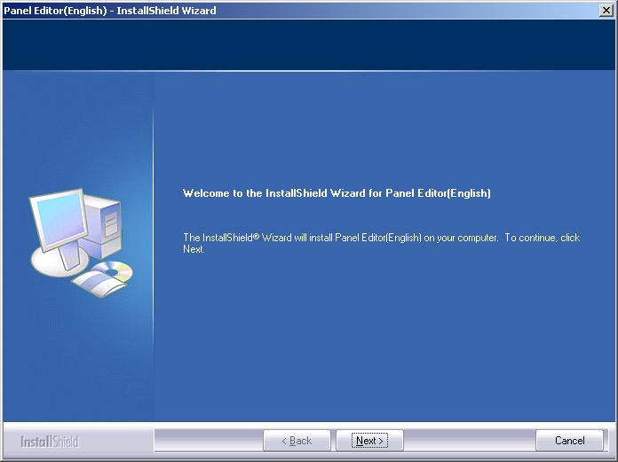

2) The Customer Information dialog box appears as shown below.
Enter your name and the name of the company and then click Next

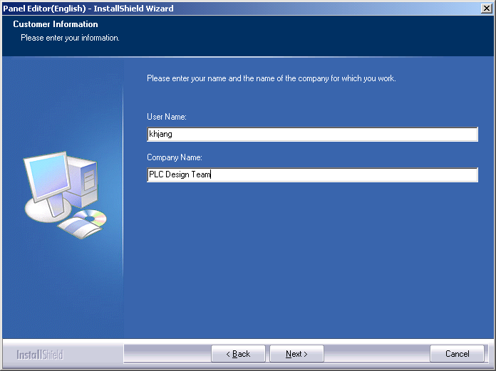

3) The Choose Destination Location dialog as shown below appears.

The installation folder is displayed. To browse path, click Change.
To continue, click Next.

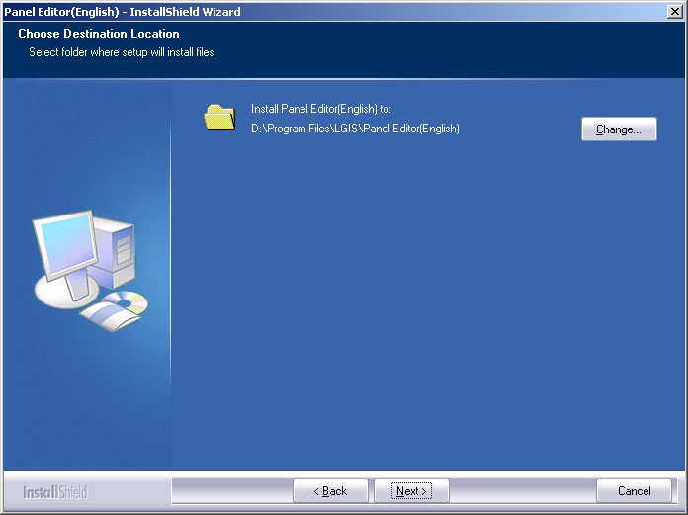

4) The Ready to Install the Program dialog box as shown below appears.

Click Install.

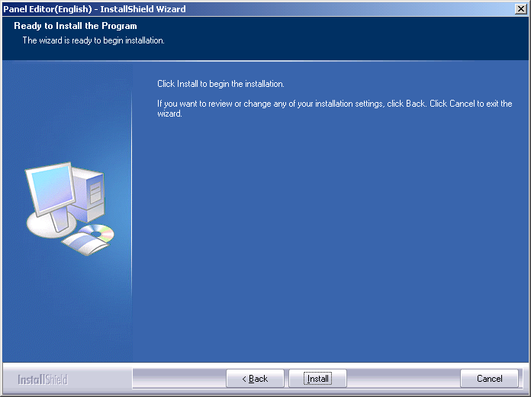

5) The Setup Status dialog box as shown below appears and the setup copys files on your computer.

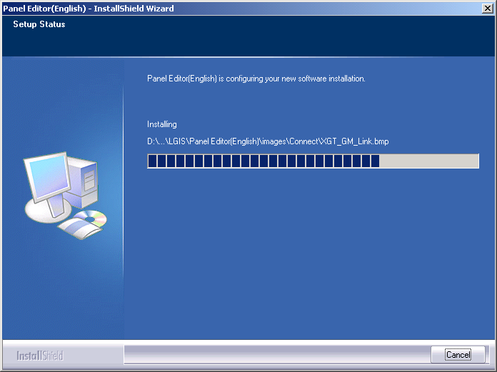

6) The Install shield Wizard Complete dialog box as shown below appears
After the installation is completed, the setup offers a choice of two end types

- Yes, I want to restart my computer now.
- No, I will restart my computer later.

After you select one, click Finish

If you don't restart your computer, the Panel Editor can be operated abnormally.
Click the finish button if the dialog box doesn't appears

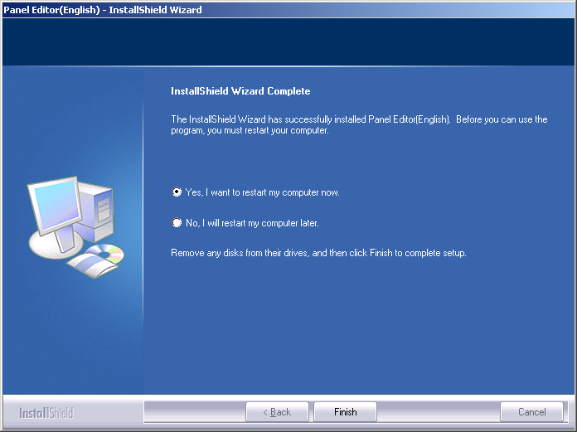

7) After the installation is completed, two short-cut icons are created,
One short-cut icon is in desktop and the other short-cut icon is in Start -> Program -> LGIS -> Panel Editor.

