6.3 File menu

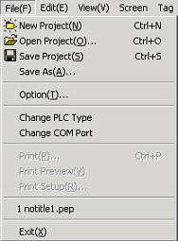

6.3.1 New project

Select 'New Project' to create a new project, then a project management window appears.

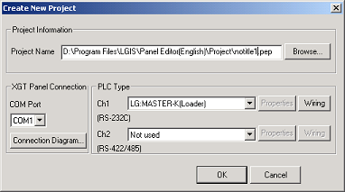

1) Project information

(1) Project name : Designate path and name of project
(2) Browse : Change path and name to save

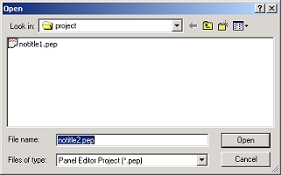

2) XGT Panel Connection

Set communication port of Panel Editor.
You can select from COM1 to COM8. please designate exact communication port to use

3) Connection diagram

Displays the Connection diagram between Panel Editor and XGT Panel.

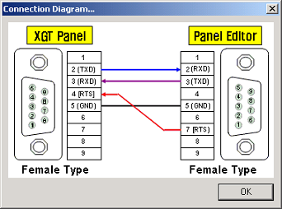

4) PLC Type

Designate the kind of PLC to connect for each channel (Ch.1 : RS-232C, Ch.2 : RS-422/485)

 | PLC to connect | Description
Ch.1  RS-232C | Not used | When doesn’t use channel 1
Ch.1  RS-232C | LG:MASTER-K(Loader) | Designate this to connect LG MASTER-K series by using loader protocol.
Ch.1  RS-232C | LG:GLOFA-GM(Loader) | Designate this to connect LG GLOFA-GM series by using loader protocol.
Ch.1  RS-232C | LG:MASTER-K(Link) | Designate this to connect LG MASTER-K series by using LG Link protocol
Ch.1  RS-232C | LG:GLOFA-GM(Link) | Designate this to connect LG GLOFA-GM series by using LG Link protocol
Ch.1  RS-232C | MODBUS Master(RTU) | Designate this to specify XGT-Panel as MODBUS(RTU) Master
Ch.1  RS-232C | MODBUS Master(ASC) | Designate this to specify XGT-Panel as MODBUS(ASC) Master
Ch.1  RS-232C | LG:INVERTER | Designate this to connect LG Inverter
Ch.1  RS-232C | OMRON(C-Mode) | Designate this to connect OMRON PLC by using C-Mode protocol
Ch.1  RS-232C | MELSEC FX | Designate this to connect Mitsubishi FX series by using dedicated protocol
Ch.1  RS-232C | MODBUS Slave(RTU) | Designate this to specify XGT-Panel as MODBUS(RTU) Slave
Ch.1  RS-232C | MODBUS Slave(ASC) | Designate this to specify XGT-Panel as MODBUS(ASC) Slave
Ch.1  RS-232C | LG:Slave(Link) | Designate this to specify XGT-Panel as LG Link Slave mode

 | PLC to connect | Description
Ch.2  RS-422  /485 | Not used | When doesn’t use channel 2
Ch.2  RS-422  /485 | LG:MASTER-K(Link) | Designate this to connect LG MASTER-K series by using loader protocol.
Ch.2  RS-422  /485 | LG:GLOFA-GM(Link) | Designate this to connect LG GLOFA-GM series by using loader protocol.
Ch.2  RS-422  /485 | MODBUS Master(RTU) | Designate this to connect LG MASTER-K series by using LG Link protocol
Ch.2  RS-422  /485 | MODBUS Master(ASC) | Designate this to connect LG GLOFA-GM series by using LG Link protocol
Ch.2  RS-422  /485 | LG:INVERTER | Designate this to specify XGT-Panel as MODBUS(RTU) Master
Ch.2  RS-422  /485 | OMRON(C-Mode) | Designate this to specify XGT-Panel as MODBUS(ASC) Master
Ch.2  RS-422  /485 | MELSEC FX | Designate this to connect LG Inverter
Ch.2  RS-422  /485 | MODBUS Slave(RTU) | Designate this to connect OMRON PLC by using C-Mode protocol
Ch.2  RS-422  /485 | MODBUS Slave(ASC) | Designate this to connect Mitsubishi FX series by using dedicated protocol
Ch.2  RS-422  /485 | LG:Slave(Link) | Designate this to specify XGT-Panel as MODBUS(RTU) Slave

5) Communication parameter setting

(1) Ch. 1 : Set according to the followings. A communication parameter must be set so that it is equal to PLC to connect.

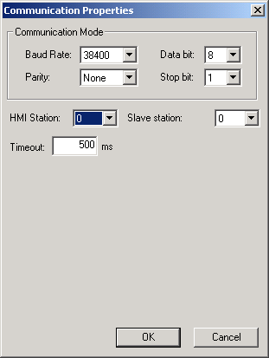

① Baud rate : Choose one of 1200, 2400, 4800, 9600, 19200, 38400, 57600, 115200 BPS.
② Data bit : Choose 7bits or 8bits.
③ Parity bit : Choose one of None, Odd, Even.
④ Stop bit : Choose 1 bit or 2 bits.
⑤ HMI station : Choose station No. of XGT Panel.(0~31)
⑥ PLC station : Choose station No. of PLC to connect.(0~31)
⑦ Timeout : Set an time interval waiting after sending request from XGT-Panel before receiving a response.

(2) Ch. 2 : Set according to the followings. A communication parameter must be set so that it is equal to PLC to connect.

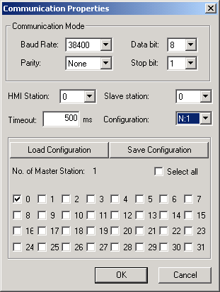

① Communication mode : Designate same method as Ch. 1
② Configuration : Choose one of 1:1, 1:N, N:1, N:M. Refer to Ch 5. system configuration for detail. In the case of N:1
or N:M configuration, all of master station must be registered
③ N:1 configuration example : This is the example of a case which three GLOFA-Panel connect to one Slave PLC. The station of GLOFA-Panel is 0, 1 and 2 each and that of PLC is 3

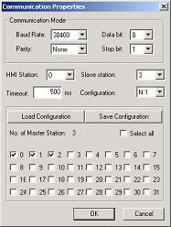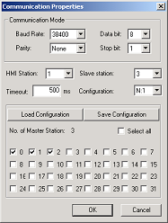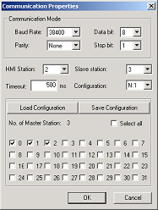
< Master 0 > < Master 1> < Master 2>

As shown above, every master station must be registered at all HMI in the case of Multi-Master system

④ Load configuration : Opens an exist configuration. It is useful for configuring multi-master system..

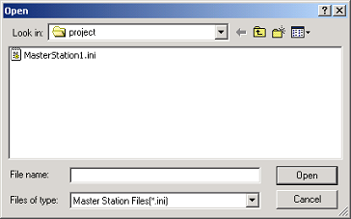

⑤ Save configuration : save a current configuration

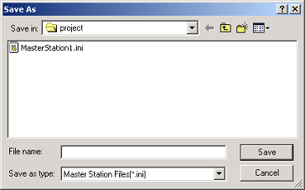

6) Wiring

Displays the connection diagram between XGT-Panel and PLC for each channel.
Refer to the Appendix for details

6.3.2 Open project

Opens an exist project.

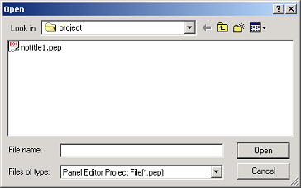

6.3.3 Save project

Saves current project.

6.3.4 Save as

Saves current project with a new name.

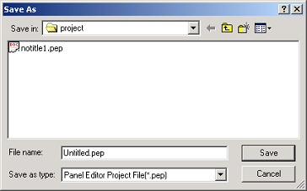

6.3.5 Option

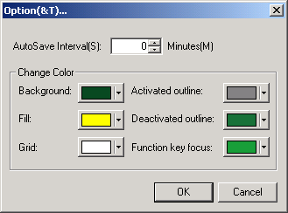

1) AutoSave Interval

Set time interval of auto-saving. the auto-saving function does not operate if specified as zero.

2) Change Color

Changes the color of background, fill, grid, outline, and so on.

6.3.6 Change PLC type

Changes current PLC Type to connect for each channel.
Refer to 6.3.1 ‘New Project’ for details.

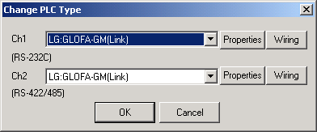

6.3.7 Change COM port

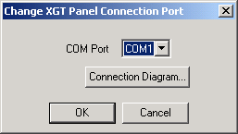

Changes the current COM Port of PC.
Refer to 6.3.1 New Project for details.

6.3.8 Print
Prints a selected screen. (Will be added at V1.1)

6.3.9 Print preview
Previews the screen to be printed. (Will be added at V1.1)

6.3.10 Print setup
Specifies print options. (Will be added at V1.1)

6.3.11 Recent projects
Shows recent project up to four projects.

6.3.12 Exit
Quit Panel Editor.

