6.4 Edit Menu

Edits Tags.

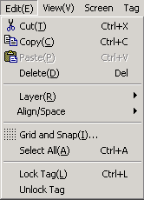

6.4.1 Cut

Cuts a selected tag and places it on the clipboard

6.4.2 Copy

Copies a selected tag and place it on the clipboard
.
6.4.3 Paste

Pastes a tag from clipboard to screen.

6.4.4 Delete

Deletes a selected tag.

6.4.5 Layer

Allows user to arrange tags on different layers.

1) Bring to front

Moves a selected tag to top layer.

2) Send to back

Moves a selected tag to bottom layer.

6.4.6 Align/space

Aligns multiple tags based on same reference point.

Icon | Item | Description
 | Left(L) | Align selected tags based on their left edge.
 | Right (R) | Align selected tags based on their right edge.
 | Top(T) | Align selected tags based on their top edge.
 | Bottom(B) | Align selected tags based on their bottom edge.
 | Screen left | Align selected tags based on left side of screen
 | Screen right | Align selected tags based on right side of screen
 | Screen top | Align selected tags based on top side of screen
 | Screen bottom | Align selected tags based on bottom side of screen
 | Horiz. Center in screen | Align selected tags based on horizontal center of screen
 | Vert. Center in screen | Align selected tags based on vertical center of screen
 | Space evenly across | Evenly spaces the selected tags horizontally.  (If the sum of width of selected tags is larger than the distance to the end point from the starting point, Evenly can not space.)
 | Space evenly down | Evenly spaces the selected tags vertically.  (If the sum of width of selected tags is larger than the distance to the end point from the starting point, Evenly can not space.)

< Align/Space Examples >

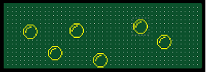
(1) Click ”Edit → Select All “
(2) Click “Edit → Align/Space → Screen bottom”

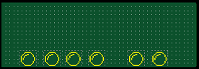
Click ”Edit → Align/Space → Space evenly across”

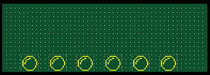
All tags spaced evenly across.

6.4.7 Grid & snap

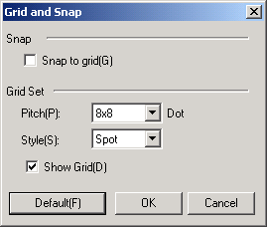

1) Snap

Makes the starting point of the tag come on a grids.

2) Grid set

(1) Pitch : Specifies the snap spacing. (One of 4x4, 6x8, 8x8, 12x16, 16x16, 24x16 and 32x16)
(2) Style : Specifies style of grid line(One of spot, dotted line, and solid line.)
(3) Show grids : Specifies whether to display grid or to hide.
(4) Default : makes the Grid-Setting up as default values.( :8x8 size, spot, show grid)

Panel Editor Screen | Setting value
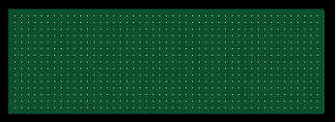 | Pitch : 4 x 4  Style : Spot
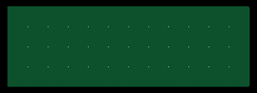 | Pitch : 16 x 16  Style : Spot
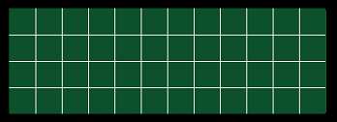 | Pitch : 16 x 16  Style : Solid line
< Grid examples >

6.4.8 Select all

Selects all tags on the screen.

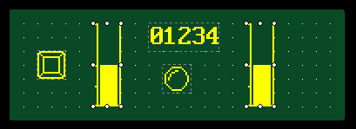

6.4.9 Lock tag

Locks properties and position of selected tags
Tag’s properties and position are locked until “Unfix selection” is selected

6.4.10 Unlock tag

Unlocks every fixed tags on current screen

6.4.11 Pop-up menu

Click the right mouse button on screen window. then, the Pop-Up menu appears and you can use some of the Edit functions

