6.5 View Menu

Specifies view option

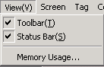

6.5.1 Toolbar

Displays or hides toolbar in menu window..

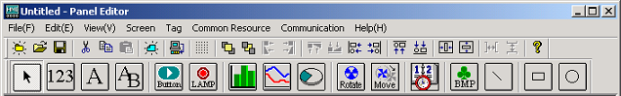
< Display toolbar >

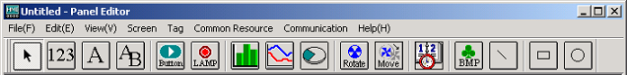
< Hide toolbar >

6.5.2 Status bar

Displays or hides status bar.

< Display status bar >

0< hide status bar >

6.5.3 Memory usage

Displays the current usage of screen, message and image memory. They are displayed on status bar also.

