6.6 Screen Menu

Manages creation and deleting of screen.

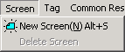

6.6.1 New screen

Click [Screen → New screen] to create a new screen, then a new screen registration window appears.

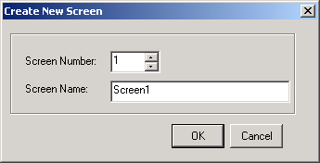

Input the number and name of new screen and click [OK].
You can see a new screen is created in the screen windows.
.
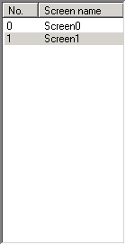

1) Screen property

Designates properties of current screen. You can set number, name, previous screen, next screen and background image

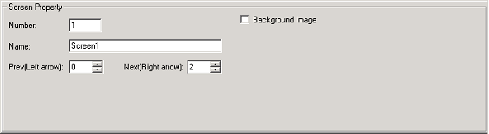

(1) Screen Number : Input the number of current screen. Every screen must have a unique number.(available from 0 to 999)
(2) Screen name : Input the name of current screen.(Available up to 23 letters)
(3) Previous screen : Input the screen number to move when ◀ key is pressed.
If the specified screen does not exist. ◀ key does not operate
(4) Next screen : Input the screen number to move when ▶ key is pressed.
If the specified screen does not exist. ▶ key does not operate

2) Background image

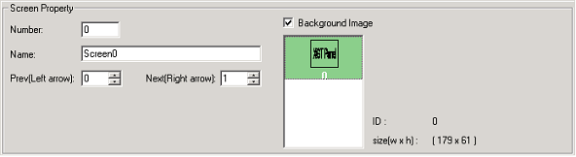

Specifies a registered image as a background image of current screen.
Refer to 6.8.2 Image management for details

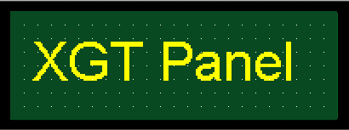
< Background image example >

6.6.2 Delete screen

Click [Screen → delete screen] to delete the selected screen

