6.8 Common Resource

The following explains about common resource of XGT-Panel.

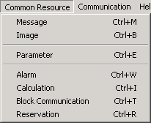

6.8.1 Message management

Manages the message contents of a message tag.

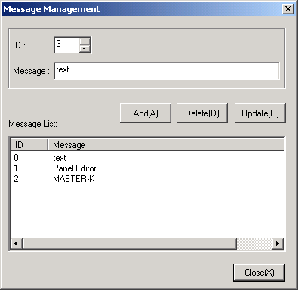

• Adds, deletes, or edits the message contents which is related on a message tag.
• Only the message contents which are registered in message management menu can be used by a message tag.
• The registered messages can be used by a multiple message tags.
• The available range of ID : 0 - 65535
• Max. size of content : Up to 24 letters
• The total number of message content varies according to the memory usage.

6.8.2 Image Management

Manages bitmap images.

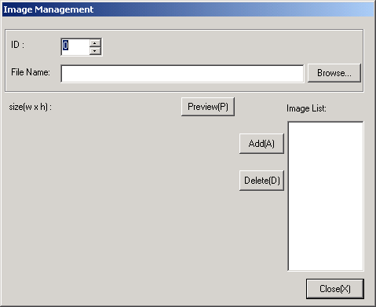
< Adds bitmap image files >

(1) Click the Browse button. then, choose a image file to register.

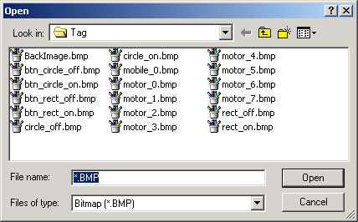

(2) Click the Preview button.

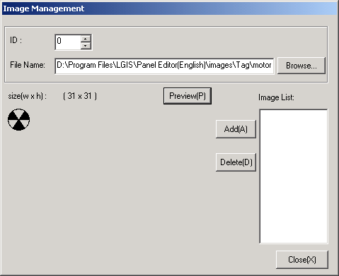

(3) Specify a ID. Then click the Add button to register a image.

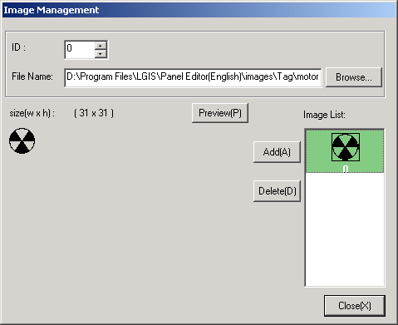

6.8.3 Parameter

Specifies various parameters of Panel Editor.

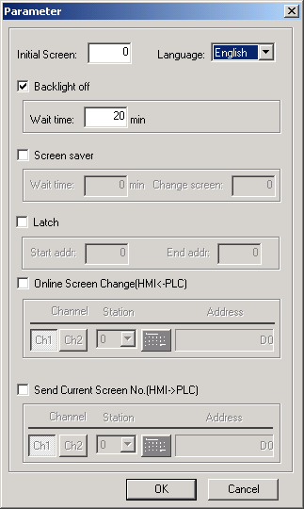

1) Initial screen
• Specifies a screen to display when the XGT-Panel is turned on.
• If the initial screen is not specified, XGT-Panel displays a screen which has lowest ID

2) Backlight off
• Turns the Backlight off if there is not a key input during specified time.(0 ~ 65535minutes)
• If any Key is pushed when the backlight is in the off-state, the backlight is turned on again.

3) Screen saver
Changes a current screen to the specified screen if there is not a key input during specified time.

4) Latch
• Specifies the latch area of system memory of XGT Panel.
• The data of latch area are retained when power is turned off(B type only)

5) Online screen change
• Changes a current screen according to the value of device.
• Refer to Ch. 6.7.2 digit tag for details about specifying address.

6) Send current screen No.
• Sends a number of current screen to PLC.
• Refer to Ch. 6.7.2 digit tag for details about specifying address.

6.8.4 Alarm

• Specifies various properties about alarm function.
• Displays a registered alarm messages and operates a buzzer when a specified activating condition occurs.

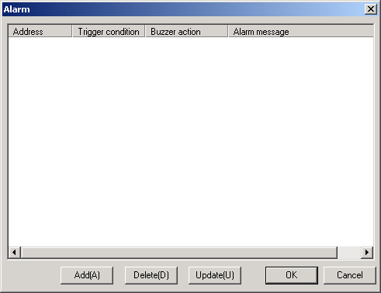

• Click the Add button to register a alarm

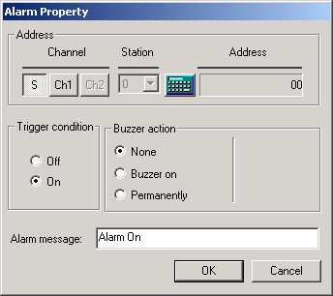

1) Address
• Specifies the address of device(Bit device)
• Refer to Ch. 6.7.5 button tag for details about specifying address.

2) Alarm trigger
• Off : Operates at the rising edge of a value of device
• On : Operates at the falling edge of a value of device

3) Buzzer action

Item | Description
None | Buzzer does not operates.
Buzzer On | Buzzer operates during specified time.  (The buzzer stops operation if the ESC/ALM key is pushed while it operates)
Permanently | Buzzer operates until the ESC/ALM key is pushed

4) Alarm message
Max. size of content : Up to 37 letters.
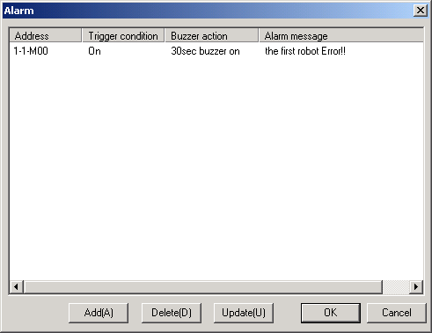
<The example of alarm>

6.8.5 Calculation

Specifies a calculation function.

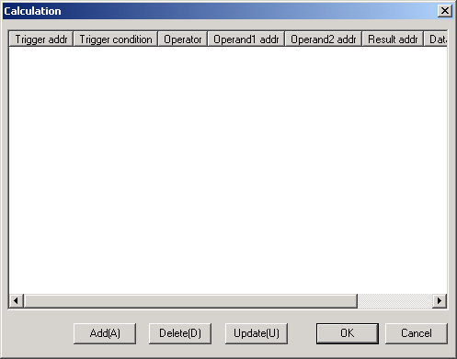

• Click the Add button to register a calculation function

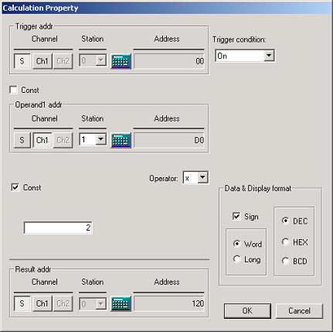

1) Trigger condition
Specifies a activating condition of calculation function.

Condition | Description
Always | Operates at every scan
On | Operates once at the rising edge of a value of trigger device
Off | Operates once at the falling edge of a value of trigger device
Toggle | Operates at the rising or falling edge of a value of trigger device
During On | Operates at every scan during value of trigger device is On
During Off | Operates at every scan during value of trigger device is Off

2) Trigger Address
• Specifies the address of trigger device(Bit device)
• Refer to Ch. 6.7.5 button tag for details about specifying address.

3) Operand Address
• Specifies the address of operand devices(Word device, Constant is available)
• Refer to Ch. 6.7.2 digit tag for details about specifying address.

4) Operator
• Specifies a operator.

Operator | Description
+ | Adds operand 2 to operand 1
- | Subtracts operand 2 from operand 1
x | multiplies operand 2 with operand 1.
/ | divides operand 1 by operand 2
% | Gets the remainder when operand 1 is divided by operand 2
& | Compares each bit of operand 1 to the corresponding bit of the operand 2. If both are 1, the corresponding bit of result device is set to 1. Otherwise it is set to 0.
| | Compares each bit of operand 1 to the corresponding bit of the operand 2. If either bit is 1, the corresponding result bit is set to 1. Otherwise it is set to 0.
^ | Compares each bit of operand 1 to the corresponding bit of the operand 2. If one bit is 0 and the other bit is 1, the corresponding bit of result device is set to 1. Otherwise it is set to 0
<<, >> | Shift the operand 1 left(<<) or right(>>) by the number of positions the operand 2 specifies
< | Compare the operand1 to the operand 2 to test the validity of the specified relationship. | Writes 1 to the result device if the tested relationship is true and writes 0 if it is false.
>
==

5) Result Address
• Specifies the address of device to save the result of calculation.(Word device)
• Refer to Ch. 6.7.2 digit tag for details about specifying address.

6) Data
• Specifies the data type.

7) Display format
(1) DEC : Displays by decimal format.
(2) HEX : Displays by hexadecimal format
(3) BCD : Displays by binary coded decimal format

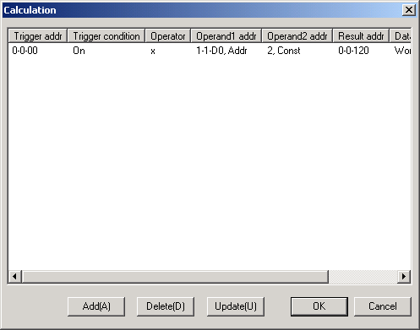
< Example of calculation >

6.8.6 Block communication

Specifies properties of block communication function.

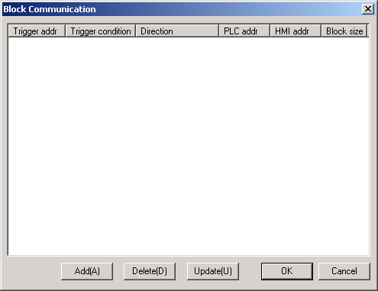

• Click the Add button to register a block communication function

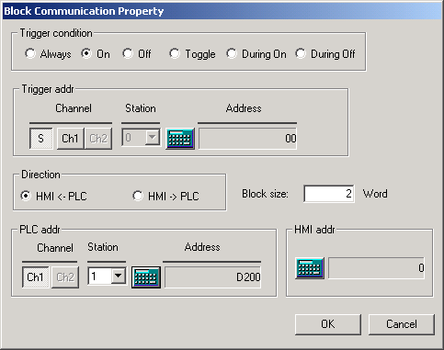

1) Trigger condition
Specifies a activating condition of block communication.

Condition | Description
Always | Operates at every scan
On | Operates once at the rising edge of a value of trigger device
Off | Operates once at the falling edge of a value of trigger device
Toggle | Operates at the rising or falling edge of a value of trigger device
During On | Operates at every scan during value of trigger device is On
During Off | Operates at every scan during value of trigger device is Off

2) Trigger Address
• Specifies the address of trigger device(Bit device)
• Refer to Ch. 6.7.5 button tag for details about specifying address.

3) Direction
• HMI <- PLC : Reads values of specified devices of PLC and writes them into the system memory of HMI.
• PLC <- HMI : Reads values of the system memory of HMI and writes them into specified devices of PLC.

4) Data
Specifies a size of data to communicate.(Max. 60Words)

5) PLC Address & HMI Address
• Specifies the addresses of PLC and system memory of HMI.
• Refer to Ch. 6.7.2 digit tag for details about specifying address.

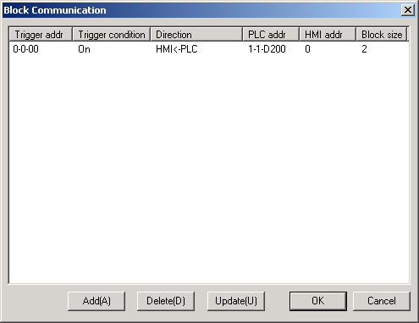

6.8.7 Reservation

Turns a specified bit on at a specified time(B type only)
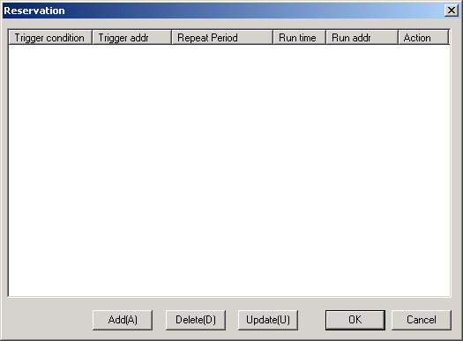

• Click the Add button to register a reservation function

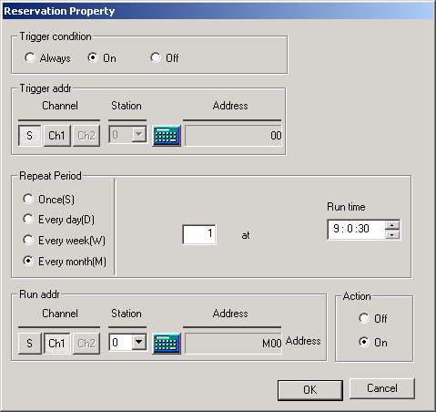

1) Trigger condition

Specifies a activating condition of reservation function.
Condition | Description
Always | Operates always
During On | Operates during value of trigger device is On
During Off | Operates during value of trigger device is Off

2) Trigger Address
• Specifies the address of trigger device(Bit device)
• Refer to Ch. 6.7.5 button tag for details about specifying address.

3) Repeat period

Item | Repeat Period
Once | Operates once at the time to be reserved
Every day(D) | Operates at the specified time of every day
Every week(W) | Operates at the specified time of day of the week.
Every month(M) | Operates at the specified time of the day of the month.

4) Run Address and Action
• Specifies the address of device and the kind of action(On or Off)
• Refer to Ch. 6.7.5 button tag for details about specifying address

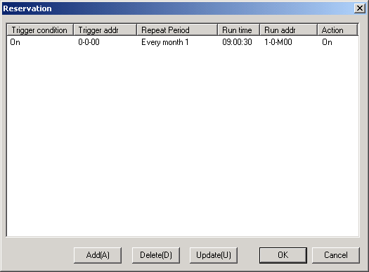

• Assume that reservation function is specified as shown above
• M0000(Bit device) of PLC is turned on at 9:00:30 of first day of every month.

