6.9 Communication Menu

The following explains about communication menu.

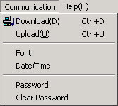

6.9.1 Download/upload

Downloads/Uploads a created project at XGT Panel.

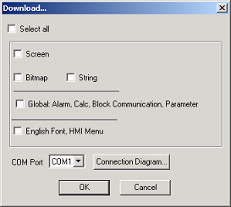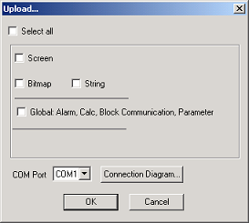

Items | Description
Screen | Downloads/Uploads screens
Bitmap | Downloads/Uploads bitmap images
Message | Downloads/Uploads messages
Global | Downloads/Uploads parameters, alarm, calculation and block communications
English font,  HMI menu | Downloads/Uploads English font, ASCII codes and HMI menu.
Select all | Downloads/Uploads all

6.9.2 Font
Downloads a specified font.( Only the Korean or the Chinese font which are offered by LG is available.)

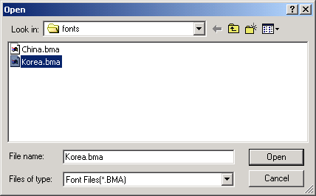

6.9.3 Date/time
• Specifies the Date/Time of XGT Panel.(B type only)
• There is two ways to write new RTC data to the CPU.
• It can be set as the time of the PC or as the specified time
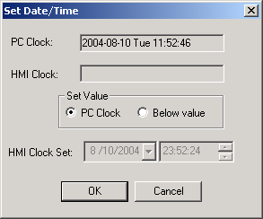

6.9.4 Password
• Specifies a download/upload password.
• Available up to 10 alphanumeric characters.
Warning

You can't download but also can't upload project if you lose the password.
Be careful not to lose when we set the password.

6.9.5 Clear password
Clears a download/upload password.

