Chapter 7. XGT Panel function

7.1 Key Operation

7.1.1 Operation mode

The XGT Panel executes its monitoring operation.
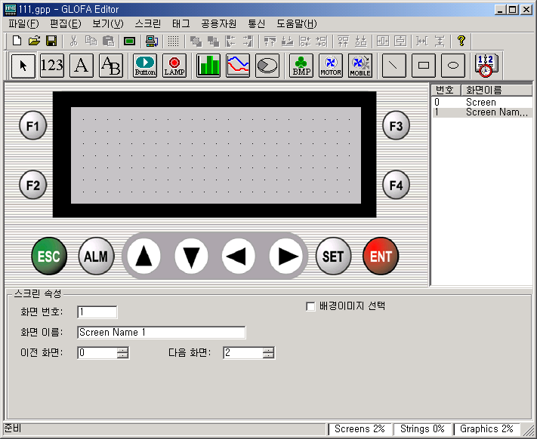

1000

200
Goal
Product
Percent
20%

7.1.2 Screen change mode

Displays a list of screens of the XGT Panel and goes to selected screen.

Displayed Screen | Key | Mode
Goal  Product  Percent  1000  200  20% | 『ESC』 | Operation mode
0. Screen 0  1. Screen 1  2. Screen 2  3. Screen 3 | 『  』  『  』  『ENT』 | Screen change mode
Goal  Product  Percent  1000  200  20% |  | Completes screen changing.  Returns to the operation mode

7.1.3 Alarm history mode

Displays a history of occurred alarms.

Displayed screen | Key | Mode
Goal  Product  Percent율  1000  200  20% | 『ALM』 | Operation mode
1. ALL ALARM LOG LIST  2. DEFINEDALARM LIST | 『  』  『  』  『ENT』 | Choose the kind of alarm list to display
00: Tank 1 is full  01:  02:  03: | 『  』  『  』  『ENT』 | Displays a alarm history
MSG : Tank 1 is full  ON :04/05/31 10:55:44  OFF:04/05/31 11:15:23 | 『ESC』 | Displays the detail contents of a selected alarm.
00: Tank 1 is full  01:  02:  03: | 『ESC』 | Returns to previous screen
1. ALL ALARM LOG LIST
2. DEFINED ALARM LIST

The screen which is displayed when alarm occurs
Goal
Product
달성율
1000
200
20%
ALM : Tank 1 is full

When the alarm occurs, the registered alarm message is appeared and is flickered.
In this case, any Key except ESC/ALM does not operate..

7.1.4 Value-changing mode

Changes a value of device which is Write-enabled

Displayed screen | Key | Mode
Goal  Product  Percent율  1000  200  20% | 『SET』 | Operation mode
Goal  Product  Percent  00000  200  20% | 『  』  『  』  『  』  『  』  『SET』 | A cursor appears.  The cursor moves.  Changes value  Selects another device
Goal  Product  Percent  2300  200  20% | 『ENT』 | Writes the value to PLC
Goal  Product  Percent  2300  200  20% |  | Completes value-changing.  Returns to the operation mode

7.1.5 Password mode

Specifies a password of value-changing.
ESCV

Items | Description
Change password | Specifies or changes a password
Lock password | Disables the value-changing of a device which the Use-password is specified.
Unlock password | Enables the value-changing of a device which the Use-password is specified.

Change Password

Displayed screen | Key | Mode
Goal  Product  Percent  1000  200  20% | 『ENT』 | Operation mode
2.PASSWORD LOCK  3.PASSWORD CHANGE  1.PASSWORD UNLOCK | 『  』  『  』  『ENT』 | Select mode
PASSWORD CHANGE  OLD  NEW -> 0********* | 『  』  『  』  『  』  『  』  『ENT』 | Change P/W mode  Input new password
PASSWORD CHANGED! | 『ESC』 | Completed

Lock/Unlock Password

Displayed screen | Key | Mode
2.PASSWORD LOCK  3.PASSWORD CHANGE  1.PASSWORD UNLOCK | 『  』  『  』  『ENT』 | Select mode
PASSWORD LOCKED! | 『ESC』 | The password is locked
2.PASSWORD LOCK  3.PASSWORD CHANGE  1.PASSWORD UNLOCK | 『  』  『  』  『ENT』 | Select mode
INPUT PASSWORD  ->0********* | 『  』  『  』  『  』  『  』  『ENT』 | Input password
PASSWORD CLEARED! | 『ESC』 | The password is unlocked

7.1.6 Date/time

Specifies time and date.

Date/Time

Displayed screen | Key | Mode
2.PASSWORD LOCK  3.PASSWORD CHANGE  1.PASSWORD UNLOCK | 『  』 | Select menu
5.BUZZER VOLUME SET  6.BACK LIGHT SET  4.DATE / TIME SET | 『ENT』 | Select menu
-06-01 Tue  15:06:57  4. DATE / TIME SET  2004 | 『SET』  『  』  『  』  『  』  『  』  『ENT』 | Specify date and time  (Set the day of week to correspond to the date.)
-06-02 Wed  15:06:57  4. DATE / TIME SET  2004 | 『ESC』 | Completed
5. BUZZER VOLUME SET
6. BACK LIGHT SET

4. DATE / TIME SET

7.1.7 Buzzer volume
ESCV
Specifies a volume of buzzer.

Displayed screen | Key | Mode
5. BUZZER VOLUME SET  6. BACK LIGHT SET  4. DATE / TIME SET | 『 ENT 』 | Select menu
BUZZER VOLUME SET  OFF  LOW  HIGH | 『  』  『  』 | Select menu
BUZZER VOLUME SET  OFF  LOW  HIGH | 『ENT』 | Select the volume of buzzer
5. BUZZER VOLUME SET  6. BACK LIGHT SET  4. DATE / TIME SET | 『ESC』 | Completed

7.1.8 Backlight

Displayed screen | Key | Mode
5. BUZZER VOLUME SET  6. BACK LIGHT SET  4. DATE / TIME SET | 『 ENT 』 | Select menu
BACK LIGHT SET  OFF  ON | 『  』  『  』 | Select menu
BACK LIGHT SET  OFF  ON | 『ENT』 | Off backlight
5. BUZZER VOLUME SET  6. BACK LIGHT SET  4. DATE / TIME SET | 『ESC』 | completed

7.2 Operation Mode

7.2.1 Monitoring mode

The XGT Panel executes its monitoring operation.
ESCV

1) Display data

Each tag displays the value of the specified device.
when the value of device is changed, the tag except trend and rotate graph tag will refresh a displaying value.
If more than two tags are overlapped, the tag that was drawn on top layer hides the other tags.
When the power is supplied first time, when the screen is changed, when the mode is changed, the tag which display the
value read by communication displays nothing until the first communication succeeds.

2) Communication error

(1) Case of a first communication

① No response : In case of no response due to communication problems, the tag does not display anything during the designated timeout period and
The tag displays 0 after the specified timeout period.

② Incorrect response : In case of incorrect response due to invalid communication frames or other communication problems, the tag displays nothing until it receives valid response.

Error code & count : Communication error codes and count are stored at the following internal memory area for each channel.
(2) The error which is occurred after the first communication.

① No response : The tag does not change the displaying value.
② Incorrect response : : The tag does not change the displaying value

(3) Error code & Error Count
Refer to the following tables

 | Channel 1 | Channel 2
Error Code | M917 | M919
Error Count | M916 | M918

Error code | Error type | Error condition and causes
H0001 | FRAME_LEN_OVER_ERROR | The length of received frame is over 256 bytes
H0010 | BCC_CHECK_ERROR | The result of BCC check is wrong
H0020 | NO_MATCH_ERROR | The data of received frame are invalid
H0040 | HEX_CHANGE_ERROR | The received data can not be converted to HEX format
H0080 | FRAME_STATE_ERROR | The received data are broken
H6020 | TIME_OUT_ERROR | No response.

7.2.2 Key

1) Function key

Executes a defined function. It does not operate if not defined.
refer to 6.11 for details.

2) ESC key

Shows the list of defined screen. It is possible to move to the screen selected.
For more details about changing screen, refer to 7.1.2 screen change mode.

3) ALM key

Changes current mode to the alarm history mode.
For more details about alarm history mode, refer to 7.4 alarm.

4) SET key

Changes current mode to the value-changing mode If the tag which is enabled to write exists.
For more details about value-changing mode, refer to 7.1.4 value-changing mode.

5) ENT key

Displays the menus of XGT Panel..

- PASSWORD UNLOCK
- PASSWORD LOCK
- PASSWORD CHANGE
- DATA / TIME SET
- BUZZER VOLUME SET
- BACKLIGHT SET

For more details, refer to 7.1 Key Operation.

7.3 Screen Changing

There are 4 ways to change the screen of XGT Panel.

1) By function keys

The screen can be changed to another screen by a key which is defined as the screen change function.
ESCV
In this case, password for key operation can be set.
As a default,  is defined as previous screen and  is defined as next screen.
For more details, refer to 6.11 Key operation.

2) From the screen list

In the list of the screen, after selecting a screen to go, then pressing a ENT key.
For more details, refer to 7.1.2 Screen change mode.

3) By screen saver

When the screen saver option is enabled, if no key is inputted during specified time period, the screen goes to the specified screen.
For more details, refer to 6.8.3 Parameter.

4) By online screen change

When the online screen change option is enabled,
In case that online screen change is set, the screen goes to the screen corresponds to the value of device.
For more details, refer to 6.8.3 Parameter.

Note

1) Screen changing operates on the rising edge of input.

2) If there is no registered screen to go, the screen-changing function does not operate.

7.4 Alarm

1) Alarm message

When alarm occurs, the alarm message will be displayed at the bottom of the screen
ESCV
In this case, except the area that is covered by the alarm message, in other area all tags operates.
When alarm occurs, any key input except ESC and ALM is ignored..
If the alarm condition happens once, the displayed alarm message does not disappear although the alarm condition is
released.(Push the ESC key to hide alarm message.)
The displayed alarm message is a last one.

2) Alarm buzzer

If the alarm buzzer is specified, the buzzer operates when alarm occurs.
The buzzer stops operation if ESC or ALM key is pushed.

3) Alarm history

For happened Alarms, their histories are saved.
There are two alarm histories, all alarm history and defined alarm history.
Refer to 7.1.3 Alarm history mode for the details.

(1) All alarm list
In order which it happened recently, the latest alarm is saved at 0.
If happened alarm exceeds 100, the oldest alarm will be erased.
In B type, the time that the alarm happened and released are saved also.

(2) Defined alarm list
Alarm histories are saved for each alarm defined. (Available on B type only)
Displays the history of a selected alarm In order which it happens
If happened alarm exceeds 10, the oldest alarm will be erased.

7.5 Buzzer

The buzzer operates in the following condition

Condition | Volume | Remark
When key is pushed | The size to be set | Valid key input : 1 time  Invalid key input : 3 times
When the data communication with XGT Editor is completed. | HIGH | Program data up/download  Font download  Data / time set  Password set/clear
When alarm is happened | HIGH | When the buzzer is enabled

For more details about setting buzzer volume, refer to 7.1.7 Buzzer volume.

7.6 System Memory

1) User area(0 ~ 899 : 900 word)

Can be used for calculation, block communication and so on.
User area is erased when power is off
(But in case of B type, the area which specified as latch area is saved when power is off)

2) System flag(900 ~ 999 : 100 word)

Used for System flags. (refer to Appendix 1. for the details about system flags)
The area not defined is reserved area.
The system flags are not saved when power is off.(Although it is B-type)

3) Slave configuration

In case that a XGT Panel is configured as a slave, the master can access the system memory area of the XGT Panel by
communication.
The protocols which supports slave configuration are :
- LG:Slave(Link)
- When XGT Panel configured as LG:Slave(Link), the user memory area is treated as M area.
- MODBUS-Slave(RTU, ASC).
- the user memory area is treated as following table
Bit area |  | Word area
MODBUS Address | Data area | MODBUS Address | Data area
h1000 | M0000 | h1000 | M0000

For more details about communication protocols, refer to the user’s manual of MASTER-K120S.

