1. Program example

1.1 GMWIN example of Pnet I/F master-slave communication

Example 1
G4L-PUEA is installed in the slot number 0 of a main base and G7L-PBEA is attached to GM7. This is a program to transmit/receive data between master (station #0) and slave (station #1). Please refer to I/O configuration map.

GM4 master (station 0, Pnet: slot 0) GM7 slave (station 1, G7L-PBEA)
PWR
CPU
Pnet
OUT
OUT
OUT
OUT
OUT

• I/O configuration map

Communication configuration |  | Transmit | Receive | Size (byte)
GM4 (station 0)  (master) | Tx: GM7 | %MW0 | - | 2
GM4 (station 0)  (master) | Rx: GM7 | - | %QW0.1.0 | 4
GM7 (station 1)  (slave) | Tx: GM4 | %MW10 | - | 4 (output)
GM7 (station 1)  (slave) | Rx: GM4 | - | %QW0.0.0 | 2 (input)

* Communication capacity (data size) in each station is up to 128 bytes (64-byte limit for both transmit and receive item of each station).
1) High Speed Link parameter setup in GM4 (station 0)
• GMWIN program in the master module (GM4)
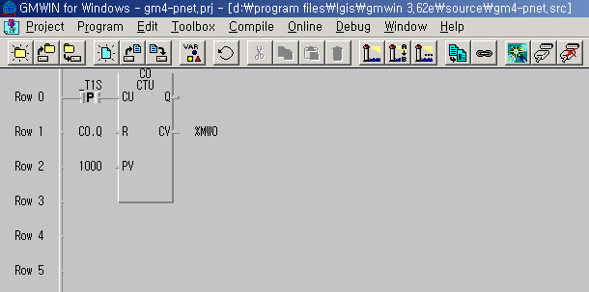

• Link Set in High Speed Link 1
Network type and slot number of High Speed Link module
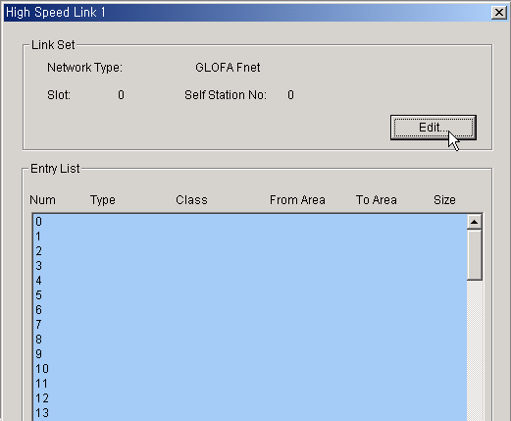
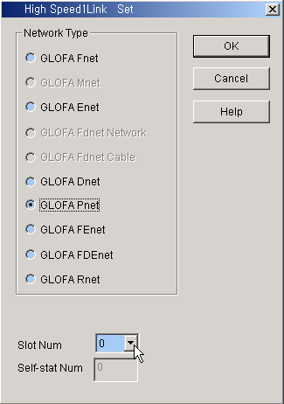
Select the network type (GLOFA Pnet) and slot number

• High Speed Link Network type setting
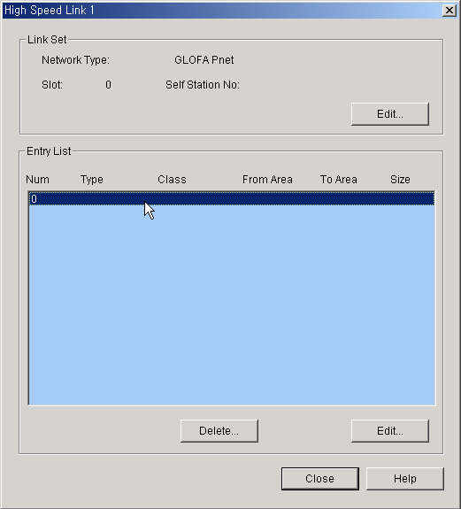
Click here to set up each information of ‘High Speed Link Item Edit’ window
• Communication parameter setup in GM4
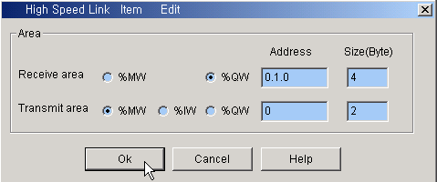
Receive area is the area of GM4 to receive data from slave (GM7) and Transmit area is the area of GM4 to transmit data to slave (GM7).
Input/output data size in High Speed Link setup must be equal to those in SyCon

• After setting up ‘High Speed Link’ parameter
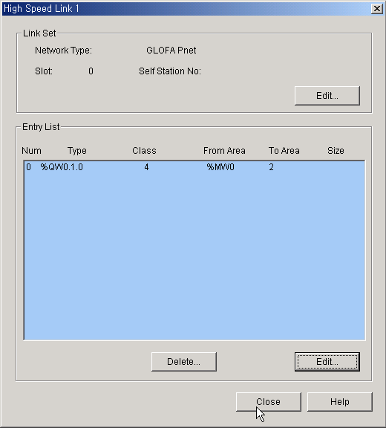
2) High Speed Link parameter setup in GM7 (station 1)
• GMWIN program in the slave module (GM7)
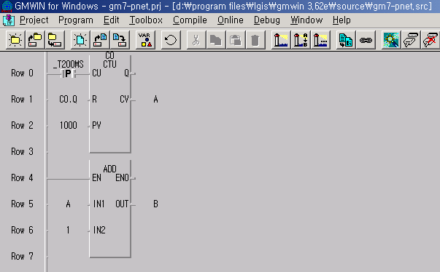
%MW10
%MW11
• Communication parameter setting in GM7
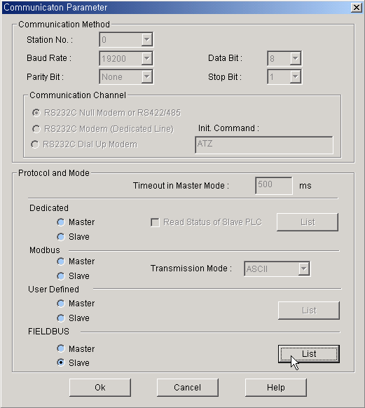
Network type setting in GM7: parameter setting in the List after clicking 'slave' in FIELDBUS
• High Speed Link parameter setting
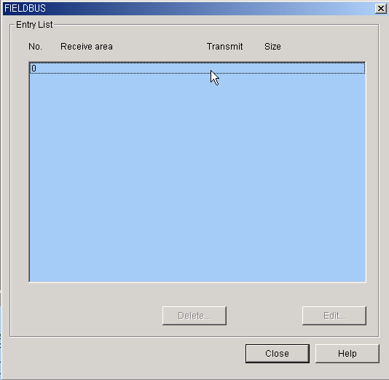
Click here to set up High Speed Link parameter

Receive area is the area of GM7 to receive data from master (GM4) and Transmit area is the area of GM7 to transmit data to master (GM7).

• Communication parameter setup in GM7
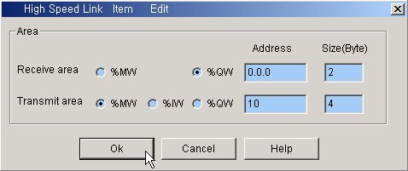
• After setting up ‘High Speed Link’ parameter
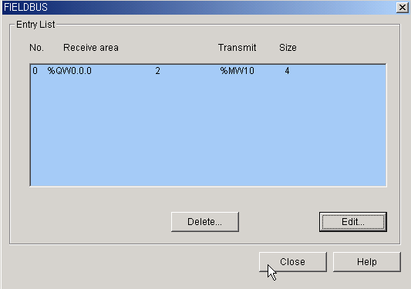

3) Profibus-DP Configurator (SyCon) setting
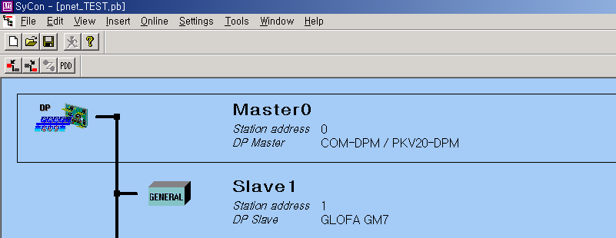
Slave module setting
Master module setting

• Master Setting
After clicking a master module setting button and place the cursor on the upper part.
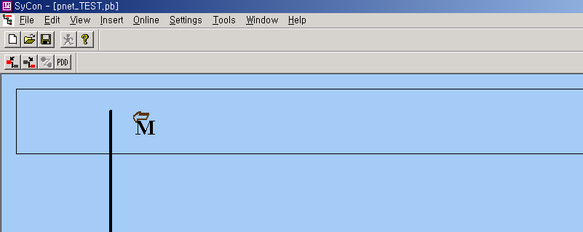

Left mouse click on the above position then you’ll see the following window.
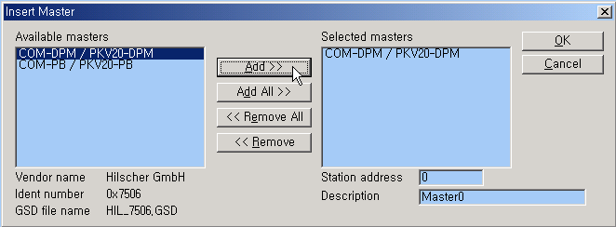
Select the master module: 1) COM-DPM / PKV20-DPM for GnL-PUEA type;
2) COM-PB / PKV20-PB for GnL-PUEB
Select A-type master module then the following window will pop up.
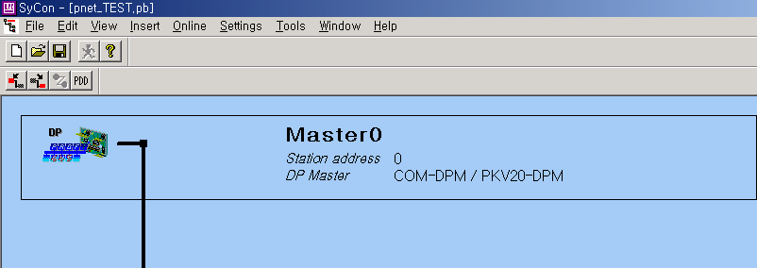
In the main menu,
Settings Master Settings (default value setting in LGIS SyCon)
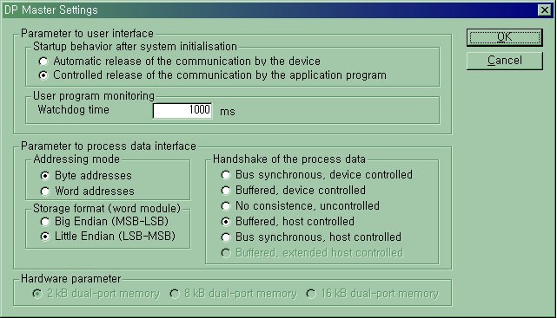

• Slave Setting
After clicking a slave module setting button and place the cursor below the master module.
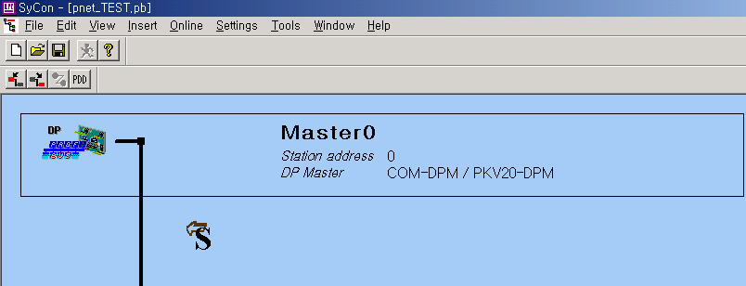

Left mouse click on the above position then you’ll see the following window where you can select the proper slave module.
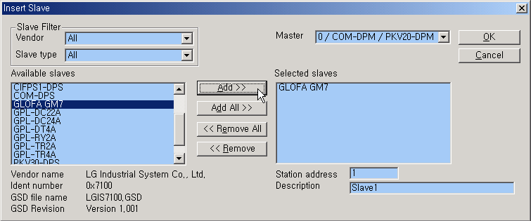
Click ‘OK’ then the following window will pop up.
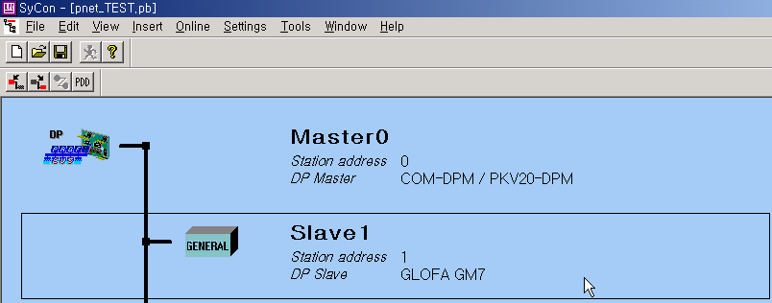

If you want to choose LGIS slave module(s) or SMART I/O(s), you should insert the LGIS GSD files in GSD folder after installing SyCon in your PC.
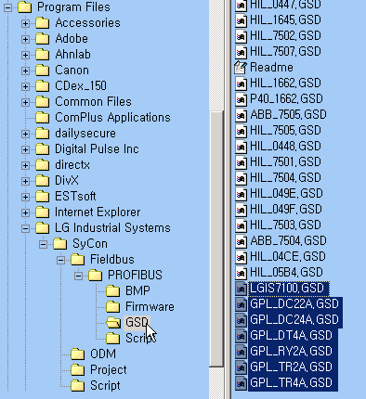

• Slave Configuration
In the main menu,
Settings Slave Configuration (2-byte output, 4-byte input)
Input and output data size must be equal to those of High Speed Link parameter in GMWIN. %MW0 in GM4 is transferred to GM7 as 2-byte output data and so does input. 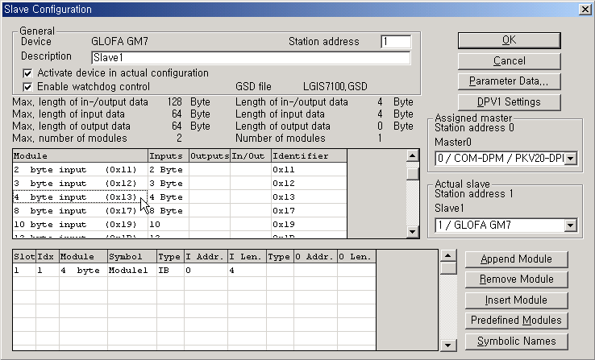
Double Click
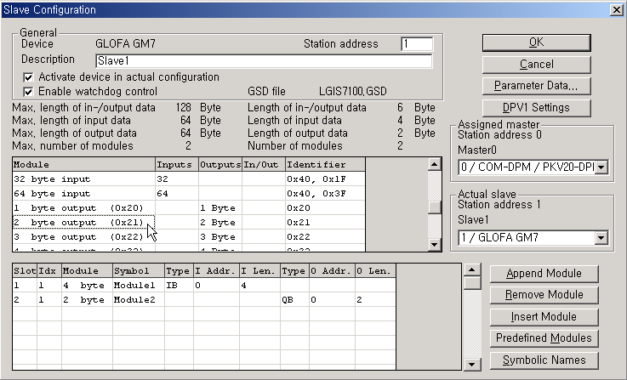
Double Click
• Device Assignment
Settings Device Assignment COM port set OK
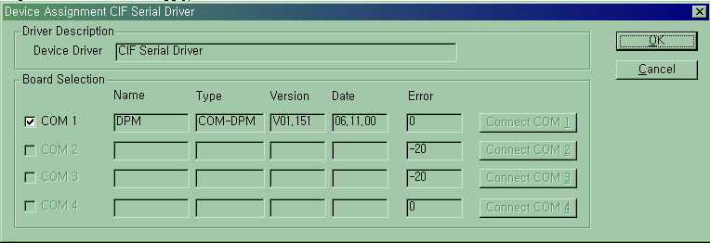
1. Click
2. Click
- COM port setting: click Connect COM1 and the box is enabled in COM1 then click on it. If the box is not enabled then click Connect COM2 and follow the same procedure.

• Download
Online Download
When an Error occurs, please make sure the configuration cable, connector and data size in both SyCon and GMWIN.

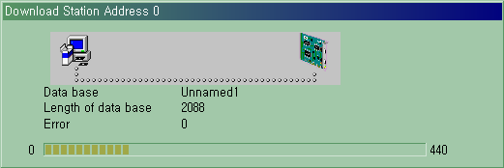

• Communication Confirmation
Online Start Communication Start Debug Mode
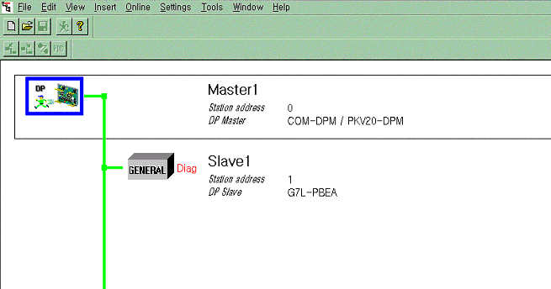

Note
- When GM7 parameter setting in SyCon, make sure that the input/output data size should be equal to that of High Speed Link setting in GMWIN.

2. In the communication between G4L-PUEA and GM7-PBEA, GM4 parameters are defined as follows:
2.1 Transmit area: %MW0
2.2 Receive area: %QW0.1.0
2.3 Transmitting data size: 2 bytes
2.4 Receiving data size: 4 bytes
2.5 %MW0 (2-byte data) in GM4 -> 2-byte GM7 Slave output
2.6 4-byte input in GM7 (SyCon) -> %QW0.1.0 (4-byte data which mean %QW0.1.0 and %QW0.1.1)

3. When GM7-PBEA is used, do GMWIN programming and parameter setting first before start communication in SyCon.

