Modbus Communication
1. System configuration
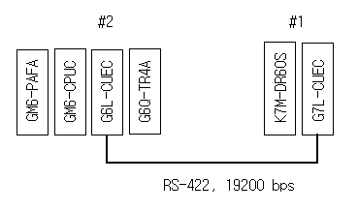

K80S: Modbus master (station number: 1)
GM6: Modbus slave (station number: 2), * online mode (operation mode: 9)

2. Parameter setting in G6L-CUEC
2.1 Communication driver download
If GM6 is turned on with G6L-CUEC set to ‘Flash Writing Mode (ver 2.0 or later): operation mode: 8)’, LED no. 0 turns on and off with a period of 1 second. Select [File]-[Open Lib] after click on [Online]-[Connect], which pops up a dialog box where you choose modbus6.lib.
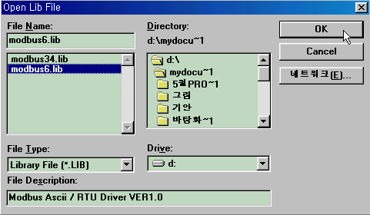

2.2 Click [Online]-[Flash Memory]-[Write], then ‘Write Library’ window will appear where you select the slot number of Cnet and choose ‘Write’ button.

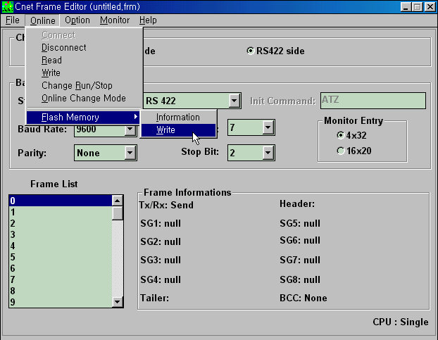

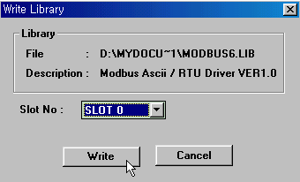
Disconnect and turn off GM6 after library writing to Cnet module is completed.

2.3 Communication mode setting
Change the operation mode of G6L-CUEC to 9, and turn on GM6 for Online connection.
Select [Online]-[Online Change Mode], then the following dialog box will pop up.
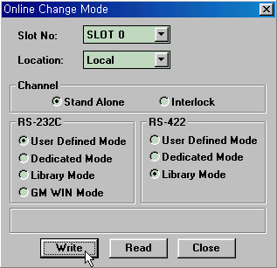
Here, you can select G6L-CUEC for RS-232C or RS-422. For Modbus communication of K80S (master) and GM6 (Modbus slave), click on ‘Library Mode’ of RS-422 and write.

3. Basic parameter setting of G6L-CUEC
3.1 Click [Online]-[Connect] in main menu. Set the ‘Basic Parameters’.
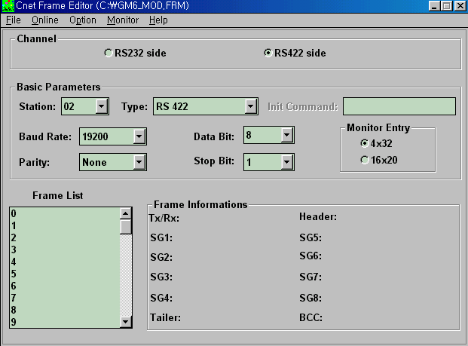

3.2 Write them on the G6L-CUEC, choosing ‘Write’ of Online
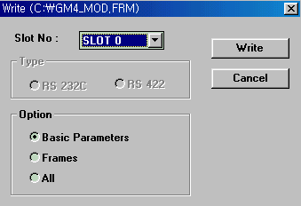

* Set the slot number where Cnet interface module is installed. Here, Slot No. is 0 as is shown in “System Configuration” on page 1.

3.3 After writing parameters, change the status of G6L-CUEC. Select [Online]-[Change Run/Stop], which opens the dialog box (refer to the below), and click on ‘Run’.
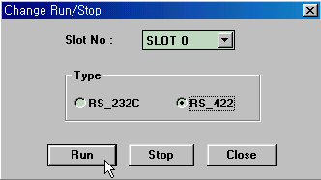

3.4 [Online]-[Disconnect]
3.5 Communication parameter setting (for example).
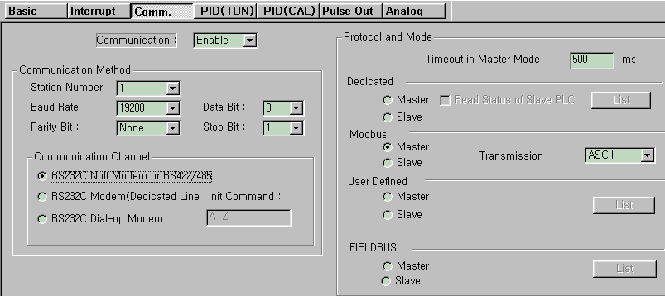

4. Program
4.1 Program for GM6
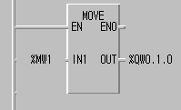

4.2 Program for K80S
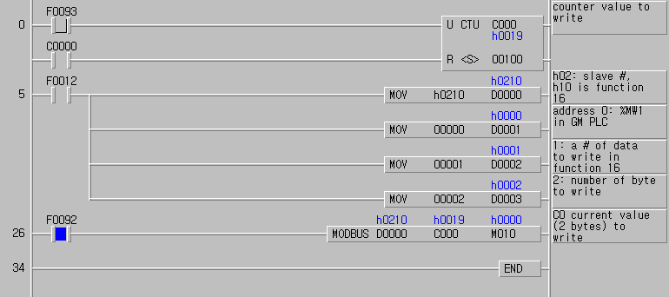
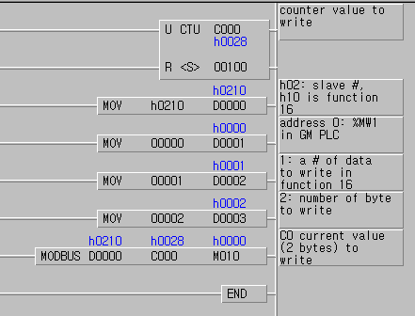
If you want to send another counter data to GM6, modify PLC program as follows:

