Function Block for Modbus Communication.

1. Features
- By using this function block, GLOFA Cnet module operates as a Modbus master on Modbus network.
- Supporting command codes are as below.
  - Read coil status: 01
  - Read input status: 02
  - Read holding registers: 03
  - Read input registers: 04
  - Force single coil: 05
  - Preset single register: 06
  - Force multiple coils: 15 (Hex 0F)
  - Preset multiple register: 16 (Hex 10)
- This function block works on user-define protocol mode of Cnet.
- Basic Communication parameters (Baudrate, Data bit, Stop bit, Parity check, Station No.) are set by
Cnet Editor and Frame editing is not required.
- Modbus RTU Protocol is supported (ASCII Protocol will be supported soon.)
- For using this function block, Cnet Module’s requirement is as below
  - Cnet module’s H/W version is higher than v2.0 (can be checked on GMWIN)
  - Cnet module’s Flash Rom OS version is higher than v1.01 (can be checked on Cnet Editor)

Modbus Master
Modbus Slave
Command

Response

Modbus (RS-422/485)
GLOFA CPU &
GnL-CUEA
Other Maker’s Device

5
6
7
9
8
4
3
2
1
0

Cnet communication mode should be
”User defined protocol mode”

2. Checking Cnet Flash Rom OS version.
- Run the frame editor and connect to the Cnet module.
- Select Flash Memory – Information in Online menu
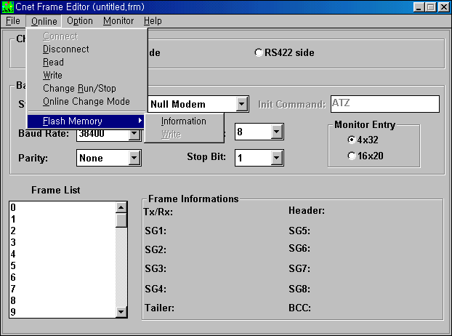

Flash Rom Version should
be higher than v1.01
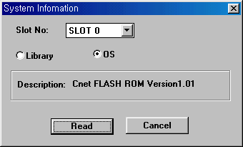

3. Upgrading Cnet Flash Rom OS (In case that version is lower than 1.01)
- Set the Cnet module to ‘Flash memory write mode’ (Mode 8) with the mode selection switch.
- RUN LED of Cnet module will blink with 1 second period
- Run the frame editor and connect to the Cnet module.
- Select ‘F6OS.BIN’ (Cnet OS for G6L-CUEA) or ‘F34OS.BIN’ (Cnet OS for G3L-CUEA) in Open Lib
menu.
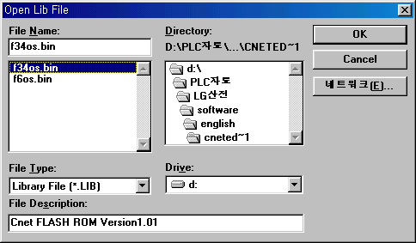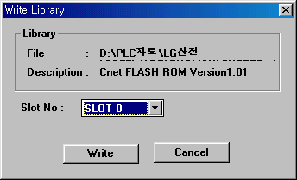
- Select Online – Flash Memory – Write in the menu, then type the slot number at which the Cnet
module is mounted, and press ‘Write’ button.
4. Parameter
- Basic Parameter
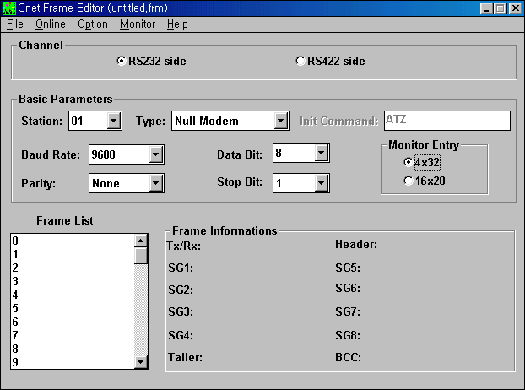
Frame editing is not required
Modbus Station No. of GLOFA
Communication specification
should be the same as that
of other station (Baudrate, Parity
Data bit, Stop bit)

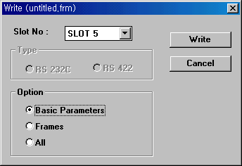
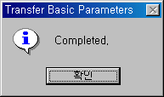

5. Programming
- Library Inserting
- Copy “modbus.Nfb” file to lib directory of GMWIN
- Select “Project → Library insert” on GMWIN menu
- Click Add then select “communi.Nfb” and “modbus.Nfb”
(N=6: G6L-CUEA, N=4: G4L-CUEA, N=3: G3L-CUEA)

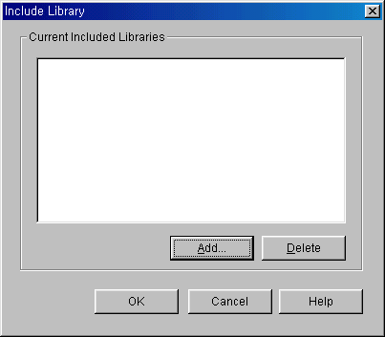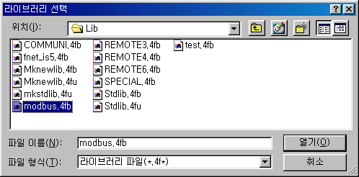

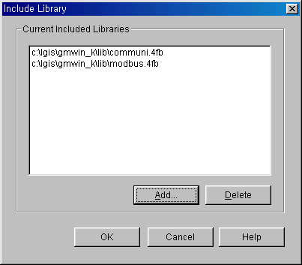

- Function Block (RTU_RD, RTU_WR)

  - RTU_RD (Data read by using Modbus RTU protocol)
 | IN / OUT | Type | Description
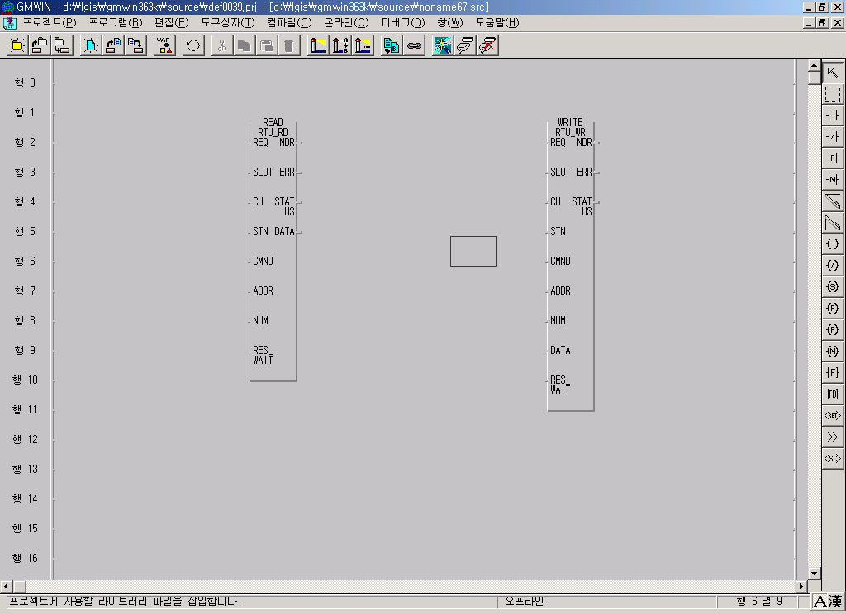 | REQ | BOOL | Execution condition for function block  (When condition changes 0 to 1, FB executes 1 time)  * Refer to note 1
 | SLOT | USINT | Slot Number cnet module installed (0 ~ 7)
 | CH | USINT | 0: RS-232C, 1: RS-422/485
 | STN | USINT | Destination station to be read (0 ~ 32)
 | CMND | USINT | Modbus Function command (1 ~4)  1: Read coil status (Bit)  2: Read input status (Bit)  3: Read holding register (Word)  4: Read input register (Word)
 | ADDR | INT | Head address to be read (0 ~ 65535)
 | NUM | USINT | Number of data to be read (1 ~ 64)
 | RES_WAIT | TIME | Response wait time  (After waiting for the time to be set, PLC CPU read  the response from Cnet module)  * Refer to note 2
 | NDR | BOOL | Holds ‘ON’ status during 1 scan after communication  Is completed successfully
 | ERR | BOOL | Holds ‘ON’ status during 1 scan after communication  Is completed abnormally
 | STATUS | USINT | Communication status code (Error code)  0: Normal, Not 0: Error code  * Refer to note 3
 | DATA | USINT  ARRY  (256) | Area which received data is stored.
  Array [0]: High Byte of 1st received word
  Array [1]: Low Byte of 1st received word
  Array [2]: High Byte of 2nd received word
  Array [3]: Low Byte of 2nd received word
  …
  - MBUS_WR (Data write by using Modbus RTU protocol)
 | IN / OUT | Type | Description
 | REQ | BOOL | Execution condition for function block  (When condition changes 0 to 1, FB executes 1 time)  * Refer to note 1
 | SLOT | USINT | Slot Number cnet module installed (0 ~ 7)
 | CH | USINT | 0: RS-232C, 1: RS-422/485
 | STN | USINT | Destination station to be written (0 ~ 32)
 | CMND | USINT | Modbus Command  05: Force single coil (Bit)  06: Preset single register (Word)  15: Force Multiple coils (Bit)  16: Preset Multiple register (Word)
 | ADDR | INT | Head address to be written (0 ~ 65535)
 | NUM | USINT | Number of data to be written (1 ~ 64)  * When using command 5 or 6 this value will be  ignored.
 | RES_WAIT | TIME | Response wait time  (After waiting for the time to be set, PLC CPU read  the response from cnet module) * Refer to note 2
 | NDR | BOOL | Holds ‘ON’ status during 1 scan after communication  Is completed successfully
 | ERR | BOOL | Holds ‘ON’ status during 1 scan after communication  Is completed abnormally
 | STATUS | USINT | Communication status code (Error code)  0: Normal, Not 0: Error code * Refer to note 3
 | DATA | USINT  ARRY  (256) | Area which writing data is stored.  * When using command 05.  Array [0] = 1 → ON  Array [0] = 0 → OFF
  Array [0]: High Byte of 1st writing word
  Array [1]: Low Byte of 1st writing word
  Array [2]: High Byte of 2nd writing word
  Array [3]: Low Byte of 2nd writing word
  …

♠ Note 1

Execution Condition
- Execution condition (REQ) of RTU_RD / RTU_WR should be turned on, after previous
execution have been completed successfully. (after ‘NDR’ have been turned on)

REQ

NDR

Communicating time = Internal processing time + response wait time
(Internal processing time: 50 ~ 60ms)

Previous request
Next request

♠ Note 2

Response Wait Time
- After waiting for the time to be set, PLC CPU read the response from cnet module
- This value can be related with received data size, transmission speed (Baudrate) and
other station’s responding performance.
- Recommended minimum value is as below. (When an error occurs with this value,
make the value longer.)

Request data  size  Baudrate | 1 ~ 16 word | 17 ~ 32 word | 33 ~ 48 word | 49 ~ 64 word
4800 bps | 150ms | 250ms | 330ms | 400ms
9600 bps | 100ms | 180ms | 230ms | 280ms
19200 bps | 80ms | 150ms | 180ms | 230ms

♠ Note 3

Status Code
- Status code indicates communication status
Status  code  (Dec) | Description | Solution | Remarks
0 | Normal | No error
1 | Illegal command  (Not allowable Command was  requested to the slave) | 1. Check the allowable command for  the slave then change the command  code In function block | Returning  value from  slave
2 | Illegal address  (Not allowable address was requested  to the slave) | 1. Check the allowable address for  the slave then change the address  In function block | Returning  value from  slave
3 | Illegal data value  (Not allowable data value was  requested to the slave) | 1. Check the allowable data range for  the slave then change the data value  In function block | Returning  value from  slave
4 | Slave device failure  (An unrecoverable error occurred while  the slave was attempting to perform  the requested action) | 1. Check the slave status | Returning  value from  slave
6 | Slave device busy | 1. Execute function block again later  when the slave is free. | Returning  value from  slave
10 | Received Frame CRC error | 1. Make the response wait time  longer than previous value.  2. Check the cable and frame status | Value  generated  by function  block
17  or 16 | Cnet module I/F error | 1. Check the slot no. designated on  function block | Value  generated  by function  block
21  or 64 | Channel(232c/422) stop | 1. Make the cnet module run mode. | Value  generated  by function  block
74 | Time out error | 1. Check the basic parameter  2. Check destination the station no.  3. Check the cable status | Value  generated  by function  block
21  or 115 | Communication mode error | 1. Check the cnet mode then select  user define protocol mode. | Value  generated  by function  block
255 | FB input parameter error | 1. Check the FB input value.  (Slot,CH,Command,Number etc) | Value  generated  by function  block

6. Example
♠ Communication between GLOFA GM6 and Inverter IG5
- Inverter Operation Command
- Using Command 16 (Preset Multiple register: Word).
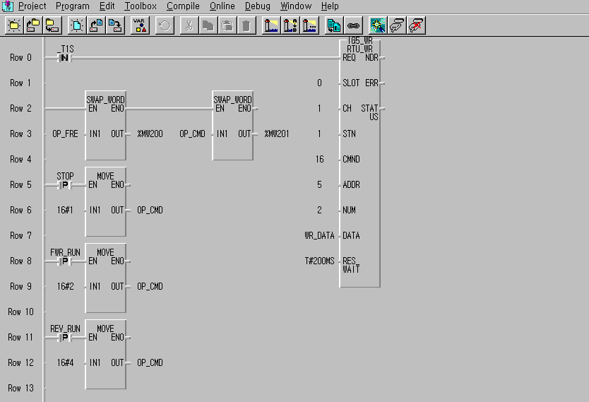
%MB400 ~%MB655
(%MW200~%MW327)

- Inverter Operation Monitor
- Using Command 03 (Read holding register: Word).
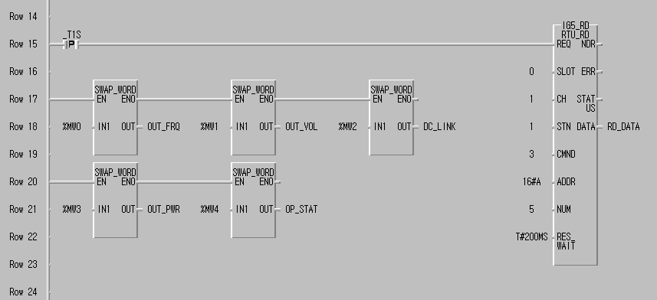
%MB0~%MB255
(%MW0~%MW127)

