- Read this manual thoroughly before using LGIS equipment. Also, pay careful attention to safety and handle the module properly.
- Safety precautions are for using the product safely and correctly in order to prevent the accidents and danger, so make sure to follow all directions in safety precautions.
- The precautions are divided into 2 sections, ‘Warning’ and ‘Caution’. Each of the meaning is represented as follows
Warning
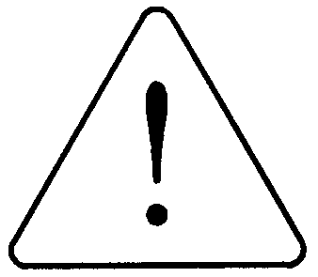
Indicates that incorrect handling may cause hazardous conditions, resulting in death or severe injury.

Caution
Indicates that incorrect handling may cause hazardous conditions, resulting in medium or slight personal injury or physical damage.

- The symbols which are indicated in the PLC and User’s Manual mean as follows;
This symbol means paying attention because of danger in specific situations.
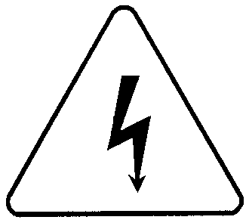
This symbol means paying attention because of danger of electrical shock.

- Store this manual in a safe place so that you can take it out and read it whenever necessary. Always forward it to the end user.
Design Precautions
Warning

 Install a safety circuit external to the PLC that keeps the entire system safe even when there are problems with the external power supply or the PLC module. Otherwise, serious trouble could result from erroneous output or erroneous operation.
- Outside the PLC, construct mechanical damage preventing interlock circuits such as emergency stop, protective circuits, positioning upper and lower limits switches and interlocking forward/reverse operation.
When the PLC detects the following problems, it will stop calculation and turn off all output in the case of watchdog timer error, module interface error, or other hardware errors.
However, one or more outputs could be turned on when there are problems that the PLC CPU cannot detect, such as malfunction of output device (relay, transistor, etc.) itself or I/O controller. Build a fail safe circuit exterior to the PLC that will make sure the equipment operates safely at such times. Also, build an external monitoring circuit that will monitor any single outputs that could cause serious trouble.

 Make sure all external load connected to output does NOT exceed the rating of output module.
Overcurrent exceeding the rating of output module could cause fire, damage or erroneous operation.

 Build a circuit that turns on the external power supply when the PLC main module power is turned on.
If the external power supply is turned on first, it could result in erroneous output or erroneous operation.

Design Precautions

Caution
 Do not bunch the control wires or communication cables with the main circuit or power wires, or install them close to each other. They should be installed 100mm (3.94inch) or more from each other.
Not doing so could result in noise that would cause erroneous operation.

Installation Precautions
Caution
 Use the PLC in an environment that meets the general specification contained in this manual or datasheet.
Using the PLC in an environment outside the range of the general specifications could result in electric shock, fire, erroneous operation, and damage to or deterioration of the product.

 Completely turn off the power supply before loading or unloading the module.
Not doing so could result in electric shock or damage to the product.

 Make sure all modules are loaded correctly and securely.
Not doing so could cause a malfunction, failure or drop.

 Make sure I/O and extension connector are installed correctly.
Poor connection could cause an input or output failure.

 When install the PLC in environment of much vibration, be sure to insulate the PLC from direct vibration.
Not doing so could cause electric shock, fire, and erroneous operation.

 Be sure to there are no foreign substances such as conductive debris inside the module.
Conductive debris could cause fires, damage, or erroneous operation.

Wiring Precautions

Warning
 Completely turn off the external power supply when installing or placing wiring.
Not doing so could cause electric shock or damage to the product.

 Make sure that all terminal covers are correctly attached.
Not attaching the terminal cover could result in electric shock.

Caution

 Be sure that wiring is done correctly be checking the product’s rated voltage and the terminal layout.
Incorrect wiring could result in fire, damage, or erroneous operation.

 Tighten the terminal screws with the specified torque.
If the terminal screws are loose, it could result in short circuits, fire, or erroneous operation.

 Be sure to ground the FG or LG terminal to the protective ground conductor.
Not doing so could result in erroneous operation.

 Be sure there are no foreign substances such as sawdust or wiring debris inside the module.
Such debris could cause fire, damage, or erroneous operation.

Startup and Maintenance Precautions
Warning

 Do not touch the terminals while power is on.
Doing so could cause electric shock or erroneous operation.

 Switch all phases of the external power supply off when cleaning the module or retightening the terminal or module mounting screws.
Not doing so could result in electric shock or erroneous operation.

 Do not charge, disassemble, heat, place in fire, short circuit, or solder the battery.
Mishandling of battery can cause overheating or cracks which could result in injury and fires.

Caution

Disposal Precaution

Caution
 Do not disassemble or modify the modules.
Doing so could cause trouble, erroneous operation, injury, or fire.

 Switch all phases of the external power supply off before mounting or removing the module.
Not doing so could cause failure or malfunction of the module.

 Use a cellular phone or walky-talky more than 30cm (11.81 inch) away from the PLC
Not doing so can cause a malfunction.
 When disposing of this product, treat it as industrial waste.
Not doing so could cause poisonous pollution or explosion.

