Chapter 5 Profibus-DP Communication

5.1 Overview

Profibus is the open type field bus that the manufacturer selects independently to apply and manufacture (Vendor-independence) and that is used widely for processing automation. DP among them is the most frequently used Communication profile and the network suitable for FA environment of Field Level and also is suitable for master-slave communication between master automation machine and distribution slave I/O machine. It is designed to install with low cost and DP is the most suitable item to replace the existing system such as 4~20mA or Hart system together with 24V parallel signal transmission to the production automation system.

Smart I/O module communication supports Profibus-DP through GM3/4/6 master module.
(G3L-PUEA/ G3L-PUEB/G4L-PUEA/ G4L-PUEB/G6L-PUEA/ G6L-PUEB)
For further information for Profibus-DP, please refer to ‘Korea Profibus Association’s homepage’. (http://www.profibus.co.kr)

5.2 Communication Specification

Classification | G3/4/6L-PUEA | G3/4/6L-PUEB
Module type | Master
Network type | Profibus-DP
Standard | EN 50170 / DIN 19245
Media Access | Logical Token Ring
Communication method | RS-485(Electric)
Topology | Bus
Modulation method | NRZ
Communication cable | Shielded Twisted Pair
Communication distance | 1200 m (9.6k ~187kbps)
Communication distance | 400 m (500kbps)
Communication distance | 200 m (1.5 Mbps)
Communication distance | 100 m (3M ~ 12Mbps)
Max. Node/network | 126 Station
Max. Node/segment | 32 Station
Max. I/O data | 1kbytes | 7kbytes
Communication parameter setting | Parameter setting by using GMWIN High Speed Link parameter and SyCon-PB
Configuration Tool | SyCon-PB
Configuration port | RS-232C Configuration Port support

5.3 Basic Performance

5.3.1 Overview

Profibus-DP Master module is available to set as the following function.

- Supports only High Speed Link communication.
- Uses parameter setting in GMWIN/KGLWIN and Configuration Tool(LGIS provided Tool : SyCon).
- Sets only sending/receiving area from GMWIN/KGLWIN highs speed link parameter setting.
- Sending/receiving data shall be saved continuously from the setting area and sent. (this is similar to the continued MAP of MASTER-K.)
- Uses SyCon to set sending/receiving number and slave area per slave station and uses Configuration Port to dselfload as master module.
- Sending/receiving number is available up to 512bytes/3,584bytes respectively according to the type of Daughter board.
- Sending/receiving number per slave station is set as byte unit.(set in SyCon)
- Communication begins through GMWIN/KGLWIN High Speed Link enable set.

5.3.2 Operation by High Speed Link

1) If Master module is the product of LGIS (G3/4/6L-PUEA, G3/4/6L-PUEB), it configures Profibus Network using SyCon.
- It dselfloads Profibus Network Configuration as master module.
- It sets High Speed Link parameter of master in GMWIN and dselfloads it.
- It performs High Speed Link enable set.
- If using other maker’s product as Master, it configures Profibus Network using Configuration Tool of the corresponding product.

5.3.3 SyCon

If using master module provided by LGIS (G3/4/6L-PUEA, G3/4/6L-PUEB), it is required to configure Profibus Network using SyCon and dselfload the information to the corresponding master module. As Profibus Network Configuration Tool is different from each master module, if using LGIS master module (G3/4/6L-PUEA, G3/4/6L-PUEB), it is required to use only SyCon.

SyCon execution

If there is no project using before executing SyCon, the initial screen same as the above figure will appear and if you are preparing the project, the latest project will be open.

Initial screen
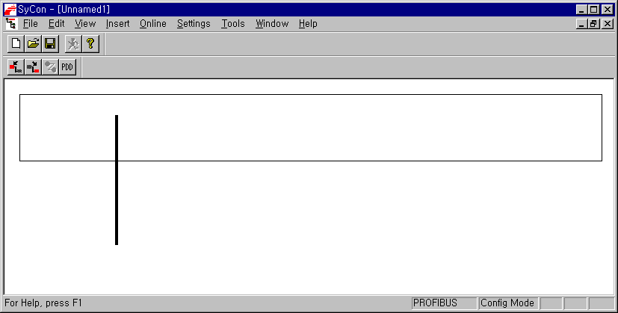

5.3.4 Insertion of Master Module

Select from the left top tool bar and click the proper point of left top from the window below.

Tool bar

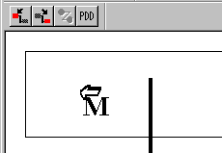

If Insert Master window is open as shself in the figure, select COM-DPM/PKV20-DPM if the using master module is G3/4/6L-PUEA and click Add button in the middle part. If the using master module is G3/4/6L-PUEB, select COM-PB/PKV20-PB and click Add button in the middle part. Confirm Station address and if necessary, it is available to change Description. If pressing OK button, master module shall be inserted.
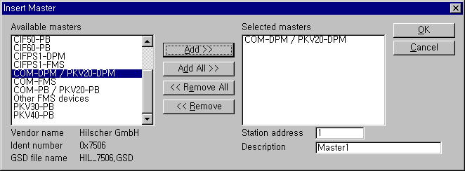
Master Insert

Inserted master module
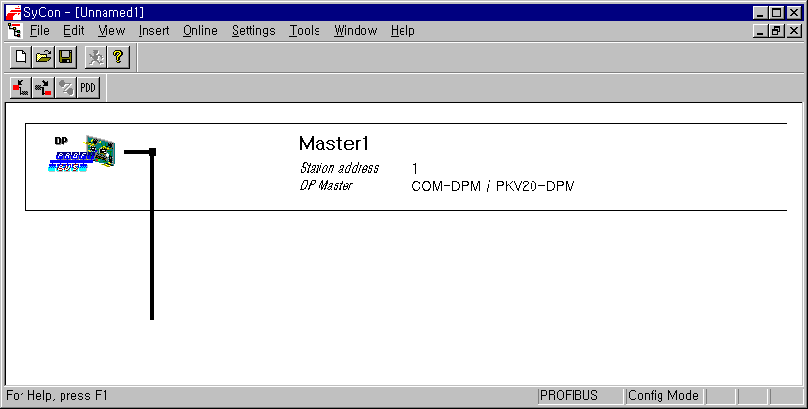

5.3.5 Master Module Setting

If you click the right side of mouse on the inserted master module and select “Master Settings...” from the appeared popup window, the following window will be open. Select “Controlled release of the communication by the application program” from “Parameter to user interface”, “Little Endian (LSB-MSB)” from “Storage format (word module)” and select ”Buffered, host controlled” from “Handshake of the process data” in order.

Master Module Setting
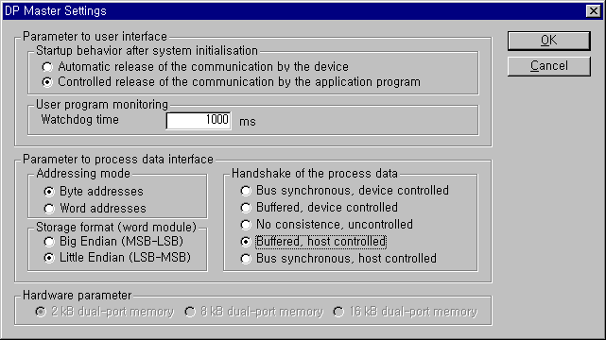

5.3.6 Insertion of Slave

Similar to master, select from left top tool bar and click master bottom, and Insert Slave window will appear as below.

Slave insert
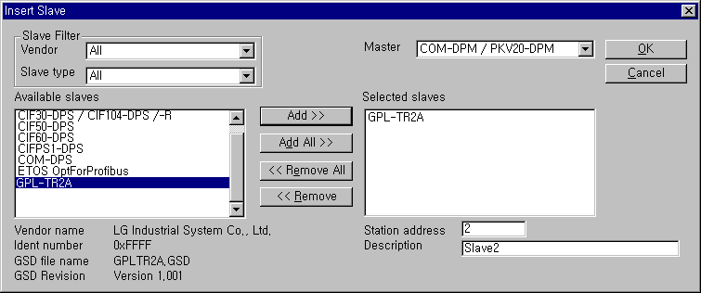

If using GPL-TR2A, select “GPL-TR2A” from the left side “Available slaves” and click “Add” button in the middle part. If there are several masters, select one from the right side “Master” and confirm “Station address” and “Description” and then click “OK” button.

Remark
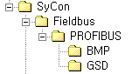
- If there is no slave to use in the slave list (Available slaves) of insert slave window, copy “GSD file” which is the original self-information supplied by the module manufacturer, from the directory below and then try again Sycon and insert slave.

5.3.7 Slave Configuration

Click the inserted slave icon with the right button of mouse and select “Slave configuration” from the appeared popup window. (or double-click the left button of mouse on the slave icon.)

Slave Configuration
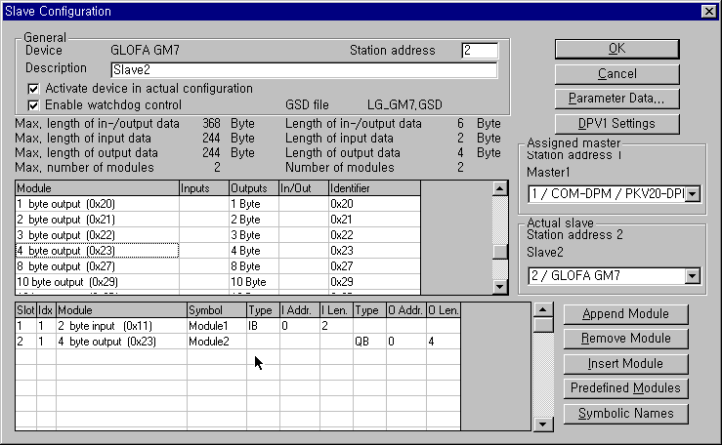

List box in the List box in the middle part shows all available module. If you select the module having the necessary point and click “Append Module” button on the right bottom, it shall be inserted to the list box below. In this case, it is required to insert input module first and then insert output module in the bottom. And the number of available module are 2.

5.3.8 Bus Parameter Setting

Bus Parameter Setting

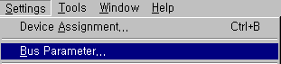

Bus parameter setting is the setting about Profibus-DP network. Select “Settings/Bus Parameter...” from the menu. Optimize field contains “Standard” and “user definition” setting and speed setting (Baud rate) contains 9.6kbps ~ 12Mbps setting. Basically, Baud rate is set as 1.5Mbps and Optimize is set as ‘standard’.

Bus Parameter
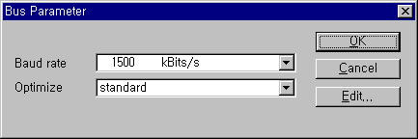

Remark
- Communication speed is related to transmission distance.
- When using 12Mbps, you should use the connector only for 12Mbps and exclusive cable.
- When using 12Mbps, min. Distance between stations shall be set as more than 1m.
- When using 12Mbps, if the communication is cut off (especially, the station far from master), search the proper end resistance value and set it random.

5.3.9 Device Allocation

It is required to dselfload the prepared configuration to the master module. In this case, click the left button of mouse and select master module icon to set which device to use. Select “Setting/Device Assignment...” from the menu.

Device Allocation

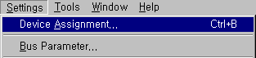

Driver Selection
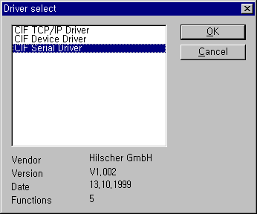

If driver selection window is open, select “CIF Serial Driver”.

Remark
- Driver to be provided by G3/4/6-PUEA/B type master module is only RS-232C port. Thus, “CIF TCP/IP Driver”, “CIF Device Driver” is not available.

Driver Selection of CIF Serial Driver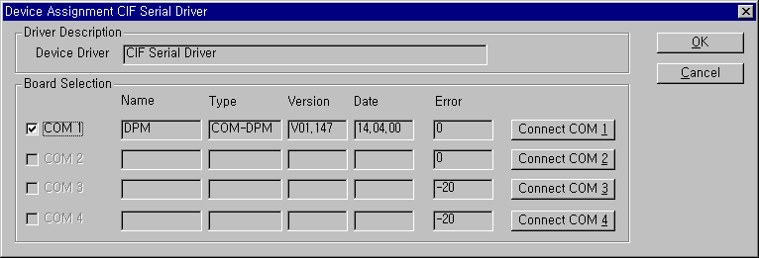

① “Connect COM1” press
the button to confirm if
the corresponding module information is indicated.
② If the corresponding
module information is shself, check the “COM1” check box.
③ If everything ends normally without error, press “OK” button.
This connects PC serial port and Configuration Port of Profibus-DP master module and applies the power of master module. Press “connect COM1” or other button according to PC serial port and confirm if the corresponding module is selected. In the figure, “version” and “Date” may have different value. If there is no error, check the check box of the left side and click “OK” button.

Remark
- When pressing “Connect COM1” button, if the module information does not appear normally and the error occurs, check the connection of cable for configuration and the cable condition first.
- If Cable is OK, it means that module must be poor. In this case, contact to the customer service center.

5.3.10 Configuration Download

If you select “Online/Dselfload” from the menu, ‘dselfload’ begins to run. In this case, all LED shall be OFF and only “READY”LED shall be blinking. After dselfload, all LED show its self function. If you carry out ‘dselfload’ in the status that the communication between the current master and slave is open, the warning window with the message “if the dselfload is done during the bus operation, the communication between the master and the slaves is stopped.” will appear. After confirming if there is a problem by communication cutoff, click “Yes(Y)” button and ‘dselfload’ will run normally.

Configuration dselfload

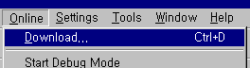

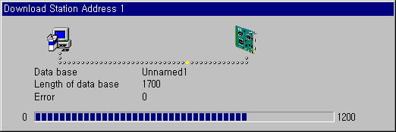
Dselfload processing window

Warning message

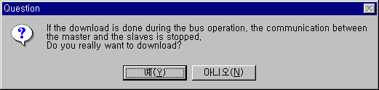

5.3.11 High Speed Link Parameter Setting in GMWIN

In the previous article, we explained the method to set Configuration and the method to dselfload this to the master module. High Speed Link parameter setting should be done after dselfloading Configuration and High Speed Link parameter selects link parameter from GMWIN project screen and sets the corresponding items and the setting order and its function per item are as follows.

  - High Speed Link parameter setting in GMWIN

Open High Speed Link parameter from Project basic screen and enter into the High Speed Link parameter setting menu.

High Speed Link parameter basic screen
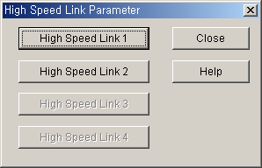

High Speed Link item of the above figure means max. Installation number of communication module according to PLC CPU type. High Speed Link button available for setting is active and in this case, High Speed Link no. is not related to the installed slot no. and the slot no. should be set in the individual parameter setting screen and only one High Speed Link parameter is available to set for one communication module.

Max. Installation number per GLOFA-GM CPU model
Classification | Available communication module | Max. Installation number | Remarks
GM3-CPUA | G3L-PUEA, G3L-PUEB | 4 | If combined with other  communication module  using HS link, installation  number shall be limited.
GM4-CPUA/B | G4L-PUEA, G4L-PUEB | 2(A type)/4(B type)
GM6-CPUA/B/C | G6L-PUEA, G6L-PUEB | 2

  - Link parameter setting

If you select the corresponding parameter from parameter setting basic screen, the High Speed Link parameter setting initial screen will appear as shself in the following figure.
Parameter setting initial screen
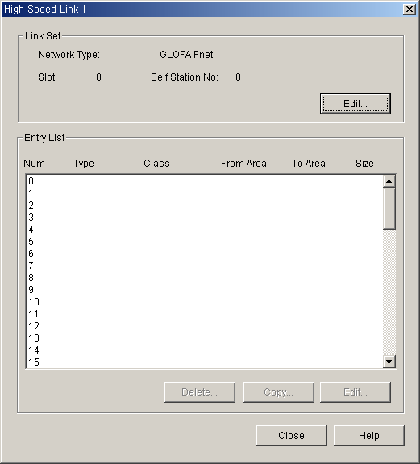

Parameter setting initial screen is composed of two items such as ‘link set’ and ‘Entry list’ and the setting method per each item and its function is as follows.

- High Speed Link setting
High Speed Link setting is the item to set the basic items of the desired communication module to set. Select ‘modify’ button of link setting and set module type, slot no. the self station no. from High Speed Link setting screen respectively.

High Speed Link set screen
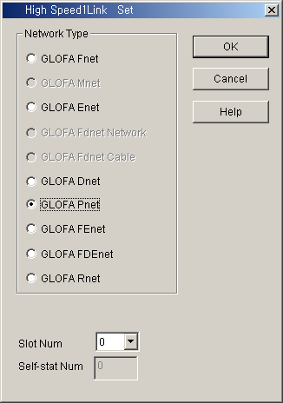

● Network type : It sets the installed communication module type and GLOFA Pnet should be set.
● Slot no. : It sets the position that the communication module to set is installed. (0 ~ 7 slot).
● The self-station no. : The master module shall be set in SyCon and the slave module shall be set by rotary switch. It is not available to change here.

- Entry List setting

Registration list is the area to register the sending/receiving information of actual data and after link setting, it is required to set in the registration no.’0’ of Entry list area and the major setting items are shself on the top of registration list menu. Select (or doubleclick) the corresponding list from High Speed Link setting screen and the user can set the corresponding item from High Speed Link item modification window as shself on the figure below.

High Speed Link item modification screen
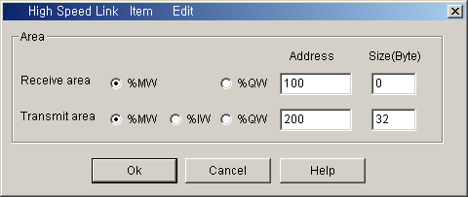

The following shows the screen after setting the sending/receiving parameter. Doubleclick the corresponding registration no. to modify the parameter.

Sending/Receiving parameter setting completion screen (example)
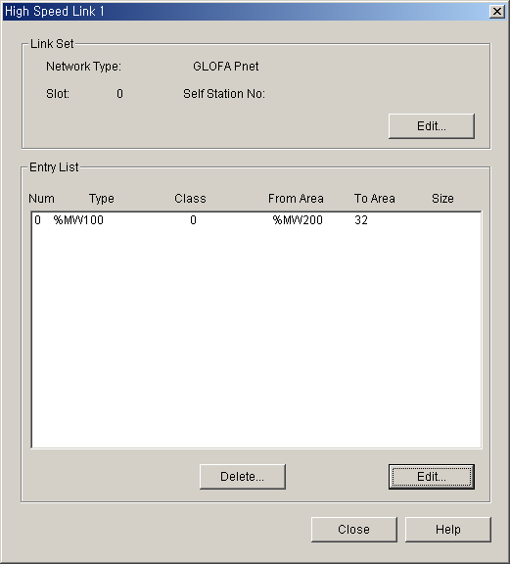

The function of each registration item is as follows.

● Area : When sending, set the area to read the data to send and set the storage area of the received data when receiving.
● Size : This means the data size to send/receive and the unit is 1 byte and it is available to set total sending/receiving as 1kbytes for G3/4/6L-PUEA and 7kbytes for G3/4/6L-PUEB.

Remark
- The size of sending/receiving area is total I/O contact number made in SyCon.
- The order of programming is carried out as G4L-PUEA 1 and GPL-TR2A(16 points), GPL-TR4A(32 points), GPL-D22A(16 points) and when setting the sending area as %MW0, the receiving area as %MW100,
- Sending area : %MW0
- Receiving area : %MW100
- Size of sending area : 6 bytes (total output contact number)
- Size of receiving area : 2 bytes (total input contact number)
And,
- %MW0 data -> GPL-TR2A output
- %MW1 ~ %MW2 data -> GPL-TR4A output
- GPL-D22A input -> %MW100 saving
- The setting order programmed in SyCon has the priority when sending/receiving the data than station no. and cable connection.

5.3.12 High Speed Link Information in GMWIN

- High Speed Link information function
High Speed Link service provides the user with the method to confirm High Speed Link service status to confirm the reliability of the data read from other station through High Speed Link as High Speed Link information because this is data exchange between more than 2 communication stations.
That is, the communication module provides the user with the high link information every regular time by collecting all data received until then about whether the High Speed Link action is done by the parameter set by the user or not. The High Speed Link information contains the overall information such as RUN-LINK (_PHSxRLINK), LINK-TROUBLE (_PHSxLTRBL) that provides the user with overall information of communication network and the individual information such as _PHSxSTATE that informs the communication status per slave station. The user can use the above information as keyword type when preparing the program and monitor the High Speed Link status by using the High Speed Link information monitor function. When operating several PLC using High Speed Link, it is required to confirm the reliability of the sending/receiving data using the High Speed Link information such as run-link, link-trouble etc.

(1) Run-Link (_PHSxRLINK)
This is the overall information that shows whether or not High Speed Link is running normally by the parameter set by the user. Once ‘ON’, it maintains ‘ON’ until link enabe is ‘OFF’ and if the following condition is given, it shall be ‘ON’.
① When ‘Link Enable’ is ‘ON’.
② When parameter registration list setting is set normally all.
③ When sending/receiving all data that corresponds with parameter registration list within the setting period.
④ When all other station status set in the parameter is ‘RUN’ and at the same time there is no error.

High Speed Link system configuration
Station 1 Station 2 Station 3 Station 4 Station 5
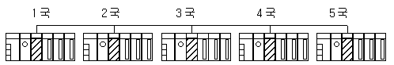
Example of High Speed Link parameter setting of each station
Station 1 | Station 2 | Station 3 | Station 4 | Station 5
sending:2 words  receiving: 2words (station 2)  receiving:2words (station 3) | sending:2words  receiving:2words  (station 1)  receiving:2words (station 4) | sending:2words  receiving:2words (station 1)  receiving:2words (station 5) | sending:2words | sending:2words
The figure shows High Speed Link system configuration to explain RUN-LINK ON condition. In case that 5 communication modules are connected by network as shself on the above figure and carry out High Speed Link as the content of parameter, RUN-LINK ON condition of Station 1 is as follows.

① When in the self station (station 1), Link-Enable is ‘ON’,
② When the self station (station 1) is RUN status,
③ When the self station (station 1) is not the error status,
④ When the sending parameter data set in the self station (station 1) is sent properly,
⑤ When the data receiving from station 2,3 is received properly,
⑥ When the action mode of other station (station 2, 3) to send the data to the self station (station 1) is RUN mode and not the error status and it is communicated properly,
⑦ When in the other station (station 2,3) of the self station (station 1), the action mode of other other station (station 4,5) set in the parameter is RUN mode and not the error status and it is communicated properly.

If the above 7 items are satisfied, RUN-LINK of station 1 shall be ON. If using RUN-LINK contact associated with program in the system where PLC of various stations performs interlocking through High Speed Link, it is available to carry out the mutual monitoring of sending/receiving data and the reliable communication. But, once RUN-LINK contact is ‘ON’, it maintains ‘ON’ status until Link-Enable becomes ‘OFF’. Thus when monitoring the abnormal status such as communication error, it is required to use ‘link-trouble ‘ information contact together as follows

(2) Link-Trouble (_PHSxLTRBL x=High Speed Link no.(1~2))

This is the overall information indicating whether the High Speed Link is running normally by the parameter set by the user. When RUN-LINK violates the condition of RUN-LINK ON in the status that RUN-LINK is ON, LINK-TROUBLE shall be ‘ON’ and if recovered, it shall be ‘OFF’.

- High Speed Link status (_PHSxSTATE[0..127] x=the salve station no. (0~127))

This is the individual information indicating the action status of the slave station and this is available to indicate max. 127 stations High Speed Link status same as max. slave station number. That is, if the sending/receiving status of the corresponding list is normal and the action mode is RUN and there is no error, it shall be ‘ON and if violating the above condition, it shall be ‘OFF’.

- High Speed Link information monitoring

High Speed Link information enables to monitor using the monitoring function after GMWIN online connecting. There are two kinds of method to monitor : the method to select ‘variable monitor’ from monitor menu and the method by link parameter monitor.

(1) Variable monitor

The variable monitor is the function to monitor by using GMWIN flag monitor function and selecting the necessary item. If you select ‘variable monitor’ from online monitor item, the variable registration screen will appear as below. Select the flag and register by selecting directly the High Speed Link information flag from variable, flag list screen one by one. In this case, as PHSxSTATE[n] is Array type flag, the user should select the array no. directly and the array no. means the slave station no. ‘x’ means the High Speed Link no. and it has the range 1~4 for GM3 PLC CPU, the range 1~2 for GM4 PLC CPU and the range 1 for GM6 PLC CPU. If you register the variable in the figure below and select ‘close’, the monitor screen will appear and if you press ‘start’ from tool box shself on the right side separately, it begins to monitor.

High Speed Link information variable registration screen

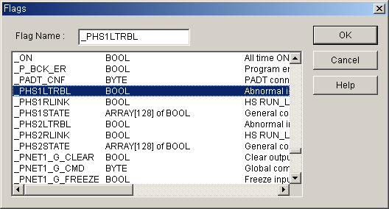

High Speed Link information monitor screen (Variable registration)
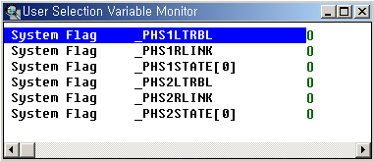

(2) Link parameter monitor

If you select ‘link parameter’ item from monitor menu of GMWIN online connection, ‘select link parameter’ screen will appear as shself on the figure below. If the user selects the desired item from parameter number set by himself and verify it, the High Speed Link parameter monitor screen will be open and the setting registration list will be monitored and indicated on the screen.

Link parameter selection screen

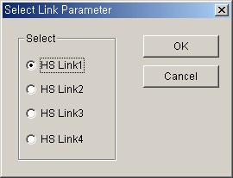

Link parameter monitor indicates the general information such as RUN-LINK, LINK-TROUBLE on the right top and the individual information for mode (action mode), communication (sending/receiving status), error with registration list no.

High Speed Link parameter monitor screen

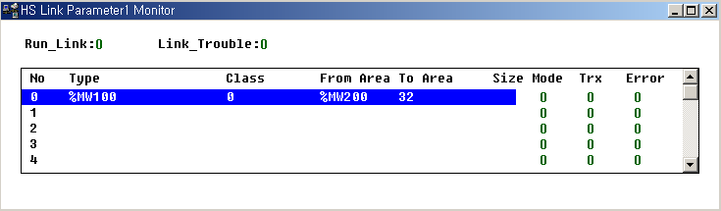

If selecting the High Speed Link information monitor as shself on the above figure, the High Speed Link parameter and information set by the user will be monitored together. And it is available to monitor the High Speed Link status with I/O data as the individual information setting value is monitored together.

5.3.13 High Speed Link Parameter Setting in KGLWIN

Profibus-DP master for MASTER-K also uses SyCon for the Configuration setting and the setting method is the same as that of GLOFA-GM. In case of MASTER-K, it should be required to set the High Speed Link parameter after dselfloading the Configuration to the master module and the High Speed Link parameter selects the parameter from KGLWIN project screen and set the corresponding item. The setting order and the function per item are as follows.

  - High Speed Link parameter setting in KGLWIN

If selecting ‘parameter’ from the following project basic screen, the High Speed Link parameter basic screen will appear and you can select the corresponding item.

KGLWIN project basic screen
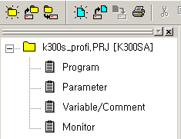
  - High Speed Link parameter selection

    - Setting method
Select the corresponding parameter from the basic screen as shself on the figure below and enter into the parameter setting.

Parameter setting basic screen
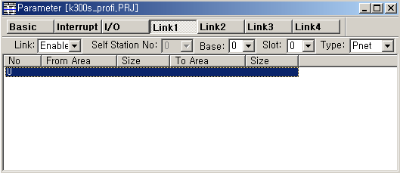

① If parameter
window is
open, press
“Link 1” and enter into the high speed
link parameter setting.
③ Sets the base no. and the
slot no. that
the current
master module
is installed,
and Pnet.

② Sets the
link enable.

The High Speed Link item tab of the above figure means max. installation number of communication module according to PLC CPU type. The High Speed Link button as much as the available setting number shall be active and in this case, the High Speed Link no. is not related to the installed slot no. and the slot no. shall be set in the individual parameter setting screen and only one High Speed Link parameter is available to set for one communication module.

The following table shows the communication model available to install per MASTER-K CPU model and max. installation number.

Max. installation number per MASTER-K CPU model
Classification | Available communication module | Max. installation number | Remarks
K1000S CPU | G3L-PUEA, G3L-PUEB | 4
K300S CPU | G4L-PUEA, G4L-PUEB | 2 /4(more than Version 3.0)
* If combined with other communication module using the High Speed Link, the installation number shall be limited.

● Link : This is the item to allow the High Speed Link and the initial value is prohibited and it is required to set ‘enable’ to execute the High Speed Link.
● The self station no. : Master module is set in SyCon and the slave module is set as rotary switch. It is not available to change here.
● Base : It sets the base position that the communication module to set is installed.
● Slot : It sets the position that the communication module to set is installed. (0 ~ 7 slot).
● Type : It sets the type of the installed communication module and sets the Pnet.

  - Parameter setting and modification
If you doubleclick the corresponding parameter from the parameter setting basic screen as shself on the figure below, the High Speed Link parameter setting screen will appear.

Parameter setting initial screen

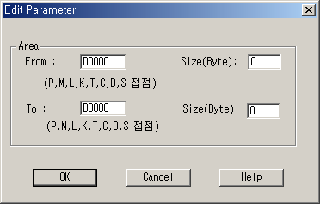

● Area : When sending, set the area to read the data to send and set the storage area of the received data when receiving.
● Size : This means the data size to send/receive and the unit is 1 byte and it is available to set total sending/receiving as 1kbytes for G3/4/6L-PUEA and 7kbytes for G3/4/6L-PUEB.

Remark
- The size of sending/receiving area is total I/O contact number made in SyCon.
- The order of 작화 is carried out as G4L-PUEA 1 and GPL-TR2A(16 points), GPL-TR4A(32 points), GPL-D22A(16 points) and when setting sending area as P000, the receiving area as P010,
- Sending area : P000
- Receiving area : P010
- Size of sending area : 6 bytes(total output contact number)
- Size of receiving area : 2 bytes(total input contact number),
And,
- P000 data -> GPL-TR2A output
- P001~P002 data -> GPL-TR4A output
- GPL-D22A input -> P010 saving.

- %MW1 ~ %MW2 data -> GPL-TR4A output
- GPL-D22A input -> %MW100 saving

3) The setting order programmed in SyCon has the priority when sending/receiving the data than station no. and cable connection.

