Chapter 6 DeviceNet Communication

6.1 Overview

DeviceNet was born to meet the demand to replace the high-cost analog 4~20mA standard with simple digital standard and is the communication link to connect various kinds of industrial devices such as limit switch, photo electronic sensor, motor controller, inverter, barcode reader, panel display etc. to the network. The characteristics is low cost, simple installation, excellent compatibility with other maker’s device as well as outstanding application in the network application such as Master/Slave, Multiple Master, Peer-to-Peer etc. As DeviceNet uses CAN (Controller Area Network) protocol as it is and system response time is short, and the reliability is high, the production cost shall be low as we can use CAN chip with low cost.

DeviceNet Smart I/O module has the following characteristics.

- The real time control is available to communicate various I/O machine that is the lowest in the network system.
- One master module can control 63 slave module and max. 2,084 points I/O control is available.
- Network installation is flexible as multi drop and T branch connection is available.
- Available to connect the master module of LGIS and various slave module of other maker.
- Available to configure the system with the slave module of LGIS and other maker’s master module.
- Available to set station number (MAC Address) with hardware. (0 ~ 63 stations).
- The communication speed is set automatically according to the master setting.
- Available to install 2 master modules in GLOFA-GM4 and GM6.
- Available to communicate by High Speed Link parameter setting.
- Available to connect with various slave I/O.
- Supports Poll, Cos, Cyclic, Strobe method as communication method.

It is used widely for general I/O, actuator, near-by switch, light switch, valve, inverter, A/D module, D/A module, position control etc.

6.2 Communication Specification

1) Frame Specification

Items |  |  | Performance Specification
Transmission specification | Communication speed |  | 125/250/500kbps
Transmission specification | Communication distance (Thick)^{[*1]} |  | 500/250/100m
Transmission specification | Max. drop  length | 125 kbps | 6m(max. extension 156m)
Transmission specification | Max. drop  length | 250 kbps | 6m(max. extension 78m)
Transmission specification | Max. drop  length | 500 kbps | 6m(max. extension 39m)
Transmission specification | Data packet |  | 0~8 Byte
Transmission specification | Network structure |  | Trunk/drop line  Power in the same network/signal cable
Transmission specification | Bus method^{[*2]} |  | Multi slave/ multi casting  Peer-to-Peer method  Poll, Strobe, COS/Cyclic method
Transmission specification | Max. node number |  | Max. 64 MAC ID/MAC Identifier  32 I/O per node (max. 2,048 I/O)
Transmission specification | System type |  | Node insertion and removal in the status of voltage ON.
Transmission specification | Action voltage |  | DC 24V
Transmission specification | Diagnosis function |  | The duplicate station check /bad station monitor /CRC error Check

Remark
1) The transmission distance of Smart I/O module is in inverse proportion to data transmission ratio and when using Thin cable, the transmission distance is limited to 100m regardless of data transmission ratio.
2) For cable manufacturing and installation, please contact and discuss with the experts.

6.3 Communication Parameter Setting

DeviceNet should set generally the slave station that the master module will communicate with and set the station number, communication method, data size to communiction, communication period necessary for the communication with the slave in order to enable to communicate. The files set as above are called “Scanlist file” with which the master module communicates with the slave module. Thus, after setting the Scanlist file such service type, communication speed, station number etc. from High Speed Link parameter edit menu, Dnet I/F module begins to communicate by receiving all the setting Scanlist file from CPU.

In order to communicate with SMART I/O DeviceNet module, High Speed Link communication service is used. This function is used when changing the data and information of other station periodically at every specified time. By referring the changing data of the self-station or other station periodically each other, it enables to utilize the data to the system effectively and carry out the communication by setting the parameter simply.
The parameter setting method is to designate its own area and the area of other station to send or receive and data size, message type, station no. in GMWIN High Speed Link parameter and then carry out the communication. Data size is available to communicate at least 1byte up to 256bytes(2,048 points) and the communication period is available to set min. 5ms up to 10sec. according to the communication contents. As it is available to communicate with other station by simple parameter setting, it is easy to use this program and the high speed process of internal data enables to process lots of data at the same time periodically.
The following table shows High Speed Link point per communication model.

Max. Communication Point per model
Classification |  | Max. communication point | Max. block no. | Others
SMART I/O  module | GDL-TR2A | 16 points | 64 (0-63) | Output module
SMART I/O  module | GDL-TR4A | 32 points | 64 (0-63) | Output module
SMART I/O  module | GDL-RY2A | 16 points | 64 (0-63) | Output module
SMART I/O  module | GDL-DT4A | 32 points | 64 (0-63) | Combined module
SMART I/O  module | GDL-D22A | 16 points | 64 (0-63) | Input module
SMART I/O  module | GDL-D24A | 32 points | 64 (0-63) | Input module

Remark
- For further information for master setting, please refer to the user’s manual for DeviceNet.
- In case of GDL-DT4A, do not set as Strobe method among communication method.

6.3.1 High Speed Link Service

SMART I/O Dnet module sets its own station no. to communicate with the master module by using the rotary switch and the communication speed is set automatically according to the master module setting. To control the single type remote module, it is available to communicate only by High Speed Link parameter setting in GMWIN and easy to interface with the module of LGIS and other maker’s.

The following table shows the basic configuration of the single type remote module.

Specification of single type remote module

Module name |  |  | Contents | Service mode
GLOFA-GM |  | GDL-TR2A | TR output 16 points | Poll, Strobe, COS/Cyclic service
 |  | GDL-TR4A | TR output 32 points | Poll, Strobe, COS/Cyclic service
 |  | GDL-DT2A | DC/TR combined 16 points | Poll, Strobe, COS/Cyclic service
 |  | GDL-D22A | DC input 16 points | Poll, Strobe, COS/Cyclic service
 |  | GDL-D24A | DC input 32 points | Poll, Strobe, COS/Cyclic service
 |  | GDL-RY2A | Relay output 16 points | Poll, Strobe, COS/Cyclic service
Other maker’s example | OMRON | DRT1-OD08 | TR output 8 points | Poll service
Other maker’s example | A.B | 1794-OB16 | TR output 16 points | Poll service
Other maker’s example | A.B | 1794-IB16 | DC 24V input 16 points | Poll service

ScanList is the communication information data that the user must set so that the master module carres out the predefined communication with the slave module when the power ON. Thus, the user is required to set the information for the slave module to communicate with Dnet I/F module by using High Speed Link parameter.

The following describes the method to set the Scanlist by using High Speed Link parameter for Dnet communication.
First, select the project file which is suitable for CPU type by using GMWIN and then select High Speed Link parameter from the project file and finally select ‘high speed link 1’.

High Speed Link parameter selection screen
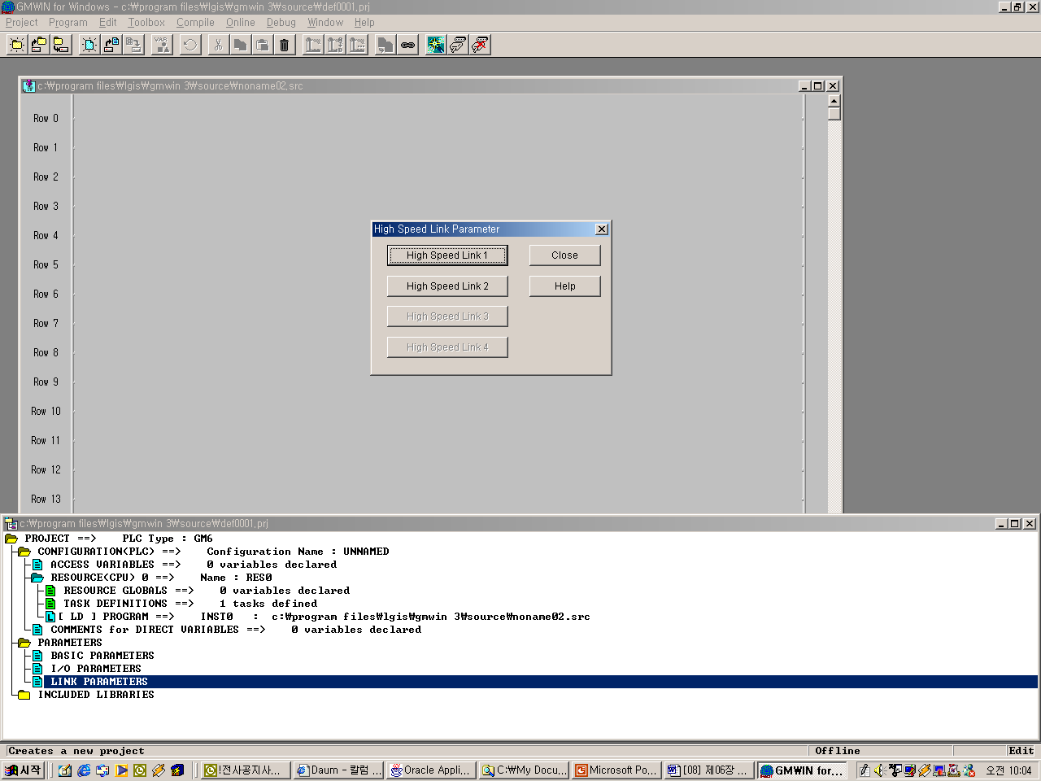

After selecting ‘high speed link 1’ , select ‘<-‘ mark from the below figure to set the slot position that Dnet I/F module is installed, station no, action mode and scan time and poll rate.

Parameter setting initial screen
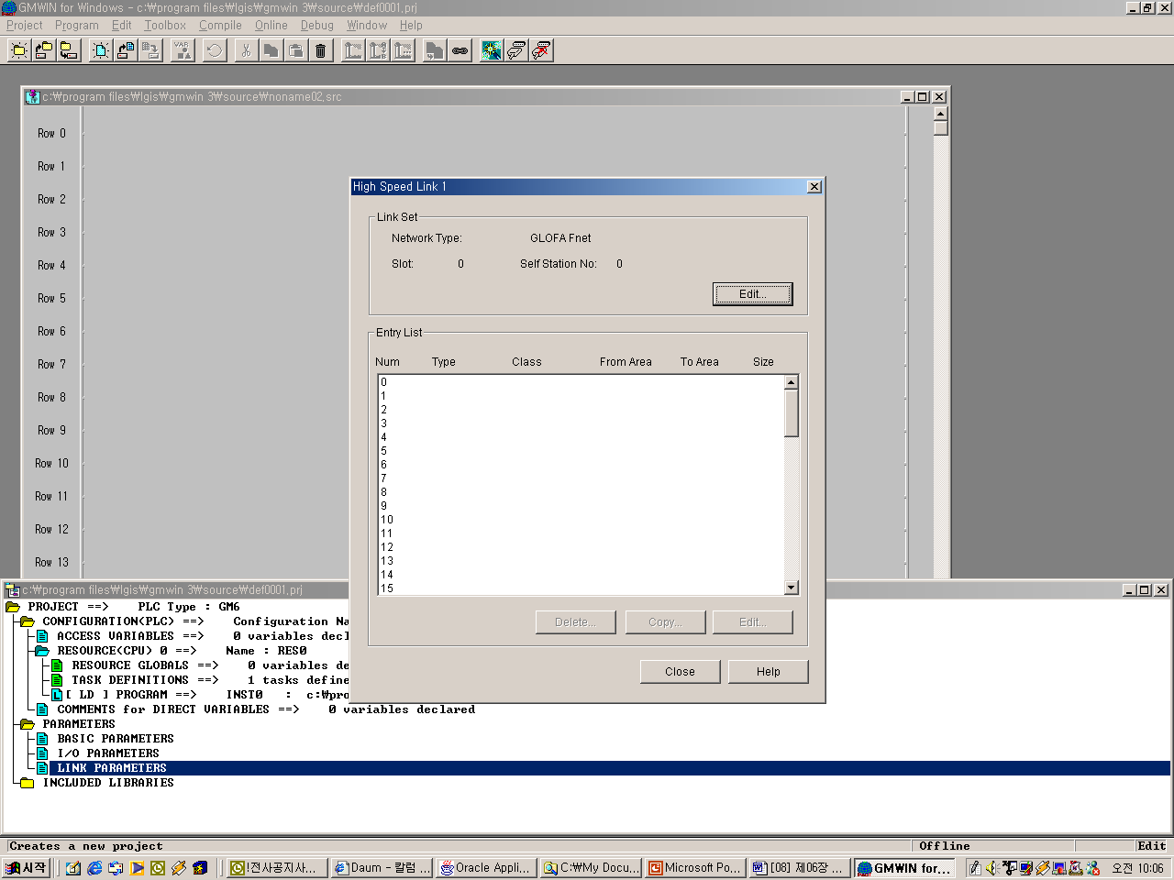

High Speed Link 1 set screen
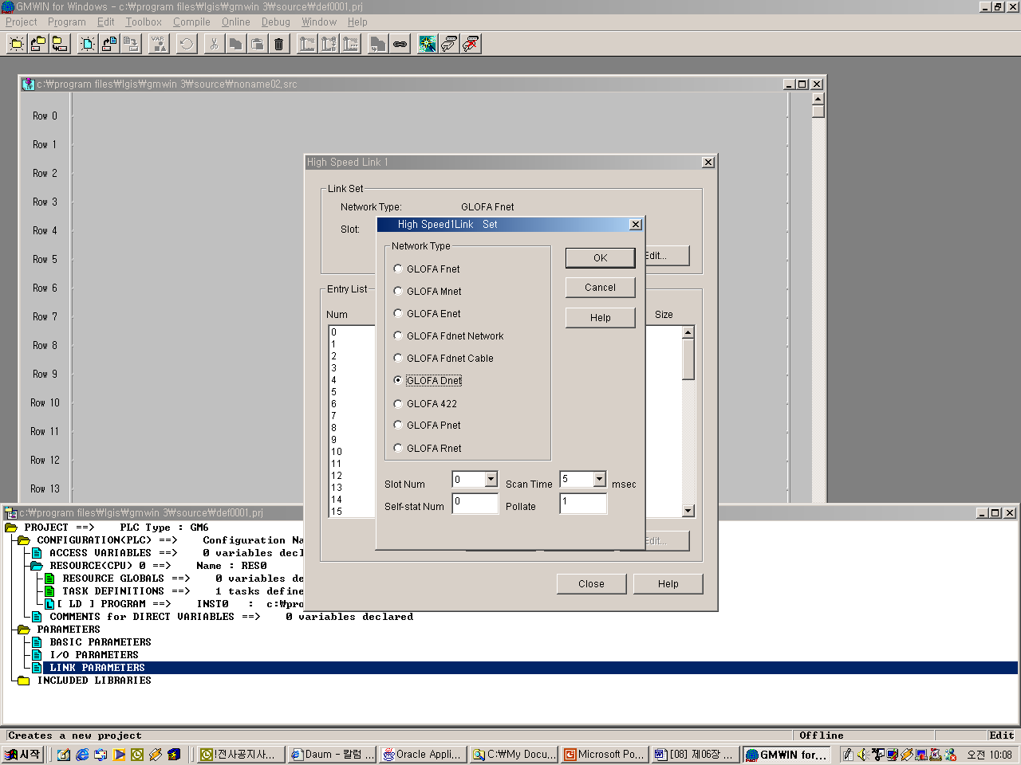

If setting the network type, slot no., self-station number, delay scan time, poll rate etc, the registration list no.’0’ shall be set automatically in the self-station and for the registration list no.1~63, the module that the user wants to communicate shall be set.

Mode and Communication area setting screen (GDL-TR2A)
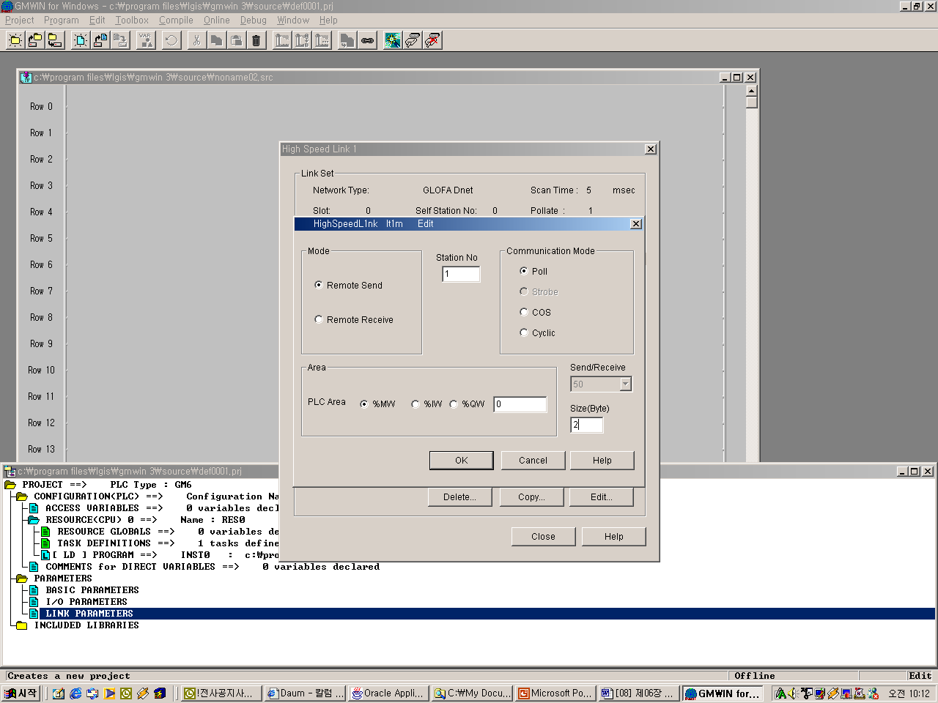

The following describes the sending data setting method of remote I/F output module. From the parameter menu, set the mode by whether or not to send/receive, the station no. by other station no. (remote module), the communication mode by ‘Poll’, the area by the data area to send and the size shall be 2 byte. The single type I/F module does not have the separate setting items and is controlled by the master module according to the communication speed.

Link setting description

Classification | Description
Network type | This is to set the communication module type by ‘GLOFA Dnet’
Slot no. | For the slot no. that the desired communication module to set is installed, select one from the range 0~7. (The right side of CPU module is ‘0’ slot.)
Self station no. | Enter the self-station no. that is set in the station number switch of communication module front side. It is available to set 0~63 by decimal number but it is not allowed to use duplicate station no. as the self station no. is the unique number to distinguish communication module in the same network system.

Scan time | This is the scan delay time (msec) to delay to next scan after Dnet I/F module scanned the slave module all.
Poll rate | This is the rate that Dnet I/F module scans the salve module. That is, if the value is ‘2’, this means that after scanning Dnet I/F module twice, one time ‘poll’ shall be executed for the module of station number set in the parameter.

In order to communicate with output module (GDL-TR2A/RY2A) among Dnet remote module, it is required to set the sending only. The receiving setting is not required.

High Speed Link parameter setting description (master module setting)

Classification |  | Description
Mode | Remote sending | Sends the data to SMART I/O output module.
Mode | Remote receiving | Receives the data from SMART I/O input module.
Station no. |  | Designates the station no. of single type I/F module to communicate.
Communi  cation mode | Poll | Performs Poll service.
Communi  cation mode | Strobe | Performs Strobe service.
Communi  cation mode | COS | Performs COS service.
Communi  cation mode | Cyclic | Performs Cyclic service.
Area | In case of Remote sending mode | Designates the sending data area of the self-station to send to the SMART I/O output module.
Area | In case of Remote receiving mode | Designates the area of the self-station to save the data received from SMART I/O input module.  (%IW area Disable)
Sending/receiving period (msec) |  | Sets the sending/receiving period of the data.
Size (byte) |  | Sets the data size to send/receive and in case of communication between self-station, the unit is 2bytes and in case of communication with other makers, the data size shall be set as the byte that the corresponding module requires.

In order to communicate with input module among SMART I/O DeviceNet module, it is required to set the receiving only as shown on the figure. The sending setting is not required.

Mode and Communication area setting screen (GDL-D22A)
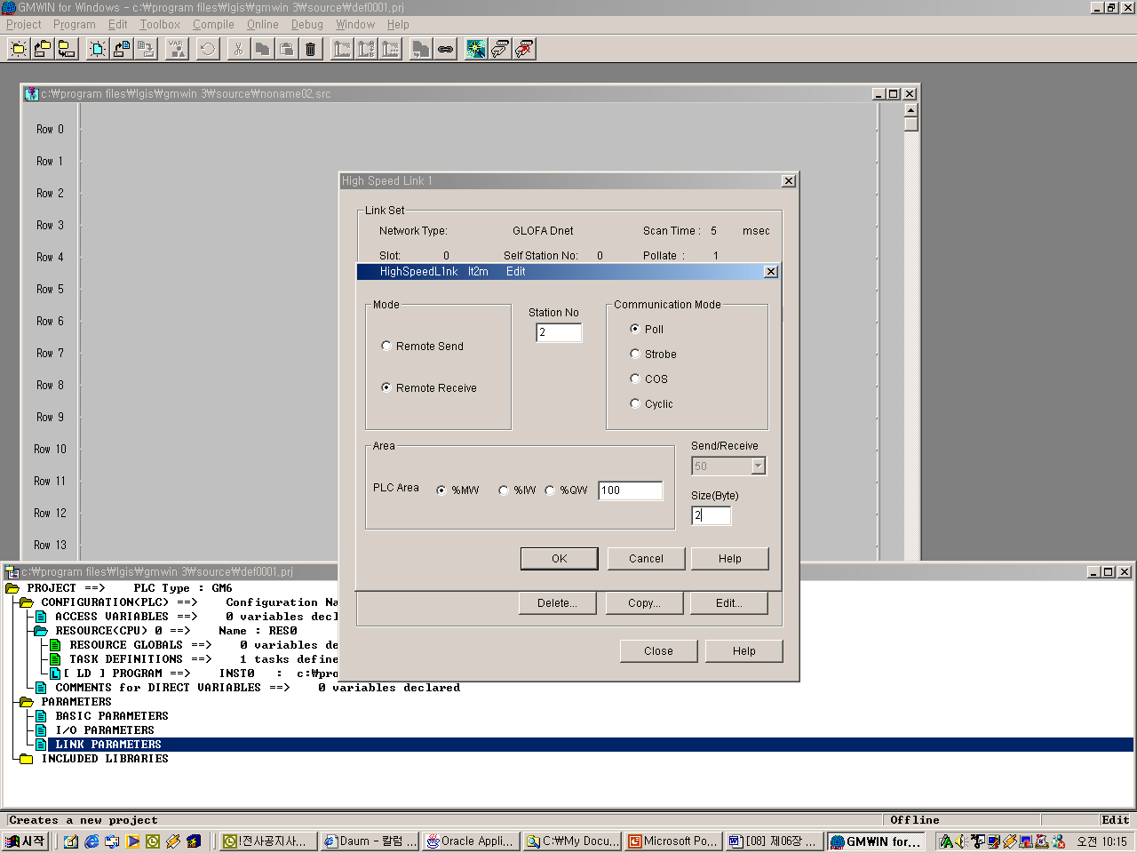

The following shows the setting to communicate with station 1,2 using Poll service.

High Speed Link parameter sending/receiving setting
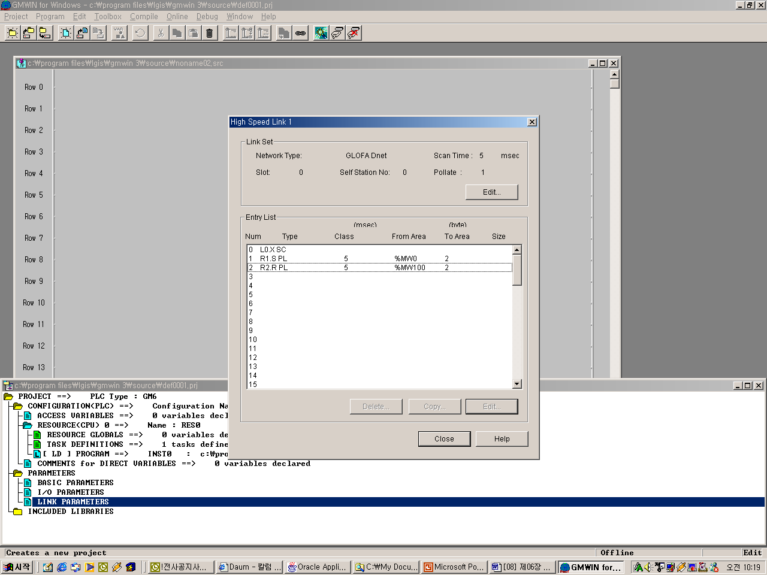

Remark
- When communicating with the single type I/F module of other maker, the setting method is the same as GLOFA-GM series and only data size shall be set as follows.
 DRT1-OD08 : 1 byte
 1794-OB16/IB16 : 4 bytes

- In case of connecting the other maker’s module (OMRON) that has the different communication speed from the master (G4/6L-DUEA) speed and the Smart I/O simultaneously, it occurs as follows.

G4L-DUEA OMRON(speed control by manual) Smart I/O
125kbps 125/250/500kbps normal action
250kbps 125kps not connected
250kbps 250/500kbps normal action
500kbps 125/250kbps not connected

3) When setting High Speed Link in the master (G4/6L-DUEA), in case of the combined module (GDL-DT4A), it is not available to connect if setting only with input. If setting only with output or the combined, the connection shall be done normally.

The meaning of Poll service setting

Scan type | Sending period | PLC area | Size | Description
R1.S PL | 5×1 =  5msec | %MW0 | 2 | Sends 2 byte data in %MW0 to the station 1 every 5msec by using Poll Request.
R2.R PL | - | %MW100 | 2 | Saves 2 byte received by station 1 using Poll Response in %MW100.
* Here the sending period is Scan time × Poll rate.

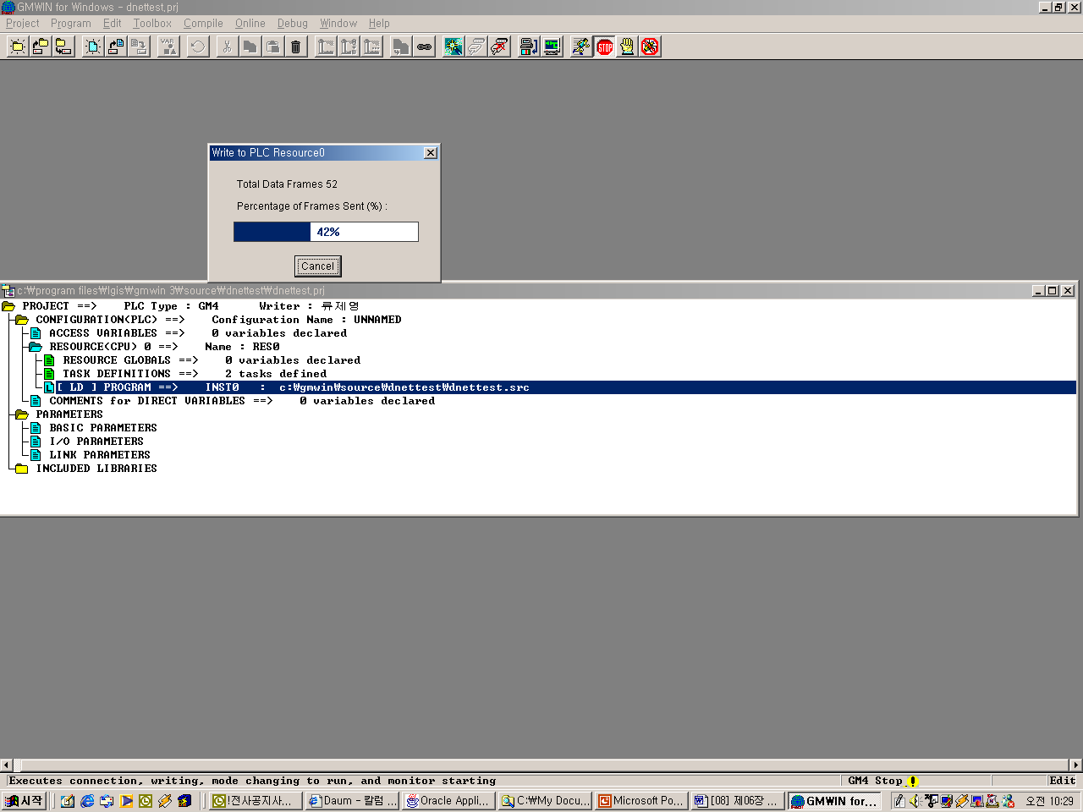
Program Write

As shown on the above, in order to communicate with Dnet master module and Smart I/O module, the user should check the slave information correctly and then set High Speed Link parameter. Thus, after setting High Speed Link parameter correctly, the user can download it through the online connection of GMWIN.

High Speed Link Enable link

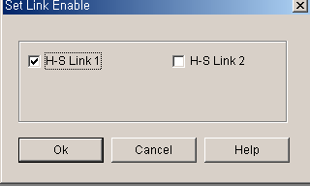

If program download is completed, Enable the ‘link enable’ setting in the online menu. If Enable is confirmed, change the CPU program mode with RUN. If the mode is changed with RUN, the data sharing begins immediately and the communication starts.

6.4 Program Examples

6.4.1 GLOFA-GM Series

Program Example 1: Communication between Dnet modules of LGIS and other maker

This is the program that the master communication module (station 0) is installed in GM6 base slot ‘0’ and sends/receives the data to the remote module (station 1~4) respectively. (please refer to I/O configuration map).

System configuration
Station 0 (0 slot)

OUT
OUT
OUT
OUT
OUT
PWR
CPU
Dnet
GM6 master

Termianl resistor
Trunk line
Drop line
Station 1
Terminal
resistor
Station 2
Station 3
Station 4

GDL-TR2A
GDL-D22A

DRT1-OD08
(OMRON)
1794-OB16
(Allen-Bradley)

I/O configuration map
Send/receive structure |  | Area to read | Storage area | Size (byte)
GM6  (Station 0)  (Master) | Sending: GDL-TR2A (station 1) | %MW0 | - | 2
GM6  (Station 0)  (Master) | Receiving: GDL-D22A (station 2) | - | %QW0.1.0 | 2
GM6  (Station 0)  (Master) | Sending: DRT1-OD08 (station 3) | %MW100 | - | 1
GM6  (Station 0)  (Master) | Sending: 1794-OB16 (station 4) | %MW200 | - | 4

1) High Speed Link parameter setting in GM6 (station 0)

Master module ‘link information’ setting

The sending parameter setting to Station 1(GDL-TR2A)
Station no. of remote I/F module to send the data.

When sending GDL-TR2A, data size is set as 2bytes. (basic value)

The receiving parameter setting from station 2(GDL-D22A)

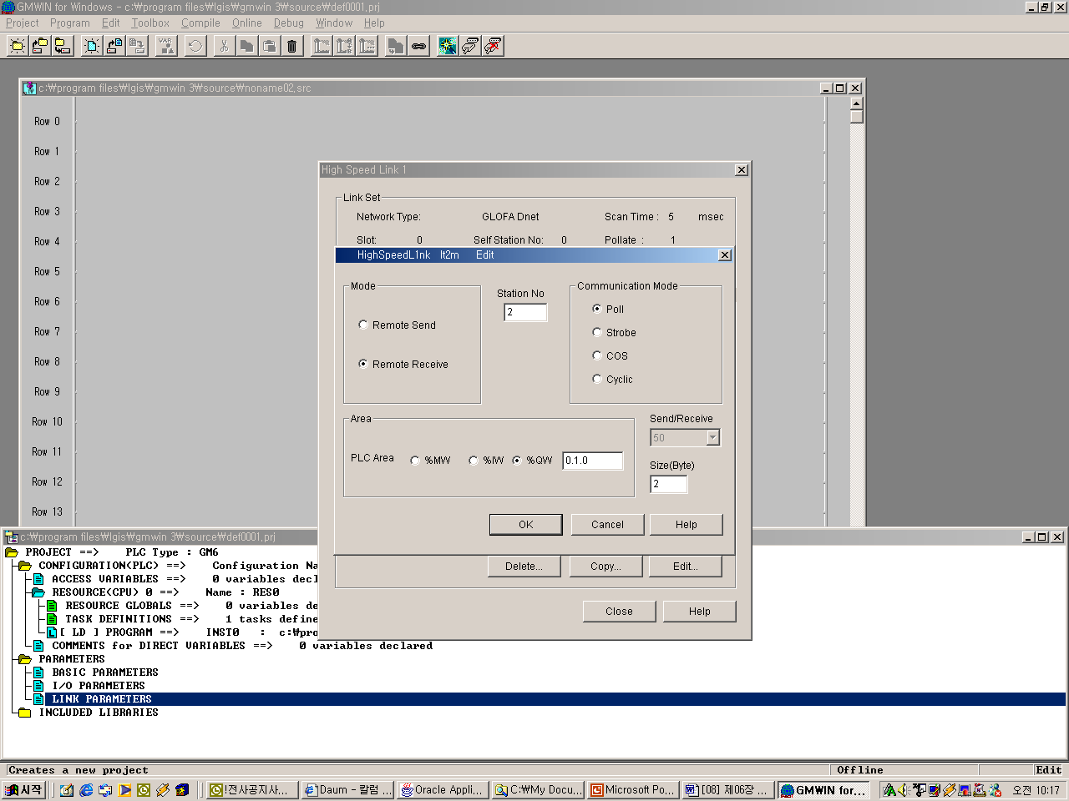
Station no. of GDL-D22A

The storage area of the data received from GDL-D22A.
When receiving from GDL-D22A, the data size is set as 2bytes.

The sending parameter setting to station 3(DRT1-OD08)
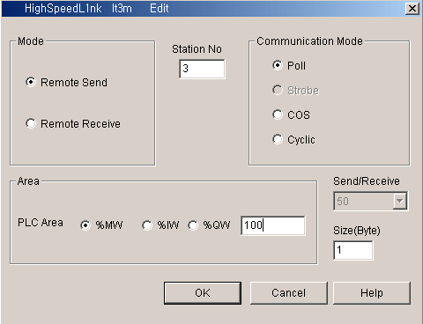

Sets the sending
data size (1byte) to
DRT1-OD08.
Station no. of
DRT1-OD08

The sending parameter setting to station 4(1794-OB16)
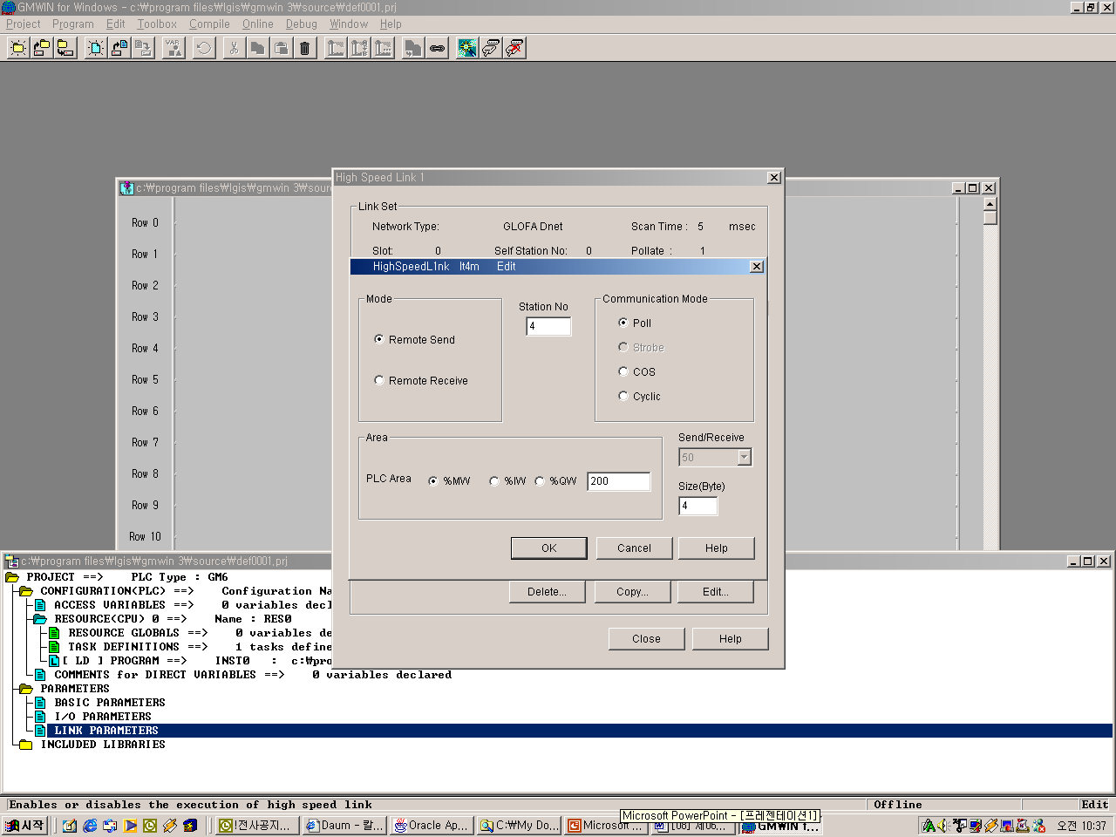

Sets the sending
data size to 1794-
OB16. (4bytes)

Master module ‘High Speed Link 1’ setting completion screen

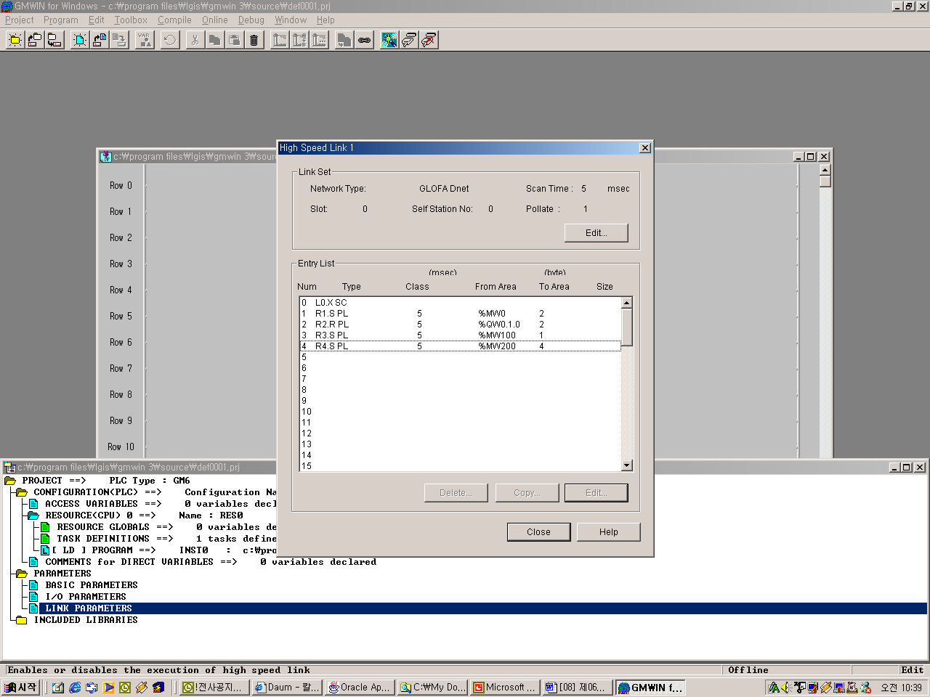

6.4.2 MASTER-K Series

Program Example - The communication between Dnet modules of LGIS

This is the program that the master communication module (station 0) is installed in K300S base slot 0 and sends/receives the data to the remote module (station 1~4) respectively. (please refer to I/O configuration map).

System Configuration
Station 0(slot 0)

OUT
OUT
OUT
OUT
OUT
PWR
CPU
Dnet
K300S master

Terminal
resistor
Trunk line
Drop line
Station 1
Terminal
resistor
Station 2
Station 3

GDL-TR2A
GDL-D22A
GDL-DT4A

I/O configuration map
Send/receive structure |  | Area to read | Storage area | Size (byte)
K300S  (Station 0)  (Master) | Sending: GDL-TR2A (station 1) | P007 | - | 2
K300S  (Station 0)  (Master) | Receiving: GDL-D22A (station 2) | - | P000 | 2
K300S  (Station 0)  (Master) | Sending/receiving: GDL-DT4A (station 3) | P007 |  | 2
K300S  (Station 0)  (Master) | Sending/receiving: GDL-DT4A (station 3) |  | P001 | 2

1) High Speed Link parameter setting in K300S (station 0)

To make Station 0,1,2 to change the data as specified on the table in the master configuration system, the user should write the user program first and then prepare the data sending/receiving map as shown on the table. And to send/receive the data as shown on the table, it is required to write High Speed Link parameter and download it in PLC and High Speed Link start shall be carried out according to the following order.

- Station number allocation and communication cable connection
- The user program writing (per station)
- Makes the data sending/receiving map
- Parameter setting in KGLWIN High Speed Link parameter setting item
- Program and parameter download execution in the online menu.
- Changing the mode to RUN in the online menu.
- High Speed Link status checking through flag monitor
- If the error occurs, repeat the above from 1).
High Speed Link parameter for the system of Example Program shall be set as follows.

KGLWIN parameter basic screen (in case of K300S)
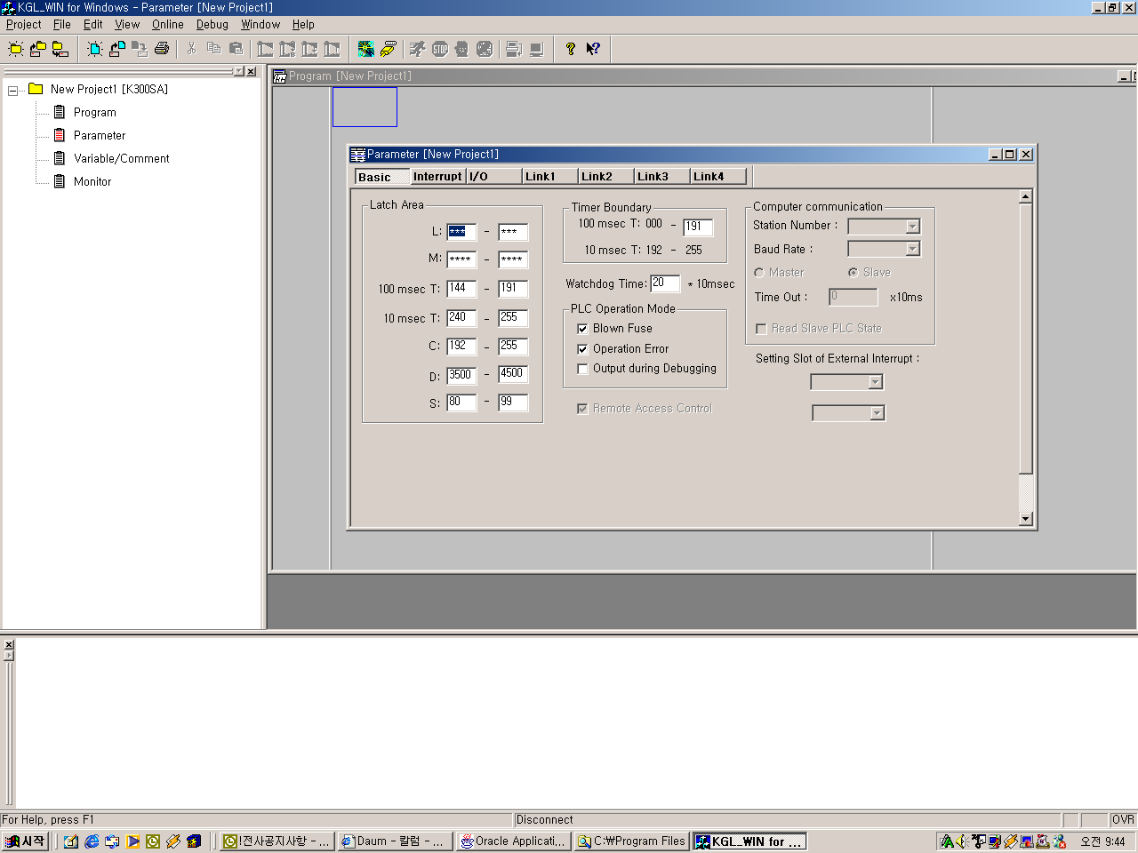

Master module ‘link information’ setting
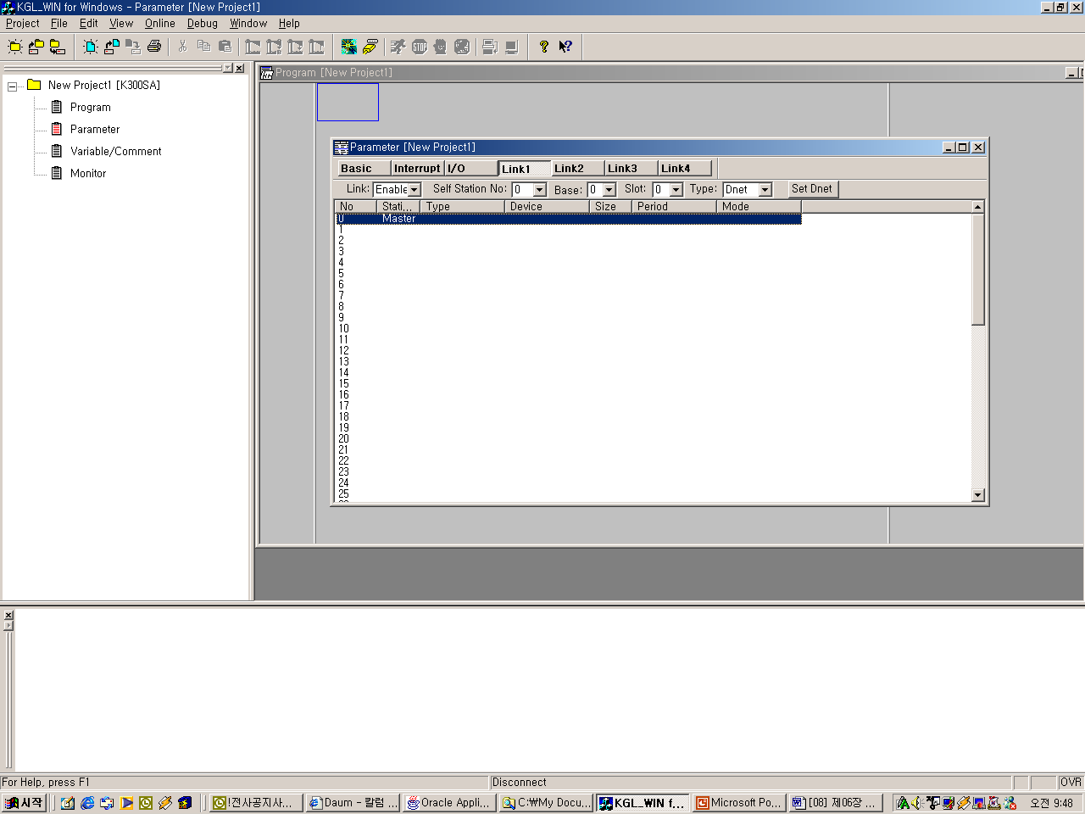

Station no.’0’ of G4L-DUEA, slot 0

The sending parameter setting to station 1(GDL-TR2A)

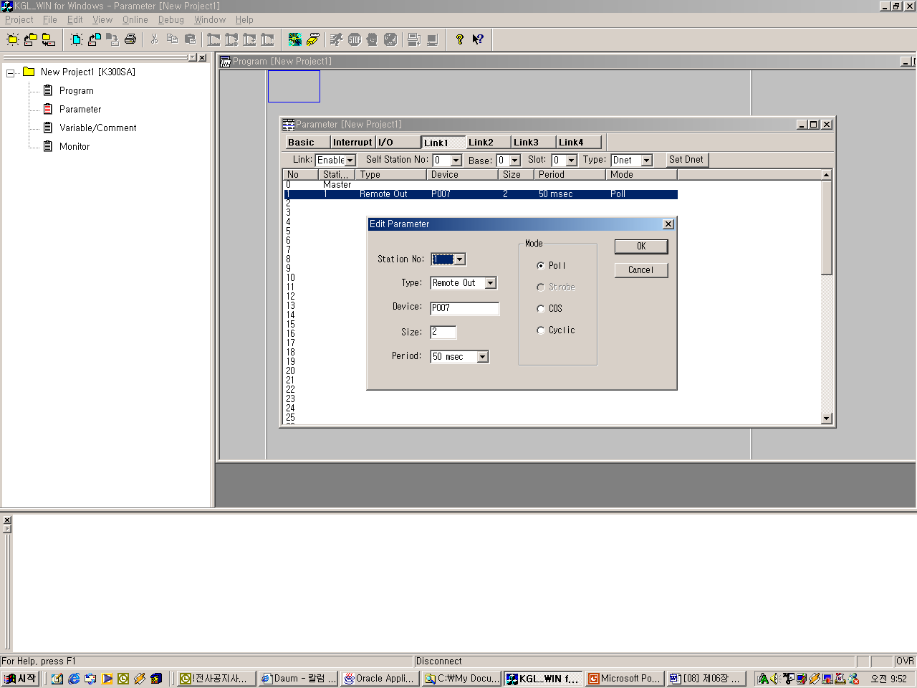

Size of station 1 GDL-TR2A, 2 bytes

The receiving parameter setting to station 2(GDL-D22A)
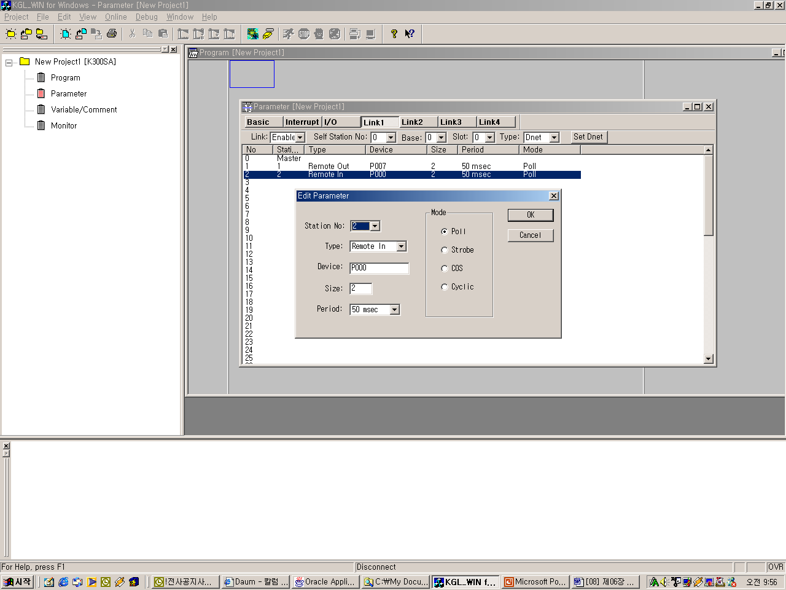

The sending parameter setting to station 3(GDL-DT4A)(combined module)
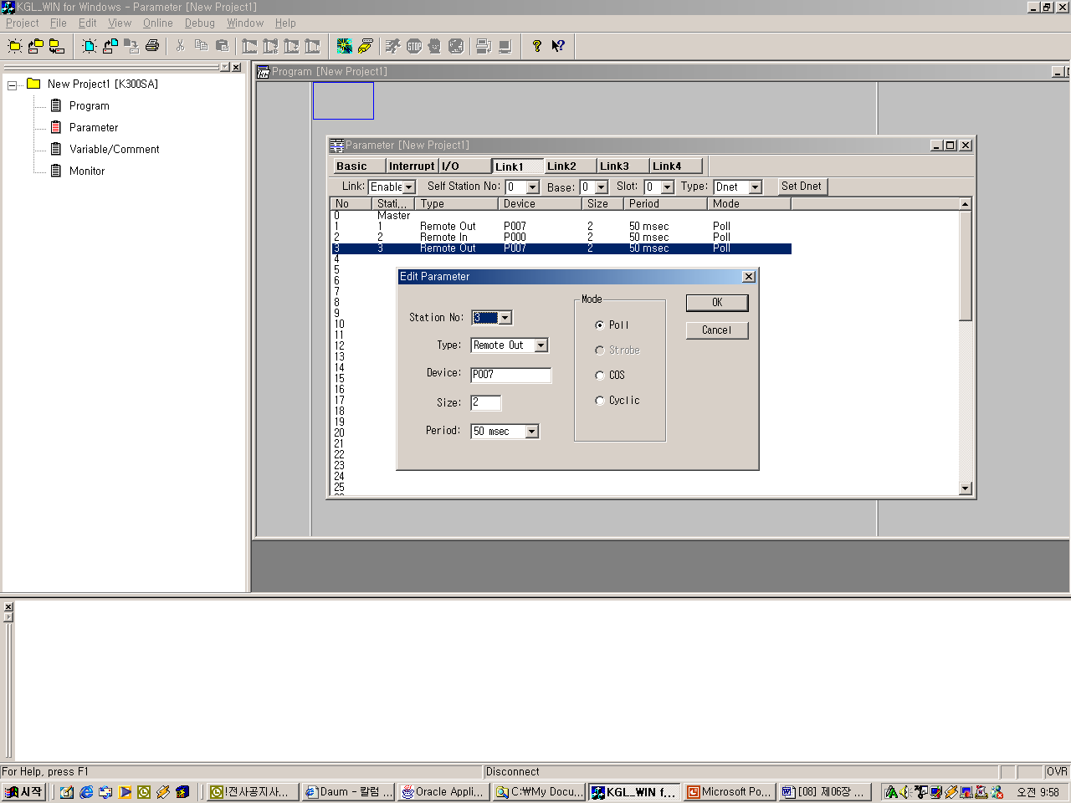

The receiving parameter setting to station 3(GDL-DT4A) (combined module)
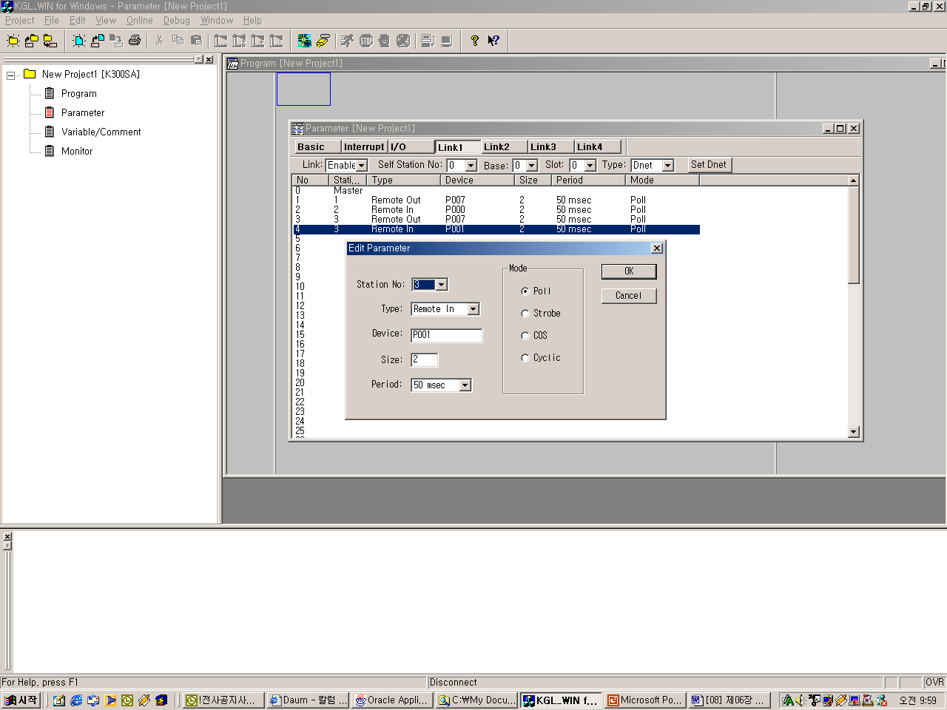

K300S High Speed Link parameter
