Chapter 7 Rnet Communication

7.1 Overview

The major characteristics of Rnet network are the cost saving of installation/maintenance, diversification of system configuration, easy maintenance and repair, easy system change.
This network supports the electrical network (twisted pair cable) that is cost effective and easy to install for the diversification of configuration.

Rnet module can be used in common for GLOFA series and MASTER-K series and applied diversely according to the system application.

In Rnet version V1.0, GLOFA Rnet and MASTER-K Rnet module can be in common.
Type | Rnet V1.0 | Remarks
Master  (RMM) | G3L-RUEA | GM3/K1000S Rnet (electric)
Master  (RMM) | G4L-RUEA | GM4/K300S Rnet (electric)
Master  (RMM) | G6L-RUEA | GM6/K200S Rnet (electric)
Master  (RMM) | G7L-RUEA | GM7/K80S Rnet (electric)

7.2 Communication Specification
Remote I/O module transmission specification (master standard)
Items |  | Specification
Transmission speed |  | 1Mbps(Rnet module common)
Encoding method |  | Manchester Biphase-L
Electric | Transmission distance  (per segment) | Max. 750m
Electric | Transmission distance  (when using the repeater) | Max. 750m * (6 repeaters + 1)  = 5.25km
Electric | Transmission wire | Twisted pair shield cable
Max. no of station number |  | Master + slave = 64 stations  (at least one master should be connected.)
Max. protocol size |  | 256 bytes
Access type of Communication |  | Circulated Token Passing
Communication method |  | Connection Oriented service  Connectionless service
Frame error check |  | CRC 16 = X¹⁵ + X¹⁴ + X¹³+ .... + X² + X + 1

7.3 Communication Parameter Setting

7.3.1 Overview

The method to program in RNET communication module is supposed to enable to communicate with Smart I/O module through High Speed Link service as mentioned on Chapter 4 ‘Communication Programming’.

High Speed Link

The High Speed Link service through Rnet communication module is available to use all the existing function and carry out the communication by simple parameter setting. The parameter shall be set in GMWIN for GLOFA series and in KGLWIN for MASTER-K and from RNET version V1.0, min. communication period can be set every scan.

1) Setting available range of Rnet communication module

max. High Speed Link point per communication model(Rnet master standard)
Classification |  | Max. communi- cation point | Max. sending point | Max. block no. | Max. point per block
RNET  Communication module | G3L-RUEA | 3,840 words | 1,920 words | 64 (0-63) | 60 words
RNET  Communication module | G4L-RUEA | 3,840 words | 1,920 words | 64 (0-63) | 60 words
RNET  Communication module | G6L-RUEA | 3,840 words | 1,920 words | 64 (0-63) | 60 words
RNET  Communication module | G7L-RUEA | 3,840 words | 1,920 words | 64 (0-63) | 60 words

Communication setting when communicating with Smart I/O module
HS link block setting |  | Sending/ Receiving period | Address area |  | HS link information
Sending | Receiving | Sending/ Receiving period | GLOFA-GM | MASTER-K | HS link information
32 | 32 | 20ms ~ 10s | %QW, %IW | P area | Ref.7.3.2

Remark
- In case of Smart I/O, if 32 points are installed for one module, max. link point is available to use up to 2,016 words for 63 stations.
- For further information, please refer to ‘Chapter 4. Communication Programming’.

7.3.2 High Speed Link Communication Status Flag

1) High Speed Link information function
It is available to confirm the reliability of data sent/received to/from other station (remote station) through High Speed Link and the user can utilize the above information by combining with High Speed Link sending/receiving data as keyword type when writing the program in case of emergency or maintenance.

High Speed Link Information
Classification | Run-link | Link-trouble  LINK_  TROUBLE | Sending/ receiving status  TRX_MODE | Action mode  DEV_MODE | Error  DEV_ERROR | High Speed Link status  HS_STATE
Information type | Overall information | Overall information | Individual information | Individual information | Individual information | Individual information
Keyword name  (□=HS link no.  1,2,3,4) | _HS□RLINK | _HS□LTRBL | _HS□TRX[n]  (n=individual parameter no.0~63) | _HS□MOD[n]  (n=individual parameter no.  0~63) | _HS□ERR[n]  (n=individual parameter no. 0~63) | _HS□STATE[n]  (n=individual parameter no.  0~63)
Data type | BIT | BIT | BIT-ARRAY | BIT-ARRAY | BIT-ARRAY | BIT-ARRAY
Monitoring | Available | Available | Available | Available | Available | Available
Program | Available | Available | Available | Available | Available | Available

7.3.3 GMWIN High Speed Link Setting

1) GMWIN project and Link parameter

If you select the High Speed Link parameter from GMWIN project basic screen, the High Speed Link parameter basic screen will appear and you can select the corresponding item.

High Speed Link parameter basic screen
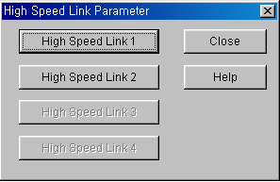
If selecting ‘parameter’-‘High Speed Link parameter’ from project screen, the above menu will appear.

High Speed Link parameter basic screen through GM7 master
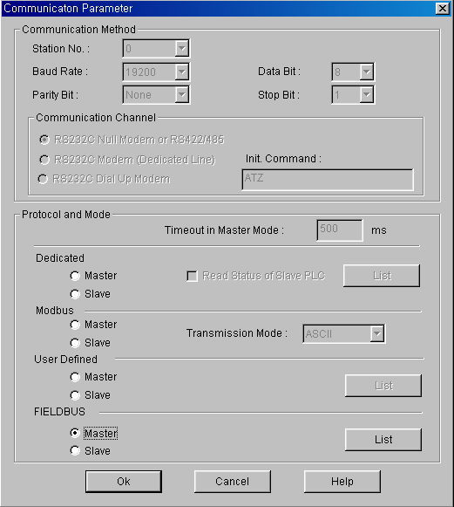

In case of GM7 RNET, select [parameter]-[High Speed Link parameter] from project screen.

2) Setting function
The High Speed Link items 1~4 means max. installation number of communication module according to PLC CPU type. It is available to install max. 4 communication module for GLOFA GM1/GM2/GM3 CPU/GM4-CPUB, max. 2 for GLOFA GM4-CPUA/GM6 and max. 1 for GM7.

Communication module installation relation per CPU model
Classification | Available communication module | Max. installation number  (note 1)
GLOFA-GM3 | G3L-RUEA | 4 EA
GLOFA-GM4-CPUA | G4L-RUEA | 2 EA
GLOFA-GM4-CPUB | G4L-RUEA | 4 EA
GLOFA-GM6 | G6L-RUEA | 2 EA
GLOFA-GM7 | G7L-RUEA | 1 EA

3) Link parameter setting
If you select the corresponding parameter from parameter setting basic screen, the High Speed Link parameter setting first screen will appear as shown in the following figure. If setting the parameter at first, the initial value will be indicated as shown on the figure below.

Parameter setting screen

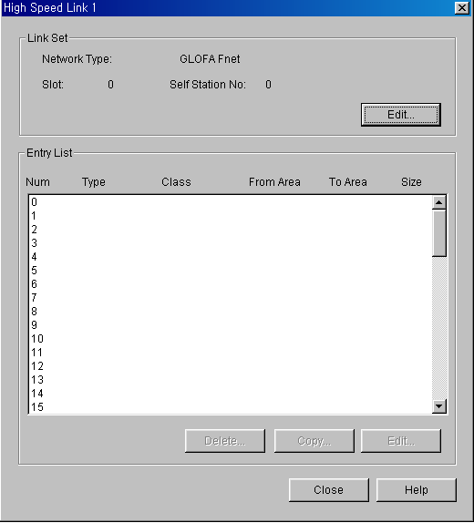

Parameter setting initial screen is composed of two items such as ‘link setting’ and ‘Entry list’ and the setting method per each item and its function is as follows.

(1) Link setting
Link setting is the item to set the basic items of communication module to perform the High Speed Link.

High Speed Link set screen

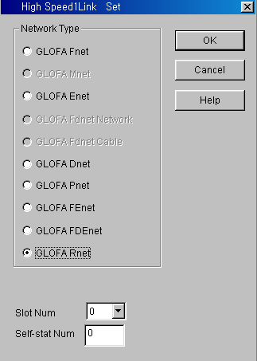

Network type : It sets the installed communication module type and Rnet shall be set.
Slot no. : It sets the position that the communication module to set is installed. (0 ~ 7 slot).
Station no. : Enters the setting self station no. into the station address switch of communication module front side. The self station no. of Rnet shall be set as ‘0’ to use.

(2) G7L-RUEA link setting

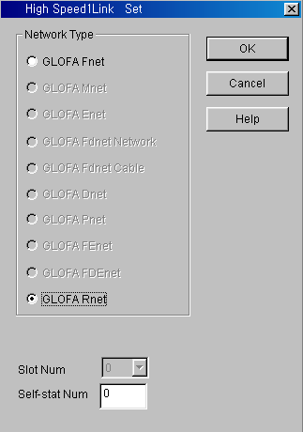

Network type : It sets GLOFA Rnet.
Slot no. : Not-active
Self station no. : The self station no. shall be set as ‘0’ and used.

(3) Entry list setting
Entry list is the area to register the actual data sending/receiving information. For further information, please refer to Chapter 4. ‘Communication Programming’.

Remark
GRL-DT4A among Smart I/O module has ‘input’ and ‘output’. Thus, in case of using the Entry list, please be sure that two lists are required for one module. In this case, when sending/receiving, the station no. shall be set same but the block no. differently.

4) High Speed Link operation

After setting the High Speed Link parameter and executing ‘make’ from GMWIN compile menu, if you select ‘parameter write’ and start the High Speed Link service, the High Speed Link service by the parameter setting begins to run. The High Speed Link start order is as follows.

- Parameter write

Parameter download screen
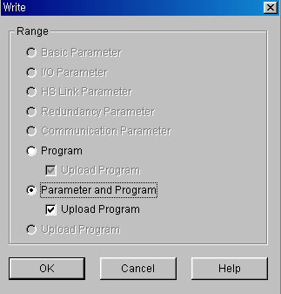

After saving the High Speed Link parameter written by the user in the GMWIN project file and connecting with PLC through ‘online connect’ from GMWIN basic menu, select ‘write’ and download the High Speed Link parameter or ‘parameter and program’.

(2) High Speed Link start

Link Enable setting
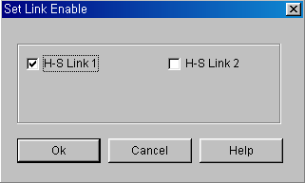

(3) G7L-RUEA High Speed Link start

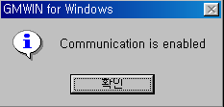

After parameter write, High Speed Link is executed after setting the ‘Link enable’. Link enable setting is available only in the stop mode of PLC. And if the High Speed Link enable setting starts, it carries out the High Speed Link regardless of PLC action mode and ‘parameter’ and ‘Link enable information’ shall be battery backup in the PLC CPU and preserved if the power is cut off.

(4) High Speed Link information monitor

It is available to monitor the current High Speed Link status by using ‘monitor’ function after the GMWIN online connection. There are two kinds of methods to monitor : by selecting ‘variable monitor’ from monitor menu and by high speed parameter monitor.

● Variable monitor
‘Variable monitor’ is the function to monitor the necessary items by using the GMWIN flag monitor function and the order to monitor is as follows.

① Select Variable monitor from online monitor items.
② Select ⊙flag from ‘register variable ‘ screen as shown on the figure.
③ Select the High Speed Link information flag you want to monitor directly one by one from Variable, Flag list screen and register. (As _HSxSTATE[n], _HSxERR[n], _HSxMOD[n],_HSxTRX[n] is ARRAY flag, the user enters the registration no. of parameter that he wants to monitor directly).

Remark
‘x’ shows the High Speed Link no. and it has the range1~4 for GM1/GM2/GM3/GM4-CPUB PLC, 1~2 for GM4-CPUA,GM6 PLC and only 1 is effective for GM7. [n] is the individual parameter no.(0~63).

If you register the variable from the menu and select ‘close’, the corresponding monitor screen will appear and the monitoring begins.

High Speed Link information variable register screen
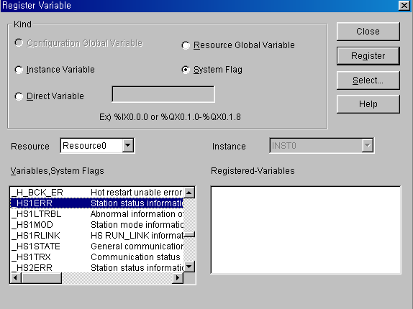

High Speed Link information monitor screen (variable registration)

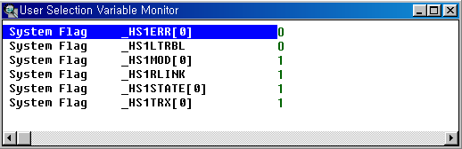
The detailed contents for the corresponding flag is described in ‘Communication module flag application’ and it is available to carry out the RNET network status diagnosis by the corresponding flag monitor properly.

● High speed parameter monitor

This is the function to monitor the High Speed Link communication status from the menu as below. Select ‘link parameter’ item from monitor menu of GMWIN online connection.

Link parameter selection screen
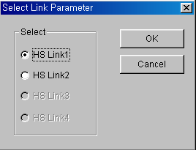

Link parameter monitor shows the general information for RUN-LINK, LINK-TROUBLE on the top screen as below and the individual information such as mode (action mode), communication (sending/receiving status), error on the setting parameter items.

High Speed Link parameter monitor screen (Example)

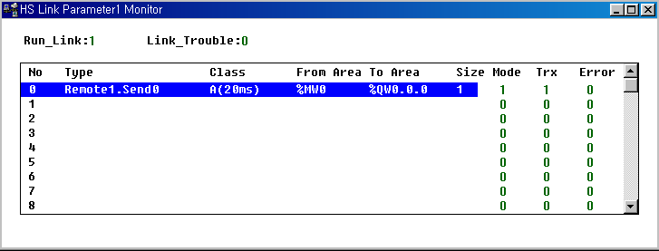
For the meaning of the value monitored on the above figure, please refer to ‘Chapter 4. Communication Programming’.

Remark
- RUN-LINK monitoring
In case that GRL-TR4A among Smart I/O is set in the parameter, RUN-LINK shall be indicated as ‘0’.

7.3.4 KGLWIN Link Setting

1) KGLWIN project and Link parameter
High Speed Link parameter selects link parameter from KGLWIN project screen and sets the corresponding item. The setting order and the function per item are as follows.

(1) KGLWIN project setting
The following shows parameter basic screen appeared when selecting ‘parameter’ window.

KGLWIN parameter basic screen (in case of K200S)

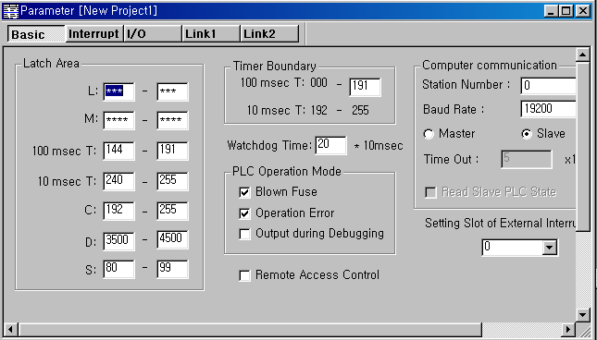

(2) Link parameter basic setting
If you select ‘Link 1’ from KGLWIN parameter basic screen, the High Speed Link 1 parameter basic screen as shown below will appear.

Link parameter basic screen
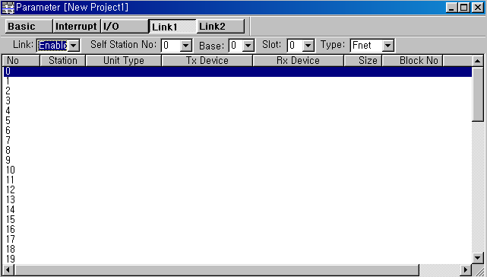

(3) K80S project and Link parameter basic setting
This is parameter basic screen to be appeared when selecting K80S parameter window.

KGLWIN parameter basic screen (in case of K80S)
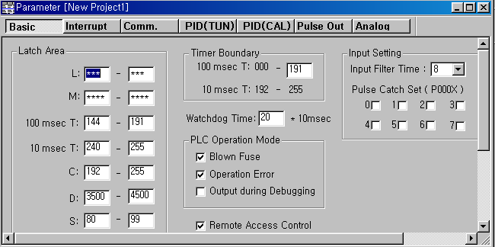

If selecting ‘communication’ from KGLWIN parameter basic screen as shown on the above figure, the communication parameter setting screen will appear as below and if you select ‘master’ from the FIELDBUS menu on the right bottom side and press ‘register list’, the High Speed Link parameter basic screen will appear.

Communication parameter setting screen

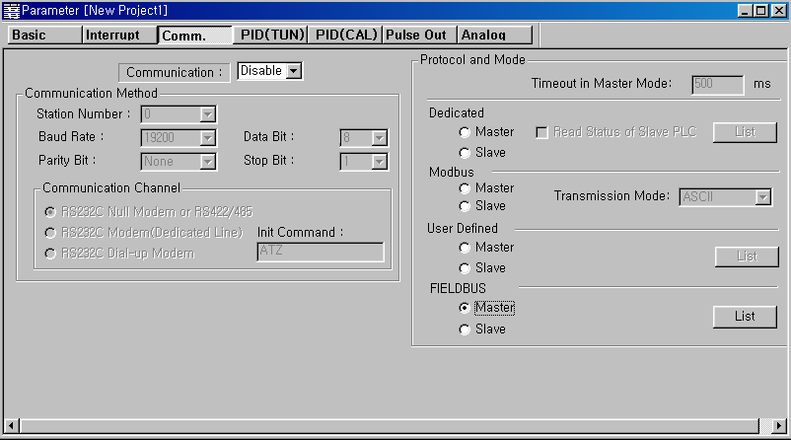

Link parameter basic screen
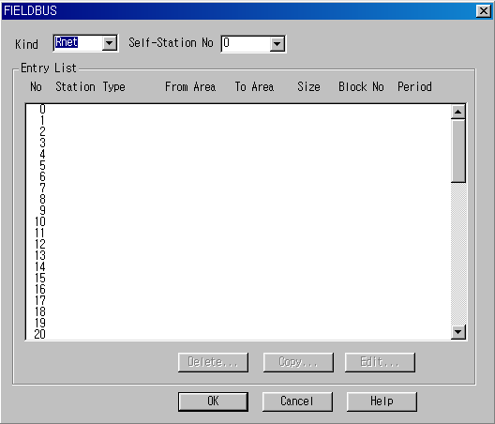

◎ Link1 : This is one of High Speed Link type and max.4 communication modules can be installed for K1000S CPU, max. 2 for K300S/K200S and max.1 for K80S. The High Speed Link no. is not related to the installed slot no. and only one High Speed Link parameter is available to set for one communication module. The table below shows the installation available communication module per CPU model and max. installation amount.

Relation of communication module installation per CPU model
Classification | Communication module | Max. installation amount | Remarks
K1000S | G3L-RUEA | 4 EA | Each communication  module can be installed by combining each other.
K300S (below v2.2) | G4L-RUEA | 2 EA
K300S (more than v2.2) | G4L-RUEA | 4 EA
K200S | G6L-RUEA | 2 EA
K80S | G7L-RUEA | 1 EA

◎ Link : It sets whether or not to execute the link of communication module. (Enable, Prohibit)
◎ Self station no. : Self station no. should be set as ‘0’ and used.
◎ Slot : This is the communication module installed slot no. and it is set by selecting one from ‘0’~‘7’.
◎ Registration no. : This is the serial no. to indicate the registered order of the

individual parameter and it is set by ‘0’ ~‘63’. It is available to register up to total 63 and not related to the sending/ receiving order. But it is available to register max. 32 for sending and 32 for receiving respectively.

(4) Link parameter detail setting

If you doubleclick in the status that the High Speed Link registration no.1 is selected, the link parameter setting screen will appear as shown on the figure below.

Link parameter modification screen (in case of the HS link registration no.0)

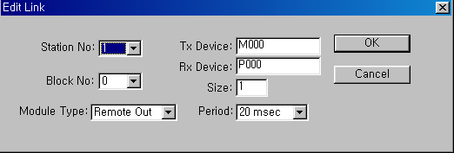

◎ Station no. : If sending/receiving the data of the setting item, it is required to set other station no. The following table shows the method to set the station no.

Station no. setting method
Communication type | Station no. | Range of station no.
Remote sending | Station no. of other station (remote) | 1~63
Remote receiving | Station no. of other station (remote) | 1~63

◎ Block No. : This is the parameter to send/receive lots of data of various areas from one station and distinguish the data of various blocks each other. If setting 32 stations for Smart I/O output module, the input should be set as 31 stations and if setting 32 stations for input. The output should be set as 31 stations because this supports up to 64 stations including master station. In this case, if setting more than 2 same block no. for the same station no., the network will be down. Thus it is not available to set more than 2 block for the same station. The max. number of connection station is 64 stations including the master station but if the sending/receiving is set for the one station at the same time, it is not available to set max. station setting.

◎ Communication type : It is set by remote sending and remote receiving.
Remote sending : when sending the data of self station to remote station.
Remote receiving : when receiving the data of remote station to self station.

◎ Sending/Receiving device : This means the area of sending/receiving. In case of remote sending that means the sending to remote station, set the sending area of self station for the sending device and the receiving area (P area) of remote station for the receiving device. As the remote receiving means the receiving from remote station, set the sending area (P area) of remote station for the sending device and the receiving area of self station for the receiving device.

Sending/Receiving device setting area per communication type
Communication type | Device | Setting available area | Remarks
Remote sending | Sending | P,M,L,K,F,D,T,C all area | Sending area of self station
Remote sending | Receiving | P area | Receiving area of remote station
Remote receiving | Sending | P area | Sending area of remote station
Remote receiving | Receiving | P,M,L,K,D,T,C area | Receiving area of self station

◎ Size : This means the size of sending/receiving data and the unit is 1 word (16 points). It is available to set max. 60words but for Rnet, it is set as 2 words at the present time because max. points of the current Smart I/O is 2words (32 points).

◎ Communication period : High Speed Link is the service to carry out the sending/receiving by the parameter set by the user at the point that PLC program ends. Thus, when PLC program scan time is short within several ms, communication module begins to transmit the data according to every program scan which results in increasing the communication amount and reducing the effectiveness of overall communication system. Thus, to prevent this, the user can set the sending/receiving period from min.20ms (RNET version V1.0 : from every scan) to max. 10sec. The sending/receiving period means the sending period if the corresponding block is set as ‘sending’ and the period to check the data receiving of the corresponding block if it is set as ‘receiving’.

(5) High Speed Link operation
After completing the High Speed Link parameter setting, if you click the ‘verify’ button from download menu and execute the parameter download, the High Speed Link service begins. In this case, the corresponding link of the link parameter basic screen should be Enable status.

Parameter download screen
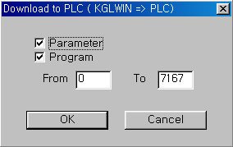

2) High Speed Link information monitor

After KGLWIN online connection, it is available to monitor High Speed Link information by using monitoring window and ‘information read’ window. There are two kinds of method to monitor : one is by selecting the flag to monitor from flag monitor menu of monitoring window to monitor the individual information and overall information and another one is by selecting the High Speed Link parameter from online-information read menu to monitor overall information.

● Flag monitor
Flag monitor is the function to monitor by selecting the necessary flag from KGLWIN [project]→[monitoring] using the flag monitor menu. First, if you select flag monitor button from monitoring window, the flag monitor screen as shown on the figure below will appear and if you press the registration button (), the flag registration screen will appear. Select the High Speed Link information flag to monitor from the flag registration screen one by one and register it. If flag registration is completed, it begins to monitor in ‘monitor’ screen. If the monitoring does not work, please check the monitor start mode once again.

Flag monitor screen and Flag registration screen
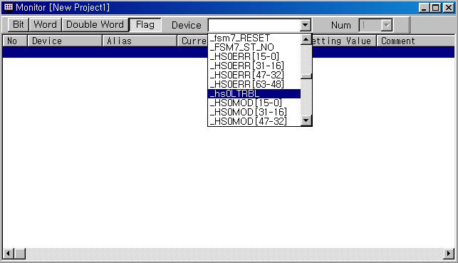

Flag monitor screen (the flag is registered.)
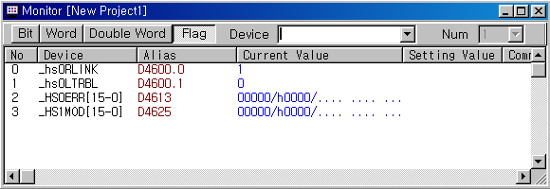

● Reading information in High Speed Link parameter monitor
If you select the High Speed Link parameter from the menu ‘online-information read’, you can see the detailed information for the High Speed Link parameter as shown on the above figure.

High Speed Link parameter monitor
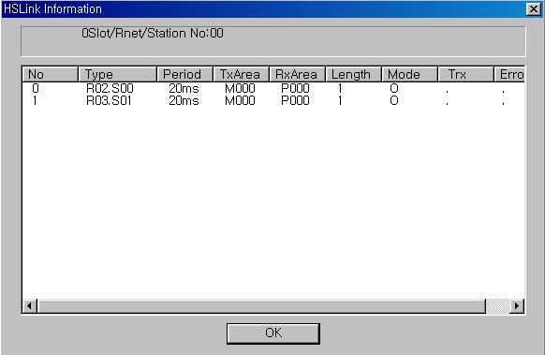

R02.R03 from the type item means Remote station (Smart I/0) 2 and 3 and SOO,S01 means the block no., and this is the parameter to transmit the data of self station (M000) to Remote (Smart I/O) station 2 (P000) through block no.’0’. R03 is also the parameter to transmit the data of self station (M000) to Remote (Smart I/O) station 3 (P000) through block no.1.

● Link information monitor from information Read

If you select the menu ‘online’-‘information read’-‘link information’, it is available to monitor the link status of the communication module installed per slot easily.

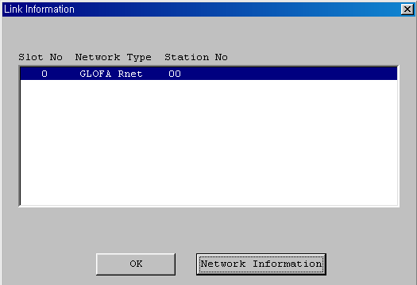

If you select the module to monitor and click the verify button, you can see the connection status of all RNET network connected to the corresponding module. (except K80S)
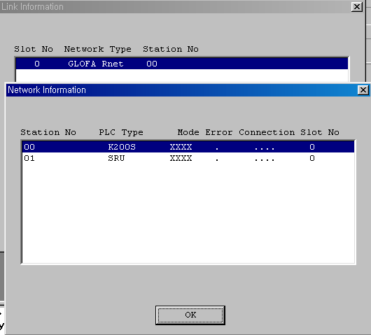

3) Flag

L area list when using the data link module (in case that installed in Slot no.0)
x : slot no., n : station no. of other station
Keyword | Address no. |  | Description
_NETx_LIV[n] | L0001~L003F | L0001 ~ L000F (1~15 stations) | This is the flag to inform that the power of other station is normal and the data is sending/receiving normally with other station through communication cable as the Alive information of other station. (Reading only)
_NETx_LIV[n] | L0001~L003F | L0010 ~ L001F (16~31 stations)
_NETx_LIV[n] | L0001~L003F | L0020 ~ L002F (32~47 stations)
_NETx_LIV[n] | L0001~L003F | L0030 ~ L003F (48~63 stations)
_NETx_LIV[n] | L0001~L003F | L0050 ~ L005F (16~31 stations)
_NETx_LIV[n] | L0001~L003F | L0060 ~ L006F (32~47 stations)
_NETx_LIV[n] | L0001~L003F | L0070 ~ L007F (48~63 stations)

High Speed Link detail flag x : K1000S=9, K300S/K200S=4 m : HS link no.
Keyword | Type | Bit position | Items | Description
_HSmRLINK | Bit | Dx600.0 | High Speed Link RUN_LINK information | This indicates that all station are acting normally according to the parameter set in the high speed line and will be ‘ON’ under the following conditions.  1. When all station set in the parameter is RUN mode and there is no error,  2. When all data block set in the parameter is communicating normally,  3. When the parameter set in the parameter of each station itself is communicating normally,  Once ‘ON’, RUN-LINK maintains the ‘ON’ unless stopped by Disable.
_HSmLTRBL | Bit | Dx600.1 | Abnormal information of High Speed Link (LINK_TROUBLE) | In the status that _HSmRLINK is ON, if the communication status of the station set in the parameter and the data block is as follows, this flag shall be ON.  1. When the station set in the parameter is not RUN mode,  2. When there is an error in the station set in the parameter,  3. When the communication status of data block set in the parameter is not smooth,  LINK-TROUBLE shall be ON if the above 1,2,3 condition occurs, and if the condition returned to the normal condition, it shall be OFF.
_HSmSTATE[k]  (k=0~63) | Bit  Array | Dx601.0  ~  Dx604.15 | General communication status information of k data block set in the High Speed Link parameter | This indicates the general status of communication information for each data block of the setting parameter.  _HSmSTATE[k] = _HSmMOD[k] & _HSmTRX[k] & _HSmERR[k]

Keyword | Type | Bit position | Items | Description
_HSmMOD[k]  (k=0~63) | Bit  Array | Dx605.0 ~  Dx608.15 | Mode information  (RUN = 1, others = 0) | Indicates the action mode of the station set in k data block of parameter.
_HSmTRX[k]  (k=0~63) | Bit  Array | Dx609.0 ~  Dx612.15 | Status information  (normal=1, abnormal=0) | Indicates whether the communication status of k data block of the parameter is communicating smoothly as set in the parameter.
_HSmERR[k]  (k=0~63) | Bit  Array | Dx613.0 ~  Dx616.15 | The status information of the station set in k data block from the High Speed Link parameter.  (normal=1, abnormal=0) | Indicates if the error occurs in the station set in k data block of the parameter.
_HSmERR[k] | Bit  Array | Dx613.0 ~  Dx616.15  (k=0~63) | 고속링크 파라미터에서 k 데이터 블록에 설정된 국의 상태정보(정상 = 1,비 정상=0) | 파라미터의 k 데이터 블록에 설정된 국에 에러가 발생했는지를 표시

High Speed Link detail flag when m=1~3
HS link type | D area address no. | Remarks
High Speed Link2 (m=1) | Dx620 ~ Dx633 | Comparing with m=0, D area address no. is as follows when m=3.  Calculation formula : when m=1~3, D area address no. address no. + 20 × m
High Speed Link3 (m=2) | Dx640 ~ Dx653
High Speed Link4 (m=3) | Dx660 ~ Dx673

7.4 Program Example

7.4.1 GLOFA-GM Series

Program Example 1 :

In GM3 base, the communication module (G3L-RUEA) is installed for slot 0, output 32 points for slot 1, and input 32 points for slot 2, respectively. This is the example to send GM3 %IW0.2.0 data to station 1 and output the data of station 2 to GM3 %QW0.1.0.
Station GM3 #0 Station GRL-TR2A #1 Station GRL-D22A #2
Output 16 point
Input 32 point

To perform the program example, first make the I/O configuration table as shown on the table below and write the High Speed Link parameter in the corresponding CPU module, respectively.

I/O configuration and Sending/receiving flow
Sending/receiving structure | Area to read | Storage area | Block no. | Size
Sending from GM3→station 1 | %IW0.2.0 | %QW0.0.0 | 0 | 1
Receiving from GM3←station 2 | %IW0.0.0 | %QW0.1.0 | 1 | 1

Working order
- Station number allocation and communication cable connection
- The user program writing (per each station)
- Make the data sending/receiving map same type of the above table
- Parameter setting in GMWIN High Speed Link parameter setting item
- Execute ‘compile’ and ‘make’ from compile menu
- Execute program and parameter write from online menu.
- Select ‘Link Enable set’ from online menu and set the High Speed Link Enable that corresponds to the setting no.
- Change the mode to RUN from online menu.
- Start ‘monitor’ from online menu and check if RUN-LINK is ON without error in the High Speed Link monitor.
- If the error occurs, repeat the above from 1).

Sending parameter setting from GM3 station 0 to station 1

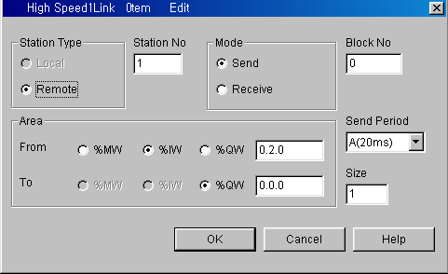

Receiving parameter setting by GM3 station 0 from station 2

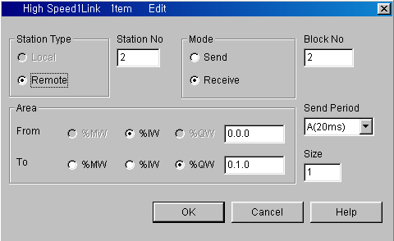

Remark
1) Do not register the same station no. more than 2 or the same block no. more than 2.

7.4.2 MASTER-K Series

Program Example 1

Here describes the High Speed Link parameter setting method to perform the data communication in RNET master system below with the I/O structure same as shown on the table below.
Master station 0 Remote station 1 Remote station 2
Network A (Rnet)
GRL-TR2A GRL-D24A

I/O configuration and Sending/receiving flow
Sending/receiving structure |  | Sending area | Receiving area
K200S  (station 0) | Sending :--> GRL-TR2A(station 1) | P0003 | -
K200S  (station 0) | Sending :--> GRL-TR2A(station 1) | - | P000
K200S  (station 0) | Receiving :<-- GRL-D24A(station 2) | P0000 | -
K200S  (station 0) | Receiving :<-- GRL-D24A(station 2) | - | P0004

From the example, K200S CPU sends the input value of input module (P3) installed in self station slot 2 by 1 word and outputs the data received from other station to P4 output module. The High Speed Link parameter configuration and program for data exchange on the above is described in the figure below. The program can be used in common and sets only link parameter respectively. (it is available to use the same program and parameter in the K1000S/K300S RNET communication.)

1) The user program writing
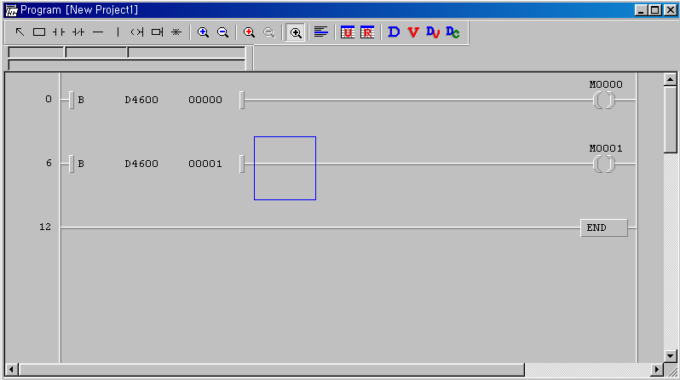

The above figure is the program to set M0000 area when RUN-LINK is ON and M0001 area when LINK-TROUBLE flag is ON.

(B) High Speed Link parameter setting
To make Station 0,1,2 to change the data as specified on the table in the master configuration system, the user should write the user program first and then prepare the data sending/receiving map as shown on the table. And to send/receive the data as shown on the table, it is required to write the High Speed Link parameter and download it in PLC and the High Speed Link start shall be carried out according to the following order.

- Station number allocation and communication cable connection
- The user program writing (per each station)
- Make the data sending/receiving map
- Parameter setting in KGLWIN High Speed Link parameter setting item
- Execute program and parameter download from the online menu
- Change the mode to RUN from the online menu.
- Check the High Speed Link status through flag monitor
- If the error occurs, repeat the above from 1).

The High Speed Link parameter for the system of program example is set as follows.

K200S (station 0) High Speed Link parameter
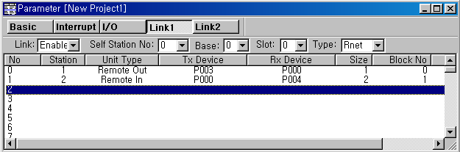

(C) High Speed Link speed fixing method.
The system of Example 1) is a simple system that the communication module of station 3 sends/receives the data of 1word per each station. And the calculation method for communication speed is as follows.

Formula St = P_scanA + C_scan
St = High Speed Link max. transmission time
P_scanA = PLC A max. program scan time
C_scan = max. communication scan time

As P_scanA is PLC scan time on the above, if assuming that it is 3ms each for the above program, (available to verify through online-information read-PLC information)

C_scan = n1 x 180us + n2 x 828us + 1,000us --------------------[formula 7-1]

n1 : output station number
n2 : input station number
C_scan = 1 x 180 + 1 x 828 + 1,000 = 2,008us
St = P_scanA(=3ms) + Cscan(2ms) = 5ms

Therefore, the sending/receiving period should be set as min. more than 5ms.

