Chapter 8 Modbus Communication

8.1 Overview

Smart I/O module communication supports modbus through GM3/4/6/7 master module.
(G3L-CUEA/G4L-CUEA/G6L-CUEC/G7L-CUEC)
This supports ASCII mode that communicates using ASCII (American Standard Code for Information Interchange) data and RTU (Remote Terminal Unit) mode that uses HEX data and the function code used in the modbus is supported by the Function Block and only function code 01, 02, 03, 04, 05, 06, 15, 16 are supported.
For further information for the protocol, please refer to ‘Modicon Modbus Protocol Reference Guide’. (http://www.modicon.com/techpubs/toc7.html)

8.2 Communication Specification

- ASCII Mode
- This communicates using ASCII data.
- Each frame uses ‘:(Colon) : H3A)’ for the header, CRLF(Carriage Return-Line Feed) : HOD HOA) for the tale.
- Max. 1second interval between Characters is allowed.
- It uses LRC to check the error.
- Frame structure (ASCII data)

Classification | Header | Station no. | Function code | Data | LRC | Tale (CR LF)
Size | 1 byte | 2 byte | 2 byte | n byte | 2 byte | 2 byte

- RTU Mode
- It uses HEX data to communicate.
- There is no header and tale and it starts from station no.(Address) and ends the frame with CRC.
- It has min. 3.5 Character Time Interval between frames.
- When exceeding more than 1.5 Character Time between Character, please disregard the corresponding frame.
- It uses 16 bit CRC to check the error.
- Frame structure (HEX data)

Classification | Station no. | Function code | Data | CRC
Size | 1 byte | 1 byte | n byte | 2 byte

Remark
- The size to compose one letter (character) is called ‘1 character’, that is, 1 character is 8bits = 1byte.
- 1 character time means the time to take when sending 1 character.
Ex.1) 1 character time calculation in communication speed 2,400 bps
2,400 bps is the speed that takes 1 second to send 2,400 bits. When sending 1 bit, 1(sec)÷2,400(bit) = 0.41(ms).
Thus, 1 character time is 0.41(ms)×8(bit) = 3.28(ms).
In case of 584, 984A/B/X, the internal processing performs the frame classification using the interval more than 1sec without LRC.

- Station no.(Address) Area
- Smart I/O series supports 0 ~ 31.
- Station 0 uses Broadcast address. Broadcast address is the station no. the salve device except self station no. recognizes and responds, and it does not support in Smart I/O series.

- Function Code Area
- In Smart I/O series, it supports Modicon function code 01, 02, 03, 04, 05, 06, 15, 16 only.
- When the response format is Confirm+ (ACK response), the same function code is used.
- When the response format is Confirm- (NCK response), set the 8th bit of function code as ‘1’ and return.

Ex) when function code is 03,
- specify only the function code part as there is a difference in the function code only.

[Request] 0000 0011 (H03)

[Confirm+] 0000 0011 (H03)

[Confirm-] 1000 0011 (H83)

Set the 8th bit of frame function code as ‘1’ and return.

- Data Area
- It transmits the data using ASCII (ASCII mode) data or HEX (RTU mode).
- The data structure is changed according to each function code.
- Response frame uses the data area as response data or error code.

- Error Check (LRC Check/CRC Check) Area
- LRC (Longitudinal Redundancy Check) : this is used in ASCII mode and takes the 2’s complement from the sum of frame except the header/the tale and carries out the ASCII conversion.
- CRC (Cyclical Redundancy Check) : this is used in RTU mode and uses 2 bytes of CRC check regulations.

Remark
All numeric data uses by mixing the hexadecimal, decimal, binary number. Each number is specified as following example.

- The example that decimal number 7, 10 is marked as each number
Hexadecimal : H07, H0A or 16#07, 16#0A
Decimal : 7, 10
Binary : 2#0111, 2#1010

- Function Code Type and Memory Mapping

Code | Function code name | Modicon PLC  Data address | Smart I/O Mapping | Remarks
01 | Read output contact status  (Read Coil Status) | 0XXXX(bit-output) | %QX0~%QX31 | Bit read
02 | Read input contact status  (Read Input Status) | 1XXXX(bit-input) | %IX0~%IX31 | Bit read
03 | Read output registers  (Read Holding Registers) | 4XXXX(word-output) | %QW0~%QW3 | Bit read
04 | Read input register  (Read Input Registers) | 3XXXX(word-input) | %IW0~%IW3 | Word read
05 | Write output contact 1 bit  (Force Single Coil) | 0XXXX(bit-output) | %QX0~%QX31 | Bit write
06 | Write output register 1 word  (Preset Single Register) | 4XXXX(word-output) | %QW0~%QW3 | Word write
15 | Write output contact continuously  (Force Multiple Coils) | 0XXXX(bit-output) | %QX0~%QX31 | Bit write
16 | Write output register continuously  (Preset Multiple Register) | 4XXXX(word-output) | %QW0~%QW3 | Word write

MASTER-K Mapping
Bit area |  | Word area
Address | Data area | Address | Data area
H0000 | P area | h0000 | P area
H1000 | M area | H1000 | M area
H2000 | L area | H2000 | L area
H3000 | K area | H3000 | K area
H4000 | F area | H4000 | F area
H5000 | T area (contact) | H5000 | T area (current value)
H6000 | C area (contact) | H6000 | C area (current value)
 |  | H7000 | S area
 |  | H8000, H9000 | D area

- Modbus Addressing Regulation
- GLOFA-GM series
In Smart I/O series, the address in the frame begins from ‘0’ and maps with Modicon data address 1, and ‘n’th address of Smart I/O series becomes Modicon address n+1. And in Smart I/O series, it uses only the continuous M area without distinguishing by output contact (0XXXX), input contact (1XXXX), output register (4XXXX), input register (3XXXX). That is, the output contact 1(00001) of Modicon product is indicated as the address ‘0’ of communication frame and the input contact 1(10001) of Modicon product is indicated as the address ‘0’ of communication frame.

Output contact(0XXXX), input contact(1XXXX), output register(4XXXX), input register(3XXXX)

Most significant data of data address in Modicon product that distinguishes output contact, input contact, output register, input register.

- MASTER-K series
XXXX area of Modicon PLC data address is allocated by the mapping of MASTER-K series. For example, when you try to read M0002 bit of MASTER-K in Modicon PLC, use the function code 01 or 02 and set the data address as H1002. When you try to read D0010 word area, use the function code 03 or 04 and set the address as H800A.

- Data Size
Smart I/O series supports the data size of 128bytes for ASCII mode and 256bytes for RTU mode and as max. value of Modicon is different according to the model, please refer to ‘Modicon Modbus Protocol Reference Guide’.

- Wiring diagram

1  2  3  4  5  6  7  8  9  Male Type | PIN spec. | Smart I/O (9-PIN)
1  2  3  4  5  6  7  8  9  Male Type | 1 | - No.1 : reserved(OS Upgrade)  - No.2 : reserved(OS Upgrade)  - No.3 : RX-  - No.4 : RX+  - No.5 : GND  - No.6/7: reserved  - No.8 : TX-  - No.9 : TX+
1  2  3  4  5  6  7  8  9  Male Type | 2
1  2  3  4  5  6  7  8  9  Male Type | 3
1  2  3  4  5  6  7  8  9  Male Type | 4
1  2  3  4  5  6  7  8  9  Male Type | 5
1  2  3  4  5  6  7  8  9  Male Type | 6
1  2  3  4  5  6  7  8  9  Male Type | 7
1  2  3  4  5  6  7  8  9  Male Type | 8
1  2  3  4  5  6  7  8  9  Male Type | 9

8.3 Communication Parameter Setting

8.3.1 GLOFA-GM Series

8.3.1.1 In case of GM3/4/6 is the master,

1) Insert communication Function Block
When communicating modbus communication with Smart I/O using GM3/4/6 as the master, it is required to insert the following Function Block library into GMWIN.

Classification |  | Corresponding Function Block library | Remarks
GM3 | G3L-CUEA | Modbus.3FB | GMWIN  Library adding
GM4 | G4L-CUEA | Modbus.4FB | GMWIN  Library adding
GM6 | G6L-CUEA | Modbus.6FB | GMWIN  Library adding

(1) Select GMWIN menu [project] → [library insert] and insert the corresponding library per model.

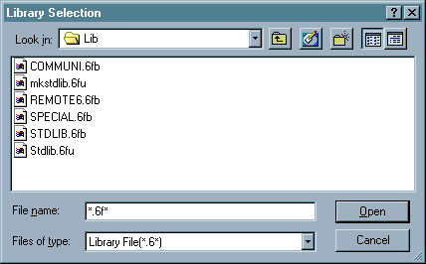

(2) Insert the Function Block into GMWIN scan program and set the Function Block I/O variable.
For the Function Block type and the method to use, please refer to Chapter 8.4. Function Block.

- RTU_WR
- RTU_RD

8.3.1.2 In case of GM7 is the master,

- Communication parameter setting

- Open the new project file in GMWIN.

- Select ‘GM7’ as PLC type.
- Create new project file for the master and the slave, respectively.

- Select communication parameter from GMWIN parameter and doubleclick and the following figure will appear.

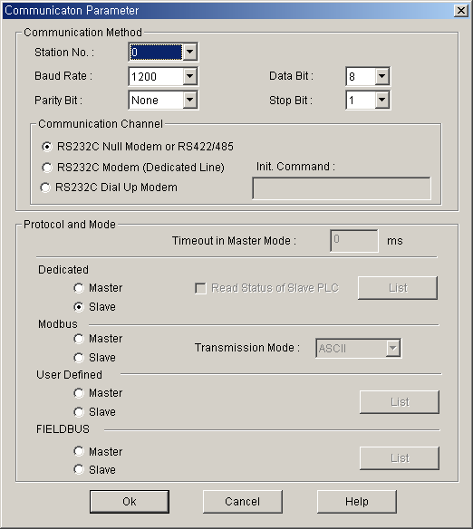

3) Set the contents as follows.

Items | Setting Description
Self station no. | Available to set 1~31 stations. (do not set station 0 as broadcast station no. It may cause the failure.)
Communication speed | Available to set 2400, 4800, 9600, 19200, 38400 bps.
Data bit | Available to set as 7 or 8 bits.  ASCII mode : set as 7 bits.  RTU mode : set as 8 bits.
Parity bit | Available to set as None, Even, Odd.
Stop bit | Available to set as 1 or 2 bits.  In case that the parity bit is set : set as 1 bit.  In case that the parity bit is not set : set as 2 bits.
Communication channel | • RS-232C null modem or RS422/485 : when communicating using GM7 basic unit and Cnet I/F module (G7L-CUEC).  • RS-232C dedicated modem : when communicating by the dedicated modem using Cnet I/F module (G7L-CUEB).  • RS-232C dialup modem : when communicating by the general modem connecting with other station by the phone using Cnet I/F module (G7L-CUEB).  Note) RS-232C exclusive modem and RS-232C dialup modem communication is done only by Cnet I/F module (G7L-CUEB) that supports RS-232C but not by Cnet I/F module (G7L-CUEC) that supports RS-422/485.
Time out when setting the master | • This is the time to wait the response frame after sending the request frame from GM7 basic unit set as the master.  • Default value is 500ms.  • When setting, max. sending/receiving period of master PLC should be considered.  • If the value smaller than max. sending/receiving period is set, it may cause the communication error.
Modbus master / slave | If setting as the master, it shall be the subject in the communication system and if setting as the slave, it will reply only according to the request frame of the master.
Transmission mode | Available to select one from ASCII mode or RTU mode.

8.3.2 MASTER-K Series

8.3.1.1 K80S modbus communication

1) Communication parameter setting

- Open new project file in KGLWIN.

- Select MK80S as PLC type.
- Create new project file for the master and the slave respectively.

- Select communication parameter from KGMWIN parameter and doubleclick, and the following figure will appear.

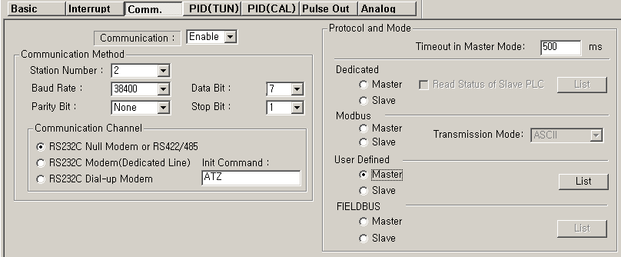
When transmission mode is
ASCII mode, set as 7 bits.

Set the contents as follows.

Items | Setting Description
Self station no. | Available to set 1~31 stations. (do not set station 0 as broadcast station no. It may cause the failure.)
Communication speed | Available to set 2400, 4800, 9600, 19200, 38400 bps.
Data bit | Available to set as 7 or 8 bits.  ASCII mode : set as 7 bits.  RTU mode : set as 8 bits.
Parity bit | Available to set as None, Even, Odd.
Stop bit | Available to set as 1 or 2 bits.  When the parity bit is set : set as 1 bit.  When the parity bit is not set : set as 2 bits.

Communication channel | • RS-232C null modem or RS-422/485 : when communicating using MK80S basic unit and Cnet I/F module (G7L-CUEC).  • RS-232C dedicated modem : when communicating by the dedicated modem using Cnet I/F module (G7L-CUEB).  • RS-232C dialup modem : when communicating by the general dialup modem using Cnet I/F module (G7L-CUEB).  Note) RS-232C dedicated modem and RS232C dialup modem communication is done by Cnet I/F module (G7L-CUEB) only that supports RS-232C and not by Cnet I/F module (G7L-CUEC) that supports RS-422/485.
Timeout when setting the master | • This is the time to wait the response frame after sending the request frame from MK80S basic unit set as the master.  • Default value is 500ms.  • When setting, max. sending/receiving period of master PLC should be considered.  • If the value smaller than max. sending/receiving period is set, it may cause the communication error.
Modbus master /  Slave | If setting as the master, it shall be the subject in the communication system and if setting as the slave, it will reply only according to the request frame of the master.
Transmission mode | Available to select one from ASCII mode or RTU mode.

8.4 Function Block

8.4.1 GLOFA-GM Series

8.4.1.1 for GM3/4/6

1) RTU_RD
Item | IN / OUT | Type | Description
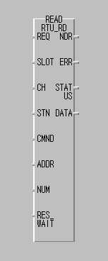 | REQ | BOOL | Function Block execution condition (Rising edge action)  - When changing from 0 to 1, one time executed.
 | SLOT | USINT | Cnet module slot no. (0 ~ 7)
 | CH | USINT | Channel setting (0 : RS-232C, 1 : RS-422/485)
 | STN | USINT | Other station no. setting (0 ~ 32)
 | CMND | USINT | Modbus Command (1 ~4)  1 : Read coil status (Bit)  2 : Read input status (Bit)  3 : Read holding register (Word)  4 : Read input register (Word)
 | ADDR | INT | Leading address of other station to Read (1 ~ 9999)
 | NUM | USINT | Data number to Read (1 ~ 64)
 | RES_WAIT | TIME | Response wait time  (after the setting wait time, eceive the response data from Cnet module of CPU.)
 | NDR | BOOL | After completing the normal communication, 1Scan ‘ON’.
 | ERR | BOOL | When communication error occurs, 1Scan ‘ON’.
 | STATUS | USINT | Communication status code (Error code)  0 : normal, if not 0, : Error code
 | DATA | USINT  ARRY  (256) | Receiving data storage area
  Array [0] : High Byte of first word
  Array [1] : Low Byte of first word
  Array [2] : High Byte of second word
  Array [3] : Low Byte of second word
  …

- Function
This is the Function Block that is executed by selecting function code 01, 02, 03, 04 from modbus protocol communication and used for Bit/Word Read. Function code 01 executes output contact status (Coil Status) Data Read and function code 02 executes input contact status (Input Status) Data Read. Function code 03 executes output register (Holding Registers) Data Read and function code 04 executes input register(Input Registers) Data Read.

- Error
Output the error code from output STATUS. For further information, please refer to error code.

Remark
Response Wait Time setting

1) After the setting wait time, receive the response data from Cnet module of CPU.
2) If the response does not reach from other station within the setting time, error (code 74 or code 10) occurs. This Function Block acts in Cnet function ‘User definition Protocol Mode’.
3) Response Wait Time shall be set considering Read/Write data number, transmission speed (Baudrate), the response speed of other station etc.
4) When setting, please refer to the table below and if error occurs, extend the setting time.

Classification | 1 ~ 16 word | 17 ~ 32 word | 33 ~ 48 word | 49 ~ 64 word
4800 bps | 150ms | 250ms | 330ms | 400ms
9600 bps | 100ms | 180ms | 230ms | 280ms
19200 bps | 80ms | 150ms | 180ms | 230ms

- RTU_WR
Item | IN / OUT | Type | Description
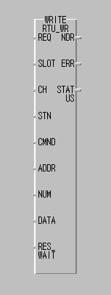 | REQ | BOOL | Function Block execution condition (Rising edge action)  - When changing from 0 to 1, one time executed.
 | SLOT | USINT | Cnet module slot no. (0 ~ 7)
 | CH | USINT | Channel setting (0 : RS-232C, 1 : RS-422/485)
 | STN | USINT | Other station no. setting (0 ~ 32)
 | CMND | USINT | Modbus Command (15 ~ 16)  15 : Force Multiple coils(Bit)  16 : Preset Multiple register (Word)
 | ADDR | INT | Leading address to Write (1 ~ 9999)
 | NUM | USINT | Data number to Write (1 ~ 64)
 | RES_WAIT | TIME | Response wait time  (after the setting wait time, receive the response data from Cnet module of CPU.)
 | NDR | BOOL | After completion of the normal communication, 1Scan ‘ON’.
 | ERR | BOOL | When communication error occurs, 1Scan ‘ON’.
 | STATUS | USINT | Communication status code (Error code)  0 : normal, if not 0, : Error code
 | DATA | USINT  ARRY  (256) | Self station data storage area to Write
  Array [0] : High Byte of first word
  Array [1] : Low Byte of first word
  Array [2] : High Byte of second word
  Array [3] : Low Byte of second word
  …

- Function
This is the Function Block to execute by selecting function code 15 and 16 from modbus protocol communication and used for Continuous 1 bit Write (function code 15), Continuous 1 word Write (function code 16). Function code 15 performs 1 bit Data Write to output contact (Coil) continuously and function code 16 performs 1 word Data Write to output register (Holding Registers) continuously.

- Error
Output the error code to output STATUS. For further information, please refer to the error code.

Remark
1) This Function Block acts in Cnet function ‘User Definition Protocol Mode’.
2) Basic parameter (Baudrate, Data bit, Stop bit, Parity check, Station No. etc.) shall be set in Cnet editor and the frame editing is not needed.
3) This supports Modbus RTU Protocol. (scheduled to support ASCII Protocol later)
4) Cnet module requirements to use this Function Block are as follows.
  - Cnet module version : more than v2.0 (available to verify in GMWIN)
  - Cnet module Flash Rom OS version : more than v1.01 (available to verify in Cnet Editor)
  - Modbus.Nfb (Modbus Function Block file, N=3,4,6) needed.

Error code table
Status  code  (Dec) | Description | Solution | Remarks
0 | Normal | No error
1 | Illegal command  (When the master requires the command that the Slave does not support.) | After confirming the command available to support by the Slave, modify the command on FB. | The error  returned from the  Slave
2 | Illegal address  (When the Master requires the address that the Slave does not support.) | After confirming the address available to support by the Slave, modify the address on FB. | The error  returned from the  Slave
3 | Illegal data value  (When the Master requires the data of the range that the Slave does not support.) | After confirming the data range available to support by the Slave, modify the data on FB. | The error  returned from the  Slave
4 | Slave device failure  (The unrecoverable error occurs while performing the Master requirements in the Slave.) | Check the Slave station status. | The error  returned from the  Slave
6 | Slave device busy | After waiting for the regular time, Master | The error  returned from the  Slave
10 | Receiving Frame CRC error | 1. After confirming the receiving frame status, extend the Response Wait Time.  2. Check the Cable and Noise status. | Function  Block internal error
16 | Cnet module I/F error  (No Cnet module in the designated slot.) | Check the slot no. designated on FB. | Function  Block internal error
64 | Channel (232c/422) stop | RUN the Cnet module.  (power reinput) | Function  Block internal error

74 | Time out error | 1. Check the basic parameter (station no./speed etc.)  2. Check the Slave station status (power etc.)  3. Check the Cable status and connecton
115 | Communication mode error | Check if Cnet user definition

8.4.1.2 for GM7

1) MOD0102
Function Block | Description
REQ
SLV_ADDR
FUNC
ADDRH
ADDRL
NUMH
NUML
RD_DATA
NDR
ERR
STAT
US
MOD0102
BOOL
USINT
USINT
USINT
USINT
USINT
USINT
BOOL[A]
BOOL
BOOL
USINT
 | Input
 | REQ | : When 1(rising edge), Function Block execution
 | SLV_ADDR | : Slave station no. input
 | FUNC | : Function code input  It supports function code 01 and 02.
 | ADDRH | : High address of starting address to read in the Slave station.
 | ADDRL | : Low address of starting address to read in the Slave station.
 | NUMH | : High address of data size to read from the starting address to read in the Slave station.
 | NUML | : Low address of data size to read from the starting address to read in the Slave station.
 | Output
 | RD_DATA | : Variable name to save the Read data.(Array number should be declared as equal to or greater than the data size.)
 | NDR | : If executing without error, output 1 and maintain 1 until calling next Function Block.
 | ERR | : When error occurs, output 1 and maintain 1 until calling next Function Block.
 | STATUS | : When error occurs, output the error code.

- Function
This is the Function Block to execute by selecting function code 01 and 02 from modbus protocol communication and used for Bit Read. Function code 01 performs output contact status (Coil status) data Read and function code 02 performs input contact status (Input Status) data Read.

- Error
Output the error code to the Output STATUS. For further information, please refer to the error code.

- Program Example

- This is the example when GM7 basic unit is the Master and when reading output contact data of Modicon product that is station no.17.

- Execute the Status Read of output contact (Coil) 00020 ~ 00056 of the Slave station (Station no.17). The output contact of the Slave station is assumed as follows and the read data is saved in the BOOL type random array variable RD_DB0 whose size is 40.

Output contact | 59 | 58 | 57 | 56 | 55 | 54 | 53 | 52 | 51 | 50 | 49 | 48 | 47 | 46 | 45 | 44 | 43 | 42 | 41 | 40
Contact status | X | X | X | 1 | 1 | 0 | 1 | 1 | 0 | 0 | 0 | 0 | 1 | 1 | 1 | 0 | 1 | 0 | 1 | 1
Hexa | 1 |  |  |  | B |  |  |  | 0 |  |  |  | E |  |  |  | B
Output contact | 39 | 38 | 37 | 36 | 35 | 34 | 33 | 32 | 31 | 30 | 29 | 28 | 27 | 26 | 25 | 24 | 23 | 22 | 21 | 20
Contact status | 0 | 0 | 1 | 0 | 0 | 1 | 1 | 0 | 1 | 0 | 1 | 1 | 1 | 1 | 0 | 0 | 1 | 1 | 0 | 1
Hexa | 2 |  |  |  | 6 |  |  |  | B |  |  |  | C |  |  |  | D
<Data status of Modicon product output contact (00020~00059)>

- The status of output contact 57,58,59 is Redundancy.
- The data shall be transmitted from low bit by byte unit. The insufficient bit part of the byte shall be filled with ‘0’. The transmission of the above data is shown on Ex.1).
Ex.1) CD 6B B2 0E 1B

Function Block input | Input value
REQ | Enter the input condition to run.
SLV_ADDR | 16#11 or 17 | : Slave station no.
FUNC | 16#01 or 1 | : Enter ‘1’ when reading output contact status.
ADDRH | 16#00 or 0 | : High byte among the address starting to read from the Slave station.
ADDRL | 16#13 or 19 | : Low byte among the address starting to read from the Slave station.  - In order to read from output contact 00020, it is required to read from no.19 according to the 8) modbus addressing regulation. And most significant data of data address shall be processed internally automatically by the input value of Function Block input FUNC without separate input.

NUMH | 16#00 or 0 | : High byte when expressing total size of data to read by Hexa.
NUML | 16#25 or 37 | : Low byte when expressing total size of data to read by Hexa.  - From the example, it is required to read 00020 ~ 00056 and total size of data shall be 37. If expressing 37 by Hexa, it shall be H0025 and it is required to enter H00 for NUMH and H25 for NUML.

- Results
Variable name | Storage value | Variable name | Storage value | Variable name | Storage value | Variable name | Storage value
RD_DB0[0] | 1 | RD_DB0[10] | 0 | RD_DB0[20] | 1 | RD_DB0[30] | 0
RD_DB0[1] | 0 | RD_DB0[11] | 1 | RD_DB0[21] | 1 | RD_DB0[31] | 0
RD_DB0[2] | 1 | RD_DB0[12] | 0 | RD_DB0[22] | 0 | RD_DB0[32] | 1
RD_DB0[3] | 1 | RD_DB0[13] | 1 | RD_DB0[23] | 1 | RD_DB0[33] | 1
RD_DB0[4] | 0 | RD_DB0[14] | 1 | RD_DB0[24] | 0 | RD_DB0[34] | 0
RD_DB0[5] | 0 | RD_DB0[15] | 0 | RD_DB0[25] | 1 | RD_DB0[35] | 1
RD_DB0[6] | 1 | RD_DB0[16] | 0 | RD_DB0[26] | 1 | RD_DB0[36] | 1
RD_DB0[7] | 1 | RD_DB0[17] | 1 | RD_DB0[27] | 1 | RD_DB0[37] | X
RD_DB0[8] | 1 | RD_DB0[18] | 0 | RD_DB0[28] | 0 | RD_DB0[38] | X
RD_DB0[9] | 1 | RD_DB0[19] | 0 | RD_DB0[29] | 0 | RD_DB0[39] | X

- The variable to save the read data should be array type variable and the size of array type variable should be equal to or greater than that of the data to read. If it is smaller, error code shall be indicated on the STATUS.
- The read data shall be saved from array variable RD_DB0[0].
- The remaining part after filling the array variable by the read data shall be redundancy.

- This is the example when GM7 basic unit is the Master and when reading input contact data of Modicon product that is station no.17.

- Execute the Status Read of input contact (Input) 10197 ~ 10218 of the Slave station (Station no.17). The input contact of the Slave station is assumed as follows and the read data is saved in the BOOL type random array variable RD_DB1 whose size is 24.

Input contact | 10220 | 10219 | 10218 | 10217 | 10216 | 10215 | 10214 | 10213 | 10212 | 10211 | 10210 | 10209
Contact status | X | X | 1 | 1 | 0 | 1 | 0 | 1 | 1 | 1 | 0 | 1
Hexa | 3 |  |  |  | 5 |  |  |  | D
Input contact | 10208 | 10207 | 10206 | 10205 | 10204 | 10203 | 10202 | 10201 | 10200 | 10199 | 10198 | 10197
Contact status | 1 | 0 | 1 | 1 | 1 | 0 | 1 | 0 | 1 | 1 | 0 | 0
Hexa | B |  |  |  | A |  |  |  | C

- The status of Input contact 10219, 10220 is Redundancy.
- The data shall be transmitted from low bit by byte unit. The insufficient bit part of the byte shall be filled with ‘0’. The transmission of the above data is shown on Ex.1).
Ex.1) AC DB 35

Function Block input | Input value
REQ | Enter the input condition to run.
SLV_ADDR | 16#11 or 17 | : Slave station no.
FUNC | 16#02 or 2 | : Enter ‘2’ when reading the input contact status.
ADDRH | 16#00 or 0 | : High byte among the address starting to read from the Slave station.
ADDRL | 16#C4 or 196 | : Low byte among the address starting to read from the Slave station.  - In order to read from input contact 10197, it is required to read from no.196 according to the 8) modbus addressing regulation. And most significant data of data address shall be processed internally automatically by the input value of Function Block input FUNC without separate input.
NUMH | 16#00 or 0 | : High byte when expressing total size of data to read by Hexa
NUML | 16#16 or 22 | : Low byte when expressing total size of data to read by Hexa.  - From the example, it is required to read 10197 ~ 10218 and total size of data shall be 22. If expressing 22 by Hexa, it shall be H0016 and it is required to enter H00 for NUMH and H16 for NUML.

- Results

Variable name | Storage value | Variable name | Storage value | Variable name | Storage value | Variable name | Storage value
RD_DB1[0] | 0 | RD_DB1[6] | 0 | RD_DB1[12] | 1 | RD_DB1[18] | 1
RD_DB1[1] | 0 | RD_DB1[7] | 1 | RD_DB1[13] | 0 | RD_DB1[19] | 0
RD_DB1[2] | 1 | RD_DB1[8] | 1 | RD_DB1[14] | 1 | RD_DB1[20] | 1
RD_DB1[3] | 1 | RD_DB1[9] | 1 | RD_DB1[15] | 1 | RD_DB1[21] | 1
RD_DB1[4] | 0 | RD_DB1[10] | 0 | RD_DB1[16] | 1 | RD_DB1[22] | X
RD_DB1[5] | 1 | RD_DB1[11] | 1 | RD_DB1[17] | 0 | RD_DB1[23] | X

- The variable to save the read data should be array type variable and the size of array type variable should be equal to or greater than that of the data to read. If it is smaller, error code shall be indicated on the STATUS.
- The read data shall be saved from array variable RD_DB1[0].
- The remaining part after filling the array variable by the read data shall be redundancy.
2) MOD0304

Function Block | Description
REQ
SLV_ADDR
FUNC
ADDRH
ADDRL
NUMH
NUML
RD_DATA
NDR
ERR
STAT
US
MOD0304
BOOL
USINT
USINT
USINT
USINT
USINT
USINT
WORD[A]
BOOL
BOOL
USINT
 | Input
 | REQ | : When 1(rising edge), Function Block execution
 | SLV_ADDR | : Slave station no. input
 | FUNC | : Function code input  It supports function code 03 and 04.
 | ADDRH | : High address of starting address to read in the Slave station.
 | ADDRL | : Low address of starting address to read in the Slave station.
 | NUMH | : High address of data size to read from the starting address to read in the Slave station.
 | NUML | : Low address of data size to read from the starting address to read in the Slave station.
 | Output
 | RD_DATA | : Variable name to save the Read data. (Array number should be declared as equal to or greater than the data size.)
 | NDR | : If executing without error, output 1 and maintain 1 until calling next Function Block.
 | ERR | : When error occurs, output 1 and maintain 1 until calling next Function Block.
 | STATUS | : When error occurs, output the error code.

- Function
This is the Function Block to execute by selecting function code 03 and 04 from modbus protocol communication and used for Word Read. Function code 03 performs output register (Holding Registers) data Read and function code 04 performs input register (Input Registers) data Read.

- Error
Hold the error code to the Output STATUS. For further information, please refer to the error code.

- Program Example

- This is the example when GM7 basic unit is the Master and when reading output register data of Modicon product that is station no.17.

- Execute the Read of output register (Holding Registers) 40108 ~ 40110 of the Slave station (Station no.17). The output register of the Slave station is assumed as follows and the read data is saved in the WORD type random array variable RD_DW0 whose size is 4.

Output Register | 40110 | 40109 | 40108
Register Status | H0064 | H0000 | H022B

- The data shall be transmitted from high byte of low word by byte unit. The transmission of the above data is shown on Ex.1).
Ex.1) 02 2B 00 00 00 64
Function Block input | Input value
REQ | Enter the input condition to run.
SLV_ADDR | 16#11 or 17 | : Slave station no.
FUNC | 16#03 or 3 | : Enter ‘3’ when reading output register.
ADDRH | 16#00 or 0 | : High byte among the address starting to read from the Slave station.
ADDRL | 16#6B or 107 | : Low byte among the address starting to read from the Slave station.  - In order to read from output register 40108, it is required to read from no.107 according to the 8) modbus addressing regulation. And most significant data of data address shall be processed internally automatically by the input value of Function Block input FUNC without separate input.
NUMH | 16#00 or 0 | : High byte when expressing total size of data to read by Hexa.
NUML | 16#03 or 3 | : Low byte when expressing total size of data to read by Hexa.  - From the example, it is required to read 40108 ~ 40110 and total size of data shall be 3. If expressing 3 by Hexa, it shall be H0003 and it is required to enter H00 for NUMH and H03 for NUML.

- Results
Variable name | Storage value
RD_DW0[0] | H002B or 555
RD_DW0[1] | H0000 or 0
RD_DW0[2] | H0064 or 100
RD_DW0[3] | X

- The variable to save the read data should be array type variable and the size of array type variable should be equal to or greater than that of the data to read. If it is smaller, error code shall be indicated on the STATUS.
- The read data shall be saved from array variable RD_DW0[0].
- The remaining part after filling the array variable by the read data shall be redundancy.

- This is the example when GM7 basic unit is the Master and when reading input register data of Modicon product that is station no.

- Execute the Read of input register (Input Registers) 30009 of the Slave station (Station no.17). The input register of the Slave station is assumed as follows and the read data is saved in the WORD type random array variable RD_DW1 whose size is 2.

Input Register | 30009
Register Status | H000A

- The data is transmitted from high byte of low word by byte unit. The transmission of the above data is shown on Ex.1).
Ex.1) 00 0A

Function Block input | Input value
REQ | Enter the input condition to run.
SLV_ADDR | 16#11 or 17 | : Slave station no.
FUNC | 16#04 or 4 | : Enter ‘4’ when reading input register.
ADDRH | 16#00 or 0 | : High byte among the address starting to read from the Slave station.
ADDRL | 16#08 or 8 | : Low byte among the address starting to read from the Slave station.  - In order to read from input register 30009, it is required to read from no.8 according to the 8) modbus addressing regulation. And most significant data of data address shall be processed internally automatically by the input value of Function Block input FUNC without separate input.
NUMH | 16#00 or 0 | : High byte when expressing total size of data to read by Hexa

NUML | 16#01 or 1 | : Low byte when expressing total size of data to read by Hexa.  - From the example, it is required to read 30009 and total size of data shall be 1. If expressing 1 by Hexa, it shall be H0001 and it is required to enter H00 for NUMH and H01 for NUML.

- Results

Variable name | Storage value
RD_DW1[0] | H000A or 10
RD_DW1[1] | X

- The variable to save the read data should be array type variable and the size of array type variable should be equal to or greater than that of the data to read. If it is smaller, error code shall be indicated on the STATUS.
- The read data shall be saved from array variable RD_DW1[0].
- The remaining part after filling the array variable by the read data shall be redundancy.

- MOD0506

Function Block | Description
REQ
SLV_ADDR
FUNC
ADDRH
ADDRL
NUMH
NUML
NDR
ERR
STAT
US
MOD0506
BOOL
USINT
USINT
USINT
USINT
USINT
USINT
BOOL
BOOL
USINT
 | Input
 | REQ | : When 1(rising edge), Function Block execution
 | SLV_ADDR | : Slave station address input
 | FUNC | : Function code input  It supports function code 05 and 06.
 | ADDRH | : High address among start address to write in the Slave station.
 | ADDRL | : Low address among start address to write in the Slave station.
 | NUMH | : High address among data to write in the Slave station.
 | NUML | : Low address among data to write in the Slave station.
 | Output
 | NDR | : If executing without error, output 1 and maintain 1 until calling next Function Block.
 | ERR | : When error occurs, output 1 and maintain 1 until calling next Function Block.
 | STATUS | : When error occurs, output the error code.

- Function
This is the Function Block to execute by selecting function code 05 and 06 from modbus protocol communication and used for 1Bit Write (function code 05) and 1Word Write (function code 06). Function code 05 performs 1Bit data Write for output contact (Coil) and if setting 255 (or HFF) for input NUMH of Function Block or 0 (or H00) for input NUML, write ‘1’ for output contact and if setting 0 (or H00) for input NUMH or 0 (or H00) for NUML, write ‘0’ for output contact. Function code 06 performs 1 word data write in output register.

- Error
Output the error code to the output STATUS. Further information, please refer to Error code.

- Program Example

- This is the example when GM7 basic unit is the Master and when writing 1 bit data to the output contact of Modicon product that is station no.17.

- Write ‘1’ to the output contact (Coil) 00173 of the Slave station (station no.17)

Function Block input | Input value
REQ | Enter the input condition to run.
SLV_ADDR | 16#11 or 17 | : Slave station no.
FUNC | 16#05 or 5 | : Enter ‘5’ when writing 1 Bit to output contact.
ADDRH | 16#00 or 0 | : High byte among the address starting to write in the Slave station.
ADDRL | 16#AC or 172 | : Low byte among the address starting to write in the Slave station.  - In order to write to output contact 00173, it is required to write from No.172 according to the 8) modbus addressing regulation. And most significant data of data address shall be processed internally automatically by the input value of Function Block input FUNC without separate input.
NUMH | 16#FF or 255 | : Data to write in the Slave station  - ‘0’ → H00  - ‘1’ → HFF
NUML | 16#00 or 0 | : Data to write in the Slave station  - From the example, it is required to write ‘1’. Thus, enter HFF for HUMH and H00 for NUML.

- Results : Output contact 00173 shall be ON. (In case of GM7 basic unit, ‘1’ shall be saved in the corresponding M area.)

Output contact | 00173
Contact status | 1

- This is the example when GM7 basic unit is the Master and when writing 1Word Data to the output register of Modicon product that is station no.17.

- This is the example to write ‘3’ to the output register (Holidng Registers) 40002 of the Slave station (Station no.17).

Function Block input | Input value
REQ | Enter the input condition to run.
SLV_ADDR | 16#11 or 17 | : Slave station no.
FUNC | 16#06 or 6 | : Enter ‘6’ when writing 1Word to output register.
ADDRH | 16#00 or 0 | : High byte among the address starting to write in the Slave station.
ADDRL | 16#01 or 1 | : Low byte among the address starting to write in the Slave station.  - In order to write to output contact 40002, it is required to write from No.1 according to the 8) modbus addressing regulation. And most significant data of data address shall be processed internally automatically by the input value of Function Block input FUNC without separate input.
NUMH | 16#00 or 0 | : High byte when expressing the data to write in the Slave station by Hexa.
NUML | 16#03 or 3 | : Low byte when expressing the data to write in the Slave station by Hexa.  - From the example, it is required to write ‘3’ and if expressing the data by Hexa, it shall be H0003 and it is required to enter H00 for HUMH and H03 for NUML.

- Results : H0003 shall be saved in output register 40002. (In case of GM7 basic unit, H0003 shall be saved in the corresponding M area.)

Output register | 40002
Register status | H0003

- MOD1516

Function Block | Description
REQ
SLV_ADDR
FUNC
ADDRH
ADDRL
NUMH
NUML
BYTE_CNT
NDR
ERR
STAT
US
MOD1516
BOOL
USINT
USINT
USINT
USINT
USINT
USINT
BOOL
BOOL
USINT
WR_DATA
BYTE[A]
USINT
 | Input
 | REQ | : When 1(rising edge), Function Block execution
 | SLV_ADDR | : Slave station address input
 | FUNC | : Function code input  It supports function code 15 and 16.
 | ADDRH | : High address among starting address to write in the Slave station.
 | ADDRL | : Low address among starting address to write in the Slave station.
 | NUMH | : High address of data size to write in the Slave station.
 | NUML | : Low address of data size to write in the Slave station.
 | BYTE_CNT | : Byte size of data to write in the Slave station.
 | WR_DATA | : Variable name to save the data to write. (It should be declared as equal to or greater than the data size.)
 | Output
 | NDR | : If executing without error, output 1 and maintain 1 until calling next Function Block.
 | ERR | : When error occurs, output 1 and maintain 1 until calling next Function Block.
 | STATUS | : When error occurs, output the error code.

- Function
This is the Function Block to execute by selecting function code 15 and 16 from modbus protocol communication and used for Continuous 1Bit Write (function code 15) and Continuous 1Word Write (function code 16). Function code 15 performs 1Bit Data Write for output contact (Coil) by 1 byte continuously and Function code 16 performs 1 Word Data Write for output register (Holding Registers) continuously.

- Error
Output the error code to the output STATUS. For further information, please refer to Error Code.
- Program Example

- This is the example when GM7 basic unit is the Master and when writing Bit Data continuously to output contact of Modicon product that is station no.17.

- It writes the continued 10bit 0111001101 to output contact (Coil) 00020 in the Slave station (Station no.17) by 1bit. The data to write is saved in BYTE type random array variable WR_DB0 whose size is 2.

Variable name | Storage value
WR_DB0[0] | 2#11001101 or 16#CD
WR_DB0[1] | 2#10000001 or 16#81

- The size of BYTE_CNT is the size when converting the data to write by byte unit. As the above data is 10bit, 1byte is not enough to contain the data and 2bytes are required. It shall be filled with from low bit and the high 6 bit shall be filled with ‘0’. Thus, the size of BYTE_CNT is 2.
- If assuming that the data of 1000 0001 1100 1101 is saved in array variable WR_DB0, the data shall be transmitted by filling the high 6bit with ‘0’ from low 10 bit (01 1100 1101). As the size of data to transmit is designated by 10bit, it is required to take the low 10 bit and fill the remaining bit with ‘0’ as it is transmitted by byte unit.
- The data shall be transmitted by byte unit from low bit. The transmission of the above data is shown on Ex.1).
Ex.1) CD 01

Function Block input | Input value
REQ | Enter the input condition to run.
SLV_ADDR | 16#11 or 17 | : Slave station no.
FUNC | 16#0F or 15 | : Enter ‘15’ when writing Bit to output contact continuously.
ADDRH | 16#00 or 0 | : High byte among starting address to write in the Slave station.
ADDRL | 16#13 or 19 | : Low byte among starting address to write in the Slave station.  - In order to write from output contact 00020, it is required to write from No.19 according to the 8) modbus addressing regulation. And most significant data of data address shall be processed internally automatically by the input value of Function Block input FUNC without separate input.
NUMH | 16#00 or 0 | : High byte when expressing total size of data to write in the Slave station by Hexa.
NUML | 16#0A or 10 | : Low byte when expressing total size of data to write in the Slave station by Hexa.  - From the example, it is the 10 bit data continued from 00020 and total size shall be 10. If expressing 10 by Hexa, it shall be H000A and it is required to enter H00 for NUMH and H0A for NUML.
BYTE_CNT | 16#02 or 2 | : This is the size when converting total size of data to write in the Slave station by byte unit.  - From the example, it is the continued 10 bit data and if converted by byte unit, it shall be 2 byte. Thus, it is required to enter H02 for BYTE_CNT.

- Results
The low 10 bit only is effective as much as the setting data size among 2byte (16bit) data.

Output contact | 00029 | 00028 | 00027 | 00026 | 00025 | 00024 | 00023 | 00022 | 00021 | 00020
Contact status | 0 | 1 | 1 | 1 | 0 | 0 | 1 | 1 | 0 | 1

- This is the example when GM7 basic unit is the Master and when writing Word Data continuously to output register of Modicon product that is station no.17.

- It writes 000A and 0102 to output register (Holding Registers) 40002 in the Slave station (station no.17). The data to write is saved in BYTE type array variable WR_DB1 whose size is 4.

Variable name | Storage value
WR_DB1[0] | 2#00001010 or 16#0A
WR_DB1[1] | 2#00000000 or 16#00
WR_DB1[2] | 2#00000010 or 16#02
WR_DB1[3] | 2#00000001 or 16#01

- The size of BYTE_CNT is the size when converting the data to write by byte unit. As the above data is 2 words, it is required to use 4 bytes. Thus, the size of BYTE_CNT is 4.
- The data is transmitted from low word by byte unit. The transmission of the above data is shown on Ex.1).
Ex.1) 00 0A 01 02

Function Block input | Input value
REQ | Enter the input condition to run.
SLV_ADDR | 16#11 or 17 | : Slave station no.
FUNC | 16#10 or 16 | : Enter ‘16’ when writing Word to output register continuously.
ADDRH | 16#00 or 0 | : High byte among starting address to write in the Slave station.
ADDRL | 16#01 or 1 | : Low byte among starting address to write in the Slave station.  - In order to write from output register 40002, it is required to write from No.1 according to the 8) modbus addressing regulation. And most significant data of data address shall be processed internally automatically by the input value of Function Block input FUNC without separate input.
NUMH | 16#00 or 0 | : High byte when expressing total size of data to write in the Slave station by Hexa.
NUML | 16#02 or 2 | : Low byte when expressing total size of data to write in the Slave station by Hexa.  - From the example, it is the 2word data continued from 40002 and total size shall be 2. If expressing 2 by Hexa, it shall be H0002 and it is required to enter H00 for NUMH and H02 for NUML.

BYTE_CNT | 16#04 or 4 | : This is the size when converting total size of data to write in Slave station by byte unit.  - From the example, it is the continued 2word data and if converted by byte unit, it shall be 4 byte. Thus, it is required to enter H04 for BYTE_CNT.

- Results

Output register | 40003 | 40002
Register status | H0102 | H000A

- Error code

CODE | Error type | Meaning
01 | Illegal Function | Function code input error to the Function Block
02 | Illegal Address | The area to read/write in the slave exceeds the allowed range.
03 | Illegal Data Value | The data value to read/write in the Slave is not allowed.
04 | Slave Device Failure | Slave error status
05 | Acknowledge | This is a kind of response code that the Slave sends to the master to prevent the time of the master when it takes a time for the processing of demand command. In the master, it indicates the error code and wait for the regular time without demanding again.
06 | Slave Device Busy | The error caused by long processing time of the slave. Master must demand again.
07 | Time Out | The error occurred when exceeding the setting time of the communication parameter while communication.
08 | Number Error | The error occurred when data is ‘0’ or more than 256byte, when data size is greater than array size, and when number and BYTE_CNT is different.
09 | Parameter Error | Parameter setting error (mode, master/slave)
10 | Station Error | The error occurred when the station no. set in self station and input parameter of function is the same.

8.4.2 MASTER-K Series

1) Command Modbus

Command |  | Available area to use |  |  |  |  |  |  |  |  |  |  |  | Step no. | Flag
 |  | M | P | K |  | L | F | T | C | S | D | #D | Integral  number | Step no. | Error  (F110) | Zero  (F111) | Carry  (F112)
Modbus | S1 | 0 | 0 | 0 | 0 | 0 | 0 | 0 | 0 |  | 0 | 0 |  | 7 | 0
Modbus | S2 | 0 | 0 | 0 | 0 | 0 |  | 0 | 0 |  | 0 | 0
Modbus | S3 | 0 | 0 | 0 | 0 | 0 |  | 0 | 0 |  | 0 | 0

Modbus S1 S2 S3 | Flag
Modbus S1 S2 S3 | F110 | When exceeding #D area, it shall be ON.
Modbus S1 S2 S3 | Area setting
Modbus S1 S2 S3 | S1 | Device address to register sending/receiving parameter.
Modbus S1 S2 S3 | S2 | Device address to save sending/receiving data.
Modbus S1 S2 S3 | S3 | Device address to indicate sending/receiving status.

(1) Function
• This transmits the data saved in the S1 device to Modbus protocol through communication port. (3Word)
• This designates the leading address of the device where the received data is saved to S2.
➔ According to function of S1, it designates the leading address of the device that the received data is saved when receiving and the leading address of the data to sending when sending.
• The communication action status is saved in S3.

(2) Program Example

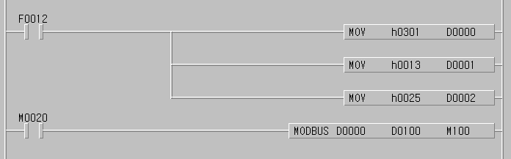
Designate the slave address (high
byte) and function code (low byte).
Designate the number to read.
When M0020 is ON, open the Modbus communication with Modbus parameter saved in D0000 and save the data received in D1000.
The communication error information is saved In M100.
Designate the address.

If the parameter Modbus is set as the Slave, it will respond when required by the master without separate command and if setting as the master, the designated data shall be transmitted to Modbus protocol designated as S1 whenever the input condition of Modbus command is ON.

• S3 format is as follows.

BIT15 BIT0
에러코드(Bit8 ~Bit15)

Error bit (Bit1)
NDR (Bit)
Error code(bit8 ~ bit 15)

• NDR : when completing the normal communiction, 1Scan ON.
• Error bit : when communication error occurs, 1Scan ON and in this case, error code is indicated Bit8 ~ Bit15.
• Error code : when error occurs, it shows the information for the error. (refer to the error code table as below.)

Error code table
Code | Name | Description
01 | Illegal Function | Function code error
02 | Illegal Address | Address allowed range exceeded
03 | Illegal Data Value | The error that data value is not allowed.
04 | Slave Device Failure | Slave error status
05 | Acknowledge | When it takes a time for the processing of demand command, the slave sends to prevent time out of the master.
06 | Slave Device Busy | The slave takes a time for the processing. The master must demand again.
07 | Time Out | When no response during Time out of communication parameter.
08 | Number Error | When data number is ‘0’ or exceeds 256Byte.
09 | Parameter Error | When the items set in the parameter (such as transmission mode etc.) are wrong.
10 | Station Error | When self station no. and input parameter of Modbus command is the same.

8.5 Program Example

8.5.1 GLOFA-GM Series

8.5.1.1 when the Master is GM3/4/6

1) Set the basic frame in Cnet module of Master PLC.

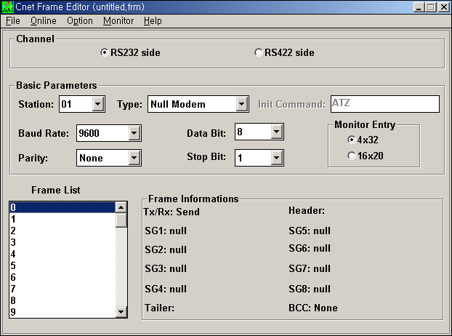

- Basic parameter (Baudrate, Parity, Data bit, Stop bit) is required to correspond with the setting content of other station.
- It is not necessary to write the frame list.

2) Insert Programming-Library

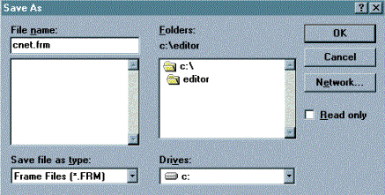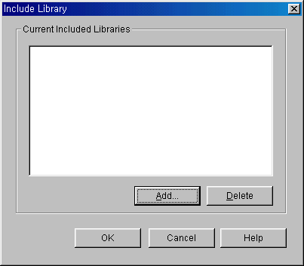

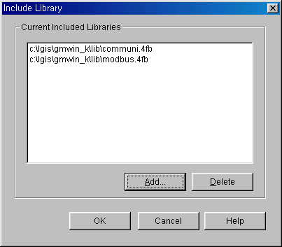

3) Load the Function Block from Scan program of GMWIN program and program it.

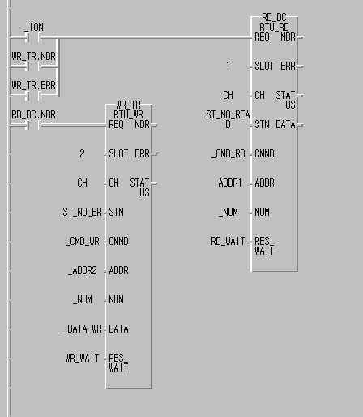

8.5.1.2 When the Master is GM7

- Slave station program : output the receiving data saved in M area to the output contact (Coil).
- Master station program : After saving 16#FF(OR 255) to %MW0(this corresponds with %MX0 ~ %MX15 or %MB0 ~ %MB1.) in the Function Block MOD0506(function code 06), read %MX0 using the Function Block MOD0102(function code 01) and save ’0’ to %MX0 ~ %MX9 using the Function Block MOD1516(function code 15) again and then read %MW0 using the Function Block MOD0304(function code 03).
- The cable used in this cable is the same as the cable used in 1:1 only protocol communication between self stations.

- Slave station setting and Program

- Create new project file and new program for the Slave station.

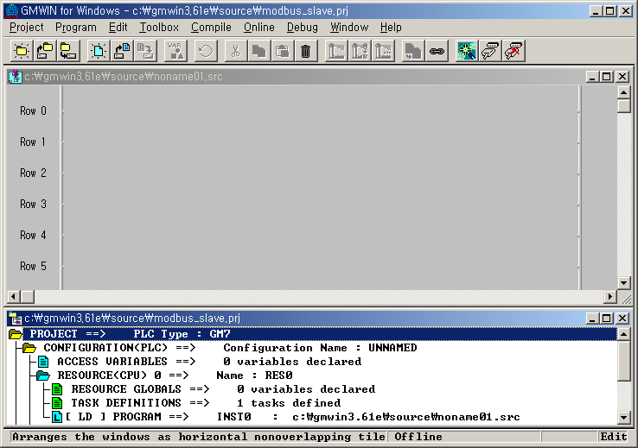

- If you select ‘communication parameter’ from GMWIN parameter and doubleclick, the communication parameter menu window will be open.

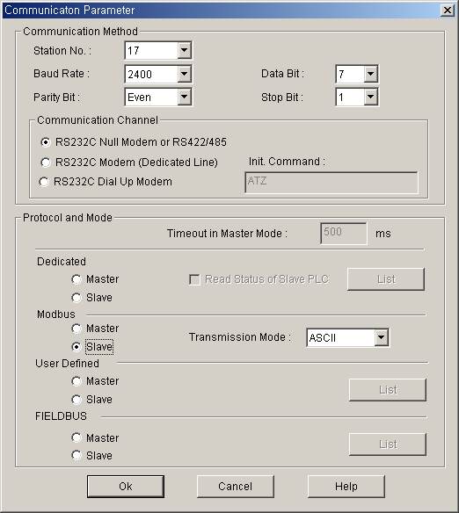

- After setting the parameter as below, press ‘verify’ button.

Communication method |  |  |  |  |  | Protocol and transmission mode
Self station no. | Communication speed | Data bit | Parity bit | Mainte- nance bit | Communication channel | Modbus | Exclusive mode
17 | 2400 | 7 | EVEN | 1 | RS232C null modem or RS422/485 | Slave | ASCII

- After creating the program as below, download it in the GM7 basic unit of the Slave station. For further program creation and download method, please refer to GMWIN user’s manual.

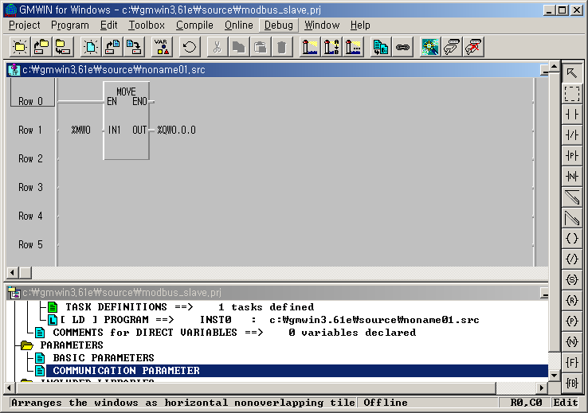

- The slave program is the program to output the data of M area to the output contact.

- Master Station setting and Program

- Create new project file and new program for the Master Station.

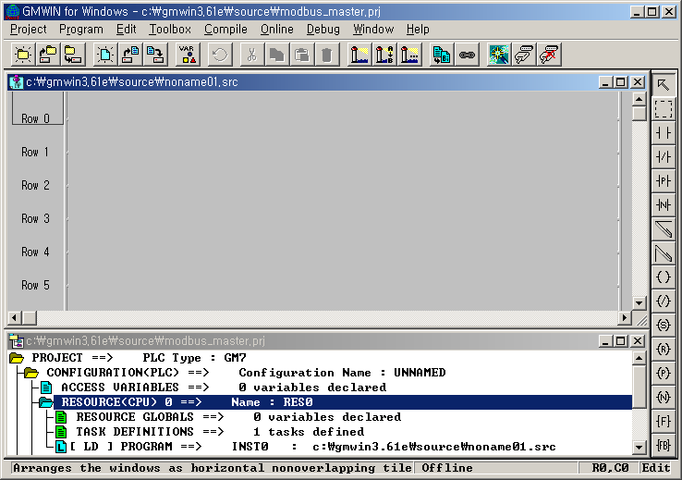

- If you select ‘communication parameter’ from GMWIN parameter and doubleclick, the communication parameter menu window will be open.

- After setting the parameter as below, press ‘verify’ button.

Communication method |  |  |  |  |  | Protocol & transmission mode
Self station no. | Communication speed | Data bit | Parity bit | Mainte- nance bit | Communication channel | Modbus | Exclusive mode
1 | 2400 | 7 | EVEN | 1 | RS232C null modem or RS422/485 | Master | ASCII

- After creating the program as below, download it in the GM7 basic unit of the Master station. For further program creation and download method, please refer to GMWIN user’s manual.

- In the program, the Function Block is used. If you doubleclick GMWIN ‘inserted library files’ items before using the Function Block, the library insert window will be open as below. Press ‘Add (A)…’ button and add COMM.7FB library and then press ‘verify’ button.

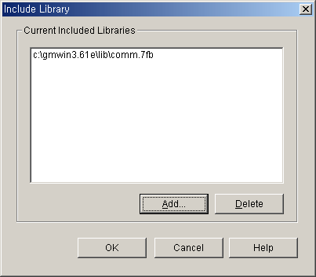

- Program Creation

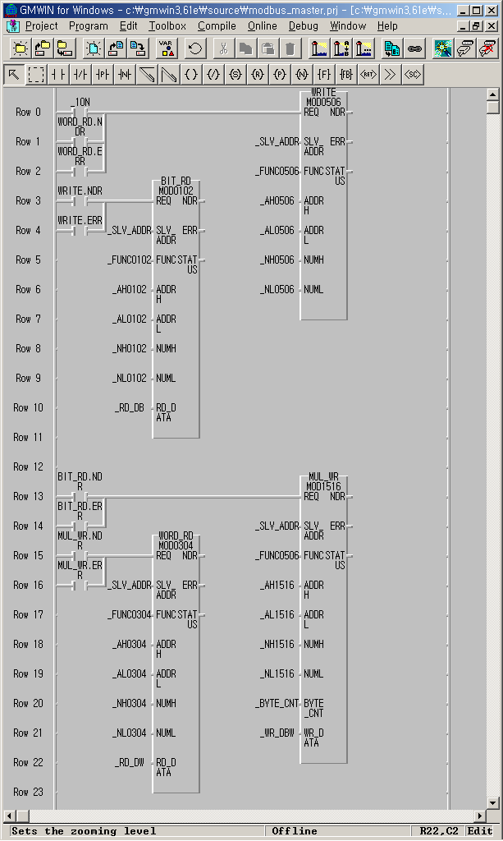

- After saving 16#FF(OR 255) to %MW0(this corresponds with %MX0 ~ %MX15 or %MB0 ~ %MB1.) in the Function Block MOD0506(function code 06), read %MX0 using the Function Block MOD0102(function code 01) and save ’0’ to %MX0 ~ %MX9 using the Function Block MOD1516(function code 15) again and then read %MW0 using the Function Block MOD0304(function code 03).
- You can see that 8 LED of output contact continues to repeat ON/OFF.
- The above figure is the screen that monitored the program execution. Thus, the value to be indicated on Array variable _RD_DB, _RD_DW is the result value after executing ‘Read’ not the initial value.
- The variable such as instance name.NDR, instance name.ERR, instance name.STATUS is generated automatically if declaring the instance variable of the Function Block.
- _1ON flag is the flag that will be ON only for 1Scan.
- Each Function Block input REQ is each Function Block output.
- The size of _BYTE_CNT must be same when converting the data by byte unit.
- If the size of Array variable is smaller than that of the data to read or writ, the error occurs.

- Variable table

Variable name | Variable type | Initial value | Variable name | Variable type | Initial value
_SLV_ADDR | USINT | 17(H11) | _NH0102 | USINT | 0(H00)
_FUNC0102 | USINT | 1(H01) | _NH0304 | USINT | 0(H00)
_FUNC0304 | USINT | 3(H03) | _NH0506 | USINT | 0(H00)
_FUNC0506 | USINT | 6(H06) | _NH1516 | USINT | 0(H00)
_FUNC1516 | USINT | 15(H0F) | _NL0102 | USINT | 1(H01)
_AH0102 | USINT | 0(H00) | _NL0304 | USINT | 255(HFF)
_AH0304 | USINT | 0(H00) | _NL0506 | USINT | 1(H01)
_AH0506 | USINT | 0(H00) | _NL1516 | USINT | 10(H0A)
_AH1516 | USINT | 0(H00) | _RD_DB | BOOL type ARRAY[40] | {0,0,…,0}
_AL0102 | USINT | 0(H00) | _RD_DW | WORD type ARRAY[4] | {0,0,0,0}
_AL0304 | USINT | 0(H00) | _WR_DBW | BYTE type ARRAY[4] | {0,0,0,0}
_AL0506 | USINT | 0(H00) | _BYTE_CNT | USINT | 2(H02)
_AL1516 | USINT | 0(H00)

8.5.2 MASTER-K Series

Program Example 1

- This is the example to execute ‘Status Read’ for output contact (Coil) 00020 ~ 00051 of the Slave station that is station no.17.
- If assuming that the output contact of the Slave station is as below, the read data shall be saved in the data register D1000.

Output contact | 51 | 50 | 49 | 48 | 47 | 46 | 45 | 44 | 43 | 42 | 41 | 40 | 39 | 38 | 37 | 36
Contact status | 0 | 0 | 0 | 0 | 1 | 1 | 1 | 0 | 1 | 0 | 1 | 1 | 0 | 0 | 1 | 0
Hexa | 0 |  |  |  | E |  |  |  | B |  |  |  | 2
Output contact | 35 | 34 | 33 | 32 | 31 | 30 | 29 | 28 | 27 | 26 | 25 | 24 | 23 | 22 | 21 | 20
Contact status | 0 | 1 | 1 | 0 | 1 | 0 | 1 | 1 | 1 | 1 | 0 | 0 | 1 | 1 | 0 | 1
Hexa | 2 |  |  |  | 6 |  |  |  | B |  |  |  | C

1) The data is transmitted from low bit by byte unit. The insufficient bit part among byte shall be filled with ‘0’. The transmission of the above data is shown on Ex.1).
Ex.1) CD 6B B2 0E

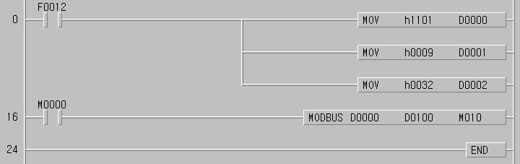
①
②
③
④

- Set the Slave station no. and Function code.
Station no.17 = h11 Function code = h01
- Set the address.
The address ‘0’ set in Modbus protocol means the actual Address 1.
If setting the actual Address 20, it is required to set Address 19.
- Set the number.
The number from Address 20 ~ 51 is 32.
- Modbus communication command.
The data to communicate by the setting form D000 ~ D002 is set to save from D1000.

The data is transmitted from low bit by byte unit. The insufficient bit part among byte shall be filled with ‘0’. The transmission of the above data is shown on Ex.1).

Ex.1) CD 6B B2 0E
Storage Data
Device | Storage value
D1000 | h CD 6B
D1001 | h B2 0E

Program Example 2

This is the example to execute ‘Status Read’ for input contact (Input) 10197 ~ 10218 of the Slave station that is station no.17.
If assuming that the input contact of the Slave station is as below, the read data shall be saved in the internal Relay M15.

Input contact | 10220 | 10219 | 10218 | 10217 | 10216 | 10215 | 10214 | 10213 | 10212 | 10211 | 10210 | 10209
Contact status | X | X | 1 | 1 | 0 | 1 | 0 | 1 | 1 | 1 | 0 | 1
Hexa | 3 |  |  |  | 5 |  |  |  | D
Input contact | 10208 | 10207 | 10206 | 10205 | 10204 | 10203 | 10202 | 10201 | 10200 | 10199 | 10198 | 10197
Contact status | 1 | 0 | 1 | 1 | 1 | 0 | 1 | 0 | 1 | 1 | 0 | 0
Hexa | B |  |  |  | A |  |  |  | C

1) The status of input contact 10219, 10220 is Redundancy.
2) The data is transmitted from low bit by byte unit. The insufficient bit part among byte shall be filled with ‘0’. The transmission of the above data is shown on Ex.1).

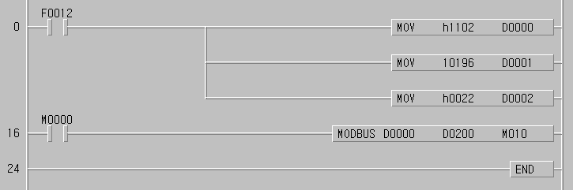
①
②
③
④

① Set the Slave station no. and function code.
Station no.17 = h11 Function code = h02
② Set the address.
The address ‘0’ set in Modbus protocol means the actual Address 1.
If setting the actual Address 10197, it is required to set Address 10196.
③ Set the number.
The number from Address 10197 ~ 10220 is 22.
④ Modbus communication command.
The data to communicate by the setting form D000 ~ D002 is set to save from D200.

The data is transmitted from low bit by byte unit. The insufficient bit part among byte shall be filled with ‘0’. The transmission of the above data is shown on Ex.2).

Ex.2) AC DB 35
Storage Data
Device | Storage value
D0200/D0201 | h AC DB / h 00 35

