APPENDIX

A.1 Communication Terminology

A1.1 Profibus-DP

Profibus
Profibus is the protocol that Bosch, Siemens, Klockener-Moeller in Germany has developed and designated as German standard DIN 19245 as well as the network designated as European standard EN50 170 with WorldFIP, P-NET recently.
Profibus is used for the real time communication between field equipment in the field of production automation, processing control, building automation and the product group is divided into Profibus-FMS (Rnet Message Specification), Profibus-DP (Decentralized Periphery), Profibus-PA(Process Automation).

Profibus-FMS
This is the solution for general purpose that provides the communication function in the cell level including the function to send the program file to act the field equipment and the related data file, the function to control the program remotely through the network, and the function to manage the various accidents to be occurred in the process of control and automation system etc.

Profibus-DP
This is the communication method to send the real time data between field equipment within the shortest time and substitute the communication system using the existing 24V or 4~20 mA analog signal with high speed digital communication method. The example to be applied is the communication between field equipment such as various sensor and actuator etc. installed in the PLC and the field.

Profibus-PA
This is made specially for process automation and the safety device is embedded and available to connect the sensor and actuator with one common bus line and perform the data communication and the power supply on the bus using 2-wire technology in accordance with International Standard IEC 1158-2.

Sycon
This is a Profibus Network Configuration Tool and when using the LGIS Master module (G3/4/6L-PUEA) as a Profibus Network, use Sycon to configure Profibus Network and download the information to the corresponding master module.

GSD file
This is the electronic device data sheet and includes manufacturer name, device name, H/W and S/W release status, support transmission rate, master related spec. (max. slave

number available to connect, upload/download option etc.) and slave related spec. (I/O channel number and type, diagnosis text spec. and module information equipped with moduler device.).

EDD (Electronic Device Description)
This introduces the device registration information of field device generally. It allows to describe the complicated automation system as well as simple field device (such as sensor and actuator) regardless of manufacturer. The device description is provided per device in the electronic form made by the manufacturer and EDD file is read by engineering tool and enables Profibus system to be set easily. And it describes the device variable and its function as well as contains the elements for operation and visualization.

Broadcast Communication
This means to send the message not recognized by the action Station to all Station (Master, Slave).

Multicast Communication
This means that the action station sends the not recognized message to the pre-defined Station group (Master, Slave).

A1.2 DeviceNet

ODVA (Open DeviceNet Vendor Association)
This is to contribute for the promotion of World industrial Automation technology, DeviceNet and the related technology. It participates in the exhibition for technical seminar and PR activity and writes/distributes the technical documents to attract the attention of the sales agents and the user for DeviceNet. ODVA’s activity includes the PR of DeviceNet Specification for each industrial sales organization in charge of network standardization, the requirements of the expansion or amendment for DeviceNet Specification according to the requirement of the market when the same Specification is selected in the real industrial automatic control system, and the proposal of the expansion or amendment of DeviceNet Specifications to the ODVA.

Bus-off
When the trouble occurs in the power of network, the error will occur.

CAN (Controller Area Network)
This is the communication protocol designed for automobile exclusive communication. Device network adapted CAN technology.

Scanlist
If the master module wants to communicate with the Slave module, it is required to know all information of the slave module (station address. message selection (Poll, Strobe etc.)) and set. This information is called ‘Scanlist’.
Dnet I/F module of GLOFA-GM PLC can set this easily just by high speed link parameter setting in GMWIN.

Connection
This means the logical connection between master and slave connected by DeviceNet and is used to maintain and manage all communication.

Profile
This provides the information for Device Configuration data. (Printed data sheet, EDS; Electronic Data Sheet etc.)

Master/Slave
The module to send/receive and manage the data is ‘master module’ and the module to reply to the data that the master module sends is ‘slave module’.

Packet
This is a pack of data that is a basic unit to transmit the data through the network. It attaches the header (Message Identifier) to the front part to add the information of the destination to go and other necessary information etc.

A1.3 Rnet

Master module (Rnet Master Module: RMM)
This is Rnet I/F module that is installed I/O digit of basic base.

Master station
This is the station connected directly GMWIN/KGLWIN so that the user performs the program download and monitoring/debugging in the same network including CPU.

Remote I/O station
Remote I/O module controls the I/O of remote station receiving I/O data from master station instead of PLC CPU in the PLC system.

Rnet
Fieldbus is the lowest network connecting the control machine and instrument device, selecting 3 among 7 layers of OSI. 3 layers are composed of Physical layer which is composed of H2 (1Mbps electric), H1 (31.23Kbbs electric), light, Wireless etc., Data Link layer selecting the Scheduled and Circulated Token bus, and Application layer that charges in the application role and this is the standard selecting the ‘User layer’ additionally.

Token
This is the access right control for Physical Medium and has the right to send the data of self station.

Rnet station no.
Station no. (G3L-RUEA...etc.) of communication module selecting Rnet specification. The station no. used in Rnet shall be set by the switch attached in the front of communication module and used as station no. of all service including high speed link service.

Manchester Biphase-L
This is data modulation method used in Rnet. The data is encoded (Encode) using Manchester-L Code and sent and the received data after encoding by Manchester is converted by Decoding.

CRC (Cyclic Redundancy Check)
This is one of error detection method and is used widely for the synchronous transmission that is called as ‘cyclic sign method’.

Terminal resistor
This is the resistance to be used to meet the mutual impedance between sending/receiving side of Physical Layer and Terminal resistance of Rnet 110Ω, 1/2W.

High Speed Link
This is the communication method to be used only between Rnet communication module so that the user can send/receive the data with high speed. The communication is carried out by setting the high speed link parameter in GMWIN/KGL-WIN.

Segment
This is the local network connecting all station by using the same Token without using any other connecting device (Gateway, repeater).

Network
This is the overall communication system composed of more than one segment and using the same Token.

A1.4 Modbus

Protocol
This is the communication regulation pre-defined on the sending/receiving side of information to send/receive the efficient and reliable information without error between more than 2 computer and terminals. Generally, it defines the establishment of calling, connection, structure of message exchange form, retransmission of error message, line inversion procedure, character synchronization between terminal etc.

BPS (Bits Per Second) and CPS(Characters Per Second)
BPS is the transmission rate unit how many bit is transmitted per second when transmitting the data and CPS is the number of character to be transmitted per second. Usually 1 character is 1Byte(8Bit) and thus, CPS is the byte number available to transmit per second.

Node
This means the connecting joint of data in network tree structure and generally the network is composed of lots of node. This is expressed also as Station no.

Packet
This is the term used in packet exchange method that divides the information into packet unit and transmits and also is the compound term of Package and Buket. Packet is the thing attached the header indicating the address of other station by dividing the transmitting data into the designated length.

Port
This is a part of data processing device to send/receive the data from remote terminal in the data communication and in case of Cnet serial communication.

RS-232C
This is the serial communication standard designated by EIA according to the recommendation of CCITT as the interface to connect the modem and terminal or model and computer. This is used for modem connection as well as direct connection to the null modem. The demerits are that the transmission distance is short and only 1:1 communication is available. The specification that overcome this demerits is RS-422, RS-485.

RS-422/RS-485
This is one of serial transmission specification and the transmission distance is long and 1:N connection is available comparing with RS-232C. The difference between 2 specification is that RS-422 uses 4 signal cable such as TX(+), TX(-), RX(+), RX(-) while RS-485 has (+), (-) 2 signal cable and performs the sending/receiving through the same signal cable. So, RS-422 performs full duplex mode communication and RS-485 performs semi duplex mode communication.

A.2 External Dimension

- External dimension of 16 point unit
The external dimension of Profibus-DP, DeviceNet, Rnet, Modbus etc are all same.
Unit: mm
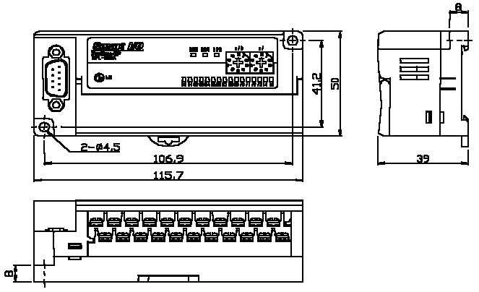

- External dimension of 32 point unit
The external dimension of Profibus-DP, DeviceNet, Rnet, Modbus etc are all same.
Unit: mm
