Chapter 6. Function and Function block

6.1 Function
Function is use for handling Boolean to double word data of GLOFA-GM series in GMWIN program
GMWIN has nine function groups defend on purpose of its usage
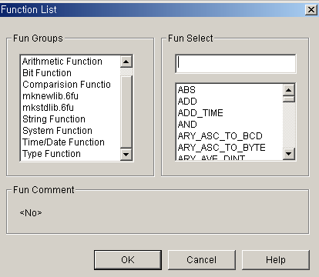

1) Arithmetic Function
Use it to make result(output) data after calculating input data by using addition(ADD), subtraction(SUB),
move(MOVE) or etc.

2) Bit Function
Use it to modify bits status of Byte or Word Variables by using shift (SHR,SHL), rotation(ROL,ROR) or etc.

3) Comparison Function
Comparing input data value, when meet with condition make “1” Boolean output variable
Ex : Great Than(GT),Great or Equal(GE),Less Than(LT)..etc.
.
.
7) Type Function
Change type of input variable to another data type by using
Ex: Change integer data type to BCD data type(INT_TO_BCD)
Change BCD data type to integer data type(BCD_TO_INT)

6.2 Function block
Function block is selected for using timer, counter or special instruction related with special
(communication) in GMWIN program

Function block needs temporary memory to use it during executing, so user input user define
name when use it
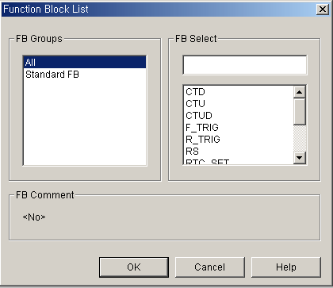

6.3 Function block

▷ Actual Input/Output connection for the function or function block is arranged by describing proper data or variable to the outside of function or function block body.

Example

Function Function block

▷ A BOOL type input and output shall be located at each function or function block in order to allow the power flow into the function or function block. EN and ENO is BOOL type Input/Ouput at the function and first input and output is BOOL type at the function block.

Example

▷The function at LD has EN input and ENO output unlike IL. EN and ENO are BOOL data type
and the function is executed when EN input is BOOL 1 and is not executed when it is BOOL 0. ENO output is generally EN value but ENO will be BOOL 0 though EN is BOOL 1 when the function error occurs. The function's EN shall be power flow line but ENO may not be. However, when the power flow line is connected to the function output not ENO, the output data type shall be BOOL. Further, if the power flow line is connected to the function output not ENO, ENO shall not be connected to anything. All inputs of function are allocated by describing the value to left of the function and shall not be missed. The function's output is stored to the variable selected to right of the function.
▷The function block at LD is used as same method at IL. The function blocks input is selected as same
method. As the function blocks output is stored in the instance, the variable may not be selected. As EN and ENO Input/Output are not in the function block, the function is executed at every function block. Therefore, the jump(-->> ) shall be used to define the execution of function block according to logical result. When the power flow line is connected to the function block, it shall be connected to Input/Output of BOOL data type.

Example

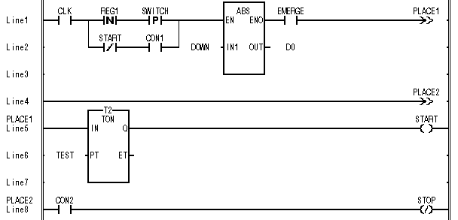
▷ The function and function block can be located everywhere at LD. Connecting power flow line to function and function blocks Input/Output and contact to power flow line can continue the logic operation.

Example

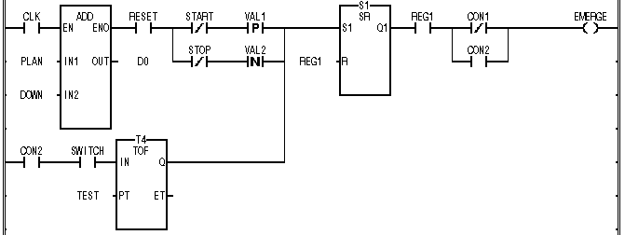

▷ The power flow line, which can be connected to one function and one function block, is only one.

Example

